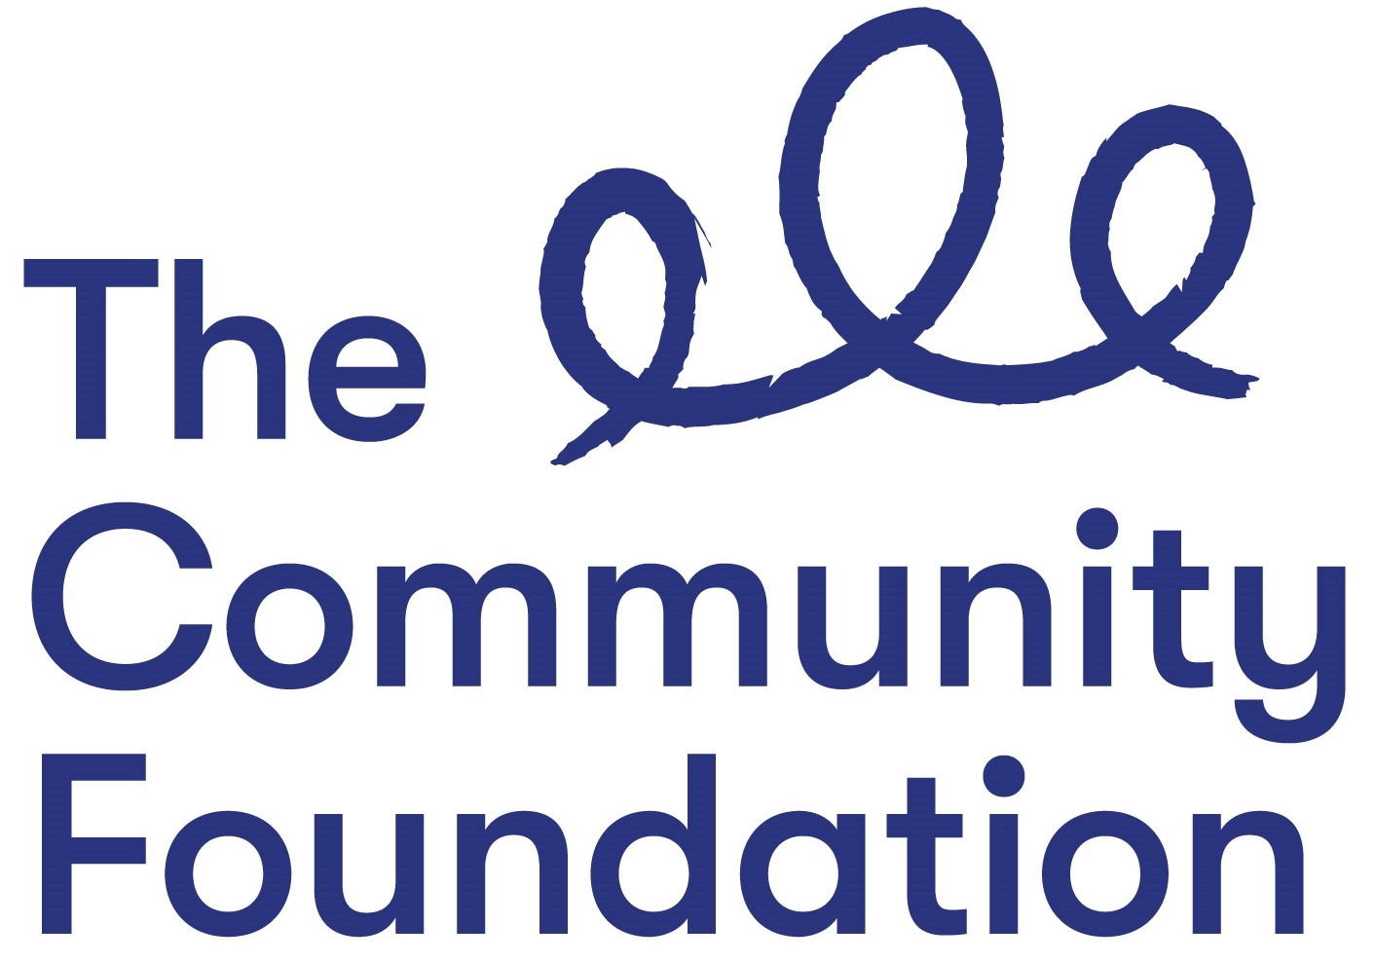

MONITORING QUESTIONNAIRE: **Private & Confidential**

**Ref:**

We are an Equal Opportunities Employer. We aim to provide equality of opportunity to all persons regardless of their religious or similar philosophical belief, political opinion, sex, pregnancy or maternity, race, age, sexual orientation, or whether they are married or in a civil partnership, or whether they are disabled, or whether they have undergone, are undergoing or intend to undergo gender reassignment. We do not discriminate against our job applicants or employees and we aim to select the best person for the job. In this questionnaire we will ask you to provide us with personal information we ask this for two reasons:

We are committed to promoting equality of opportunity and the information you provide will assist us to measure the effectiveness of our policies and develop positive action policies.

We monitor the community background and sex of our job applicants and employees in order to comply with our duties under the *Fair Employment & Treatment (NI) Order 1998.*

You are not obliged to answer the questions on this form and you will not suffer any penalty if you choose not to do so. Nevertheless, we encourage you to answer these questions. Your identity will be kept anonymous and your answers will be treated with the strictest confidence. We assure you that your answers will not be used by us to make any decisions affecting you, whether in a recruitment exercise or during the course of any employment with us.

**Community Background:**

Regardless of whether they actually practice a religion, most people in Northern Ireland are perceived to be members of either the Protestant or Roman Catholic communities.

**Please indicate the community to which you belong by ticking the appropriate box below:**

|  |  |
| --- | --- |
| I am a member of the Protestant community |  |
| I am a member of the Catholic community: |  |
| |  | | --- | | I am not a member of either the Protestant or the Catholic communities: | |  |

If you do not answer the above question, we are encouraged to use the residuary method of making a determination, which means that we can make a determination as to your community background on the basis of the personal information supplied by you in your application form/personnel file.

***Note: If you answer this questionnaire you are obliged to do so truthfully as it is a criminal offence under the Fair Employment (Monitoring) Regulations (NI) 1999 to knowingly give false answers to these questions.***

**Gender: Please indicate your sex by ticking the appropriate box below:**

Male: Female:

Other (Non-Binary, Gender Neutral etc). Please specify

|  |
| --- |
|  |

**To which ethnic group do you consider yourself to belong to:**

|  |  |  |  |  |  |
| --- | --- | --- | --- | --- | --- |
| Bangladeshi |  | Black African |  | Black Caribbean |  |
| Irish Traveller |  | Central European |  | Eastern European |  |
| Indian |  | Pakistani |  | Chinese |  |
| White |  | Mixed Ethnicity |  | Other: | |

In accordance with the *Disability Discrimination Act 1995,* a disability is defined as a physical or mental impairment which has a substantial and long-term effect on a person’s ability to carry out normal day-to-day activities.

**Do you consider yourself to have a disability?**

|  |  |
| --- | --- |
| Yes |  |
| No |  |

**If yes, please indicate which type of impairment applies to you.**

|  |  |  |
| --- | --- | --- |
| **Physical Impairment**, such as difficulty using arms or mobility requiring the use of a wheelchair or crutches | |  |
| **Sensory Impairment**, such as blind/visual impairment or deaf/hearing impairment | |  |
| **Mental health condition**, such as depression or schizophrenia | |  |
| **Learning disability**, such as Down’s Syndrome, Dyslexia or Cognitive Impairment such as Autism | |  |
| **Long standing illness**, such as cancer, HIV, diabetes, chronic heart disease or epilepsy | |  |
| Other (Please specify) |  | |

**Do you have dependents, or caring responsibilities for family members or other persons?**

Yes No

If yes, please indicate whether your dependents are:

|  |  |
| --- | --- |
| A Child/Children |  |
| A disabled person or persons |  |
| An elderly person or persons |  |
| Other (please specify) |  |

**Please complete this form and return to:lmccann@communityfoundationni.org**