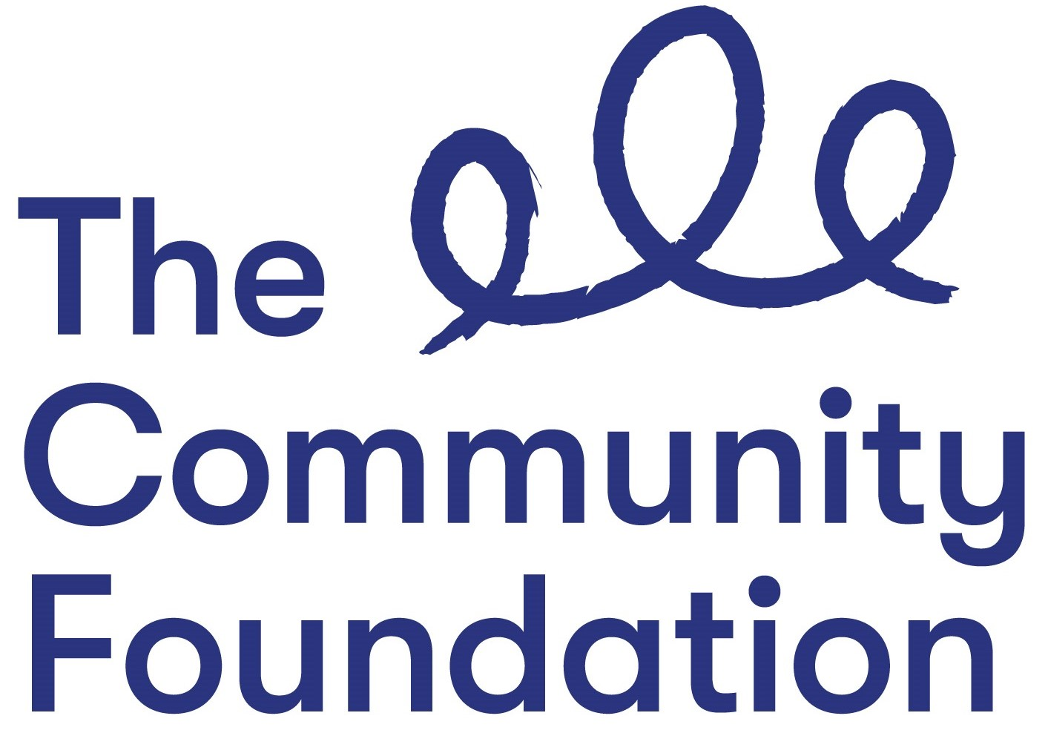

Position: Verification Officer (Fixed Term until 31 March 2024)

Salary: NJC Points 26 - 28 (£30,984 - £32,798), starting
on point 26 (£30,984) pro-rata for part-time posts

Closing Date: Tuesday 6th September 2022 at 12.00 noon

Ref: VO/0822

Section 1: PERSONAL DETAILS

The Community Foundation for Northern Ireland is an Equal Opportunities Employer and welcomes applications regardless of sex, pregnancy or maternity, marital or civil partnership status, religious or similar philosophical belief; political opinion, disability, racial group, gender reassignment, sexual orientation or age.
SURNAME: ………………………………………………………………………….

FORENAMES: ………………………………………………………………………

ADDRESS: …………………………………………………………………………..

……………………………………………………….POST CODE: ………………..

TELEPHONE NO: (Home) ……………………….

(Mobile) ……………………………..

EMAIL: ………………………………

QUALIFICATIONS:
Qualification (e.g. GCSE) | Subject | Grade Achieved | Year

FURTHER EDUCATION
Dates University/ Subjects Grade Achieved
From - To FE College etc.

MEMBERSHIP OF PROFESSIONAL ORGANISATIONS AND INSTITUTIONS
EMPLOYMENT HISTORY (please use continuation sheet if necessary)
Start with your present or most recent employment
Dates From - To  (Month & Year) | Name and Address of Employer | Position Held and Brief Description of Duties | Reason for Leaving | Salary

SECTION 2 – JOB RELATED CRITERIA

Please use this section to provide evidence of how your skills, knowledge, experience and/or qualifications meet the requirements of this post by giving examples.

NB: Only applicants who demonstrate that they meet the essential criteria will be shortlisted. Where we receive high volumes of applications, we reserve the right to shortlist those candidates who meet both the essential and desirable criteria.

ESSENTIAL CRITERIA - Qualifications/Experience
1. A good standard of education, including GCSEs in Maths and English at grade C or above (or equivalent).

2. Three years experience of working in a similar role where the main purpose of the role is verification of grant-funded expenditure such as; salary costs, overheads and project costs.

3. Experience of building good working relationships with a range of stakeholders.

4. Committed to the Foundation’s vision, mission and values. From the Background Information provided in the application pack, please write a personal statement that demonstrates your commitment to our vision, mission and values.

5.Committed to Diversity, Equality and Inclusion and to working with a diverse range of people and communities across Northern Ireland.

6. Available to attend occasional evening events.

DESIRABLE CRITERIA
7. A relevant finance/accounting Qualification, e.g Accounting Technician, Finance degree.

E 8.Experience of updating and maintaining a CRM database.

9. Working knowledge of NI procurement and tendering guidance.

10.Please advise which post you are applying for:

35 hours/week 20 hours/week

Or, if you would prefer to work a different number of hours per week, please state your preferred number of hours per week: _________

We will do our best to be as flexible as possible.

Do you need a work permit to work in the UK?

REFERENCES:
Please provide details of 2 referees familiar with your work, one of which should be your current or most recent employer.

1. Name and Address 2. Name and Address

Telephone no: Telephone no:
Email: Email:

Can they be contacted prior to interview – Yes No

I certify that all information given is correct. I understand that any false information given may result in any job offer being withdrawn.

Signed: Date:
(Typed or electronic signature accepted)

Application Forms must be completed in full and returned to:

Email: lmccann@communityfoundationni.org

CLOSING DATE: Tuesday 6th September 2022 at 12.00 noon.

CVs will not be accepted or considered by the panel. Forms received after the advertised deadline will not be considered.

