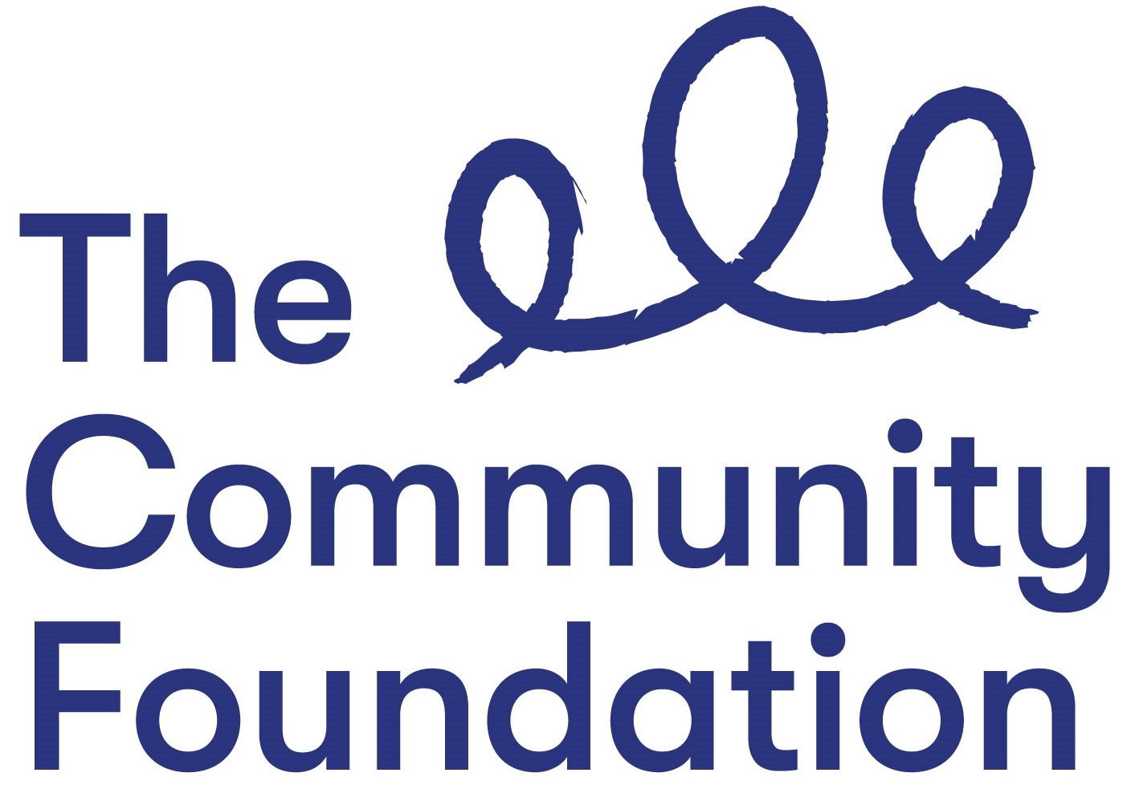

Position: Administration & Finance Support Officer - Acorn Farm Project

Hours: (30 hrs per week)

Salary: NJC Points 23- 25 (£28,226 -£30,095) pro rata, starting at point 23

Closing Date: Tuesday 30th August 2022 at 12.00 noon

Ref: AFSO/0822

Section 1: PERSONAL DETAILS

The Community Foundation for Northern Ireland is an Equal Opportunities Employer and welcomes applications regardless of sex, pregnancy or maternity, marital or civil partnership status, religious or similar philosophical belief; political opinion, disability, racial group, gender reassignment, sexual orientation or age.
SURNAME: ………………………………………………………………………….

FORENAMES: ………………………………………………………………………

ADDRESS: …………………………………………………………………………..

……………………………………………………….POST CODE: ………………..

TELEPHONE NO: (Home) ……………………….

(Mobile) ……………………………..

EMAIL: ………………………………

QUALIFICATIONS:
Qualification (e.g. GCSE) | Subject | Grade Achieved | Year

FURTHER EDUCATION
Dates University/ Subjects Grade Achieved
From - To FE College etc.

MEMBERSHIP OF PROFESSIONAL ORGANISATIONS AND INSTITUTIONS
EMPLOYMENT HISTORY (please use continuation sheet if necessary)
Start with your present or most recent employment
Dates From - To  (Month & Year) | Name and Address of Employer | Position Held and Brief Description of Duties | Reason for Leaving | Salary

SECTION 2 – JOB RELATED CRITERIA

Please use this section to provide evidence of how your skills, knowledge, experience and/or qualifications meet the requirements of this post by giving examples.

NB: Only applicants who demonstrate that they meet the essential criteria will be shortlisted. Where we receive high volumes of applications, we reserve the right to shortlist those candidates who meet both the essential and desirable criteria.

ESSENTIAL CRITERIA - Qualifications/Experience
1. A good standard of education including GCSE’s in Maths and English - or (equivalent).

2(i) At least three year’s work experience in a similar administrative role including dealing directly with a wide range of stakeholders by phone and in person.

2 (ii) At least three year’s work experience in a similar administrative role including typing letters, reports and correspondence, diary management, organising meetings and events.

2 (iii) At least three year’s work experience in a similar administrative role including producing financial reports and monitoring budgets.

3. Enthusiastic and motivated about the role and interested in Climate Change and Climate Action. Please tell us why you want this role and about your interest in Climate Change and Climate Action.

4. It is important to us that all staff are committed to Diversity, Equality and Inclusion and to working with a diverse range of people and communities across Northern Ireland.

Please tell us below how you feel you are suited to working in the Foundation and committing to working inclusively with a diverse range of people and communities across Northern Ireland.

5. Able to attend events, including occasional evening events.

DESIRABLE CRITERIA
6. Relevant IT/Finance/Business Qualification.

7. Experience of working or volunteering in a charity.

8. Experience of working with CRM systems and databases

Do you need a work permit to work in the UK?

REFERENCES:
Please provide details of 2 referees familiar with your work, one of which should be your current or most recent employer.

1. Name and Address 2. Name and Address

Telephone no: Telephone no:
Email: Email:

Can they be contacted prior to interview – Yes No

I certify that all information given is correct. I understand that any false information given may result in any job offer being withdrawn.

Signed: Date:
(Typed or electronic signature accepted)

Application Forms must be completed in full and returned to:

Email: lmccann@communityfoundationni.org

CLOSING DATE: Tuesday 30 August 2022 at 12.00 noon

CVs will not be accepted or considered by the panel. Forms received after the advertised deadline will not be considered.

