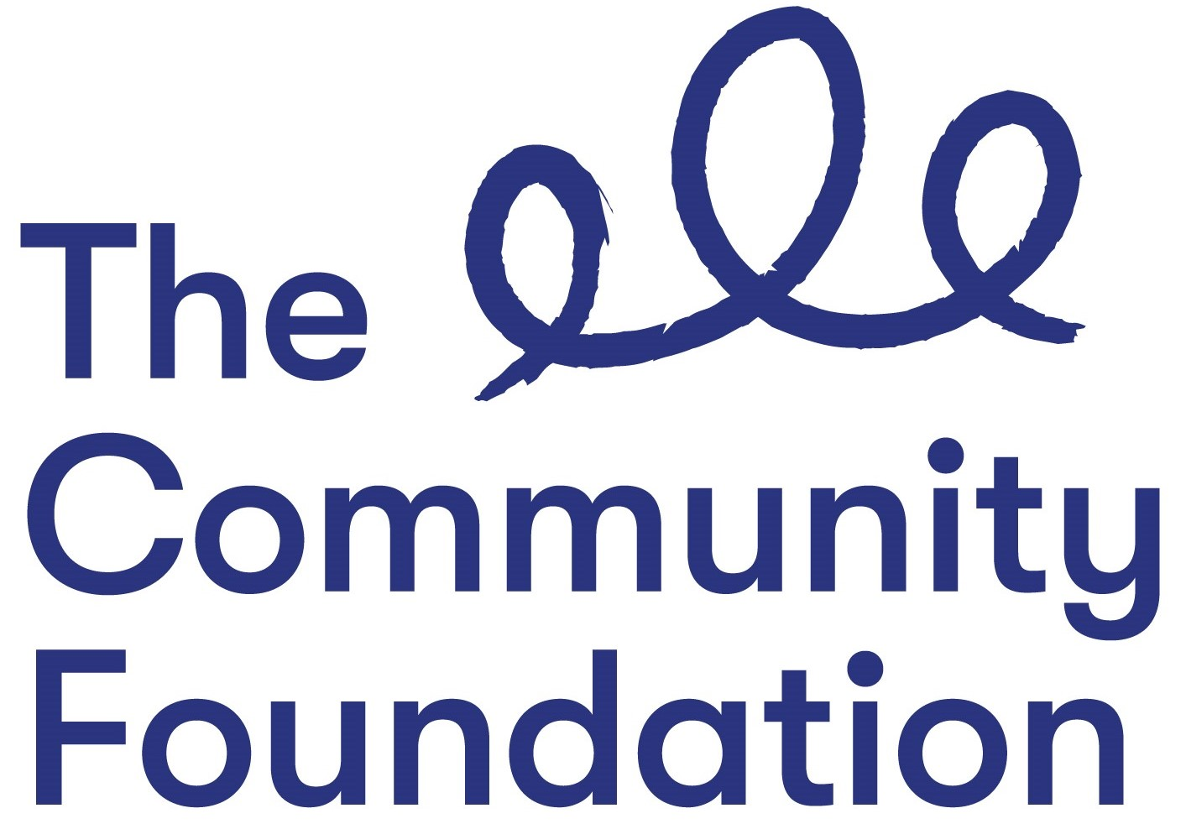

Position: Fund Development Manager

Salary NJC Points 32-35 (£36,371- £39,571)

Closing Date: Wednesday 20th April 2022 at 12.00 noon

Ref: FDM/0422

Section 1: PERSONAL DETAILS

The Community Foundation for Northern Ireland is an Equal Opportunities Employer and welcomes applications regardless of sex, pregnancy or maternity, marital or civil partnership status, religious or similar philosophical belief; political opinion, disability, racial group, gender reassignment, sexual orientation or age.
SURNAME: ………………………………………………………………………….

FORENAMES: ………………………………………………………………………

ADDRESS: …………………………………………………………………………..

……………………………………………………….POST CODE: ………………..

TELEPHONE NO: (Home) ……………………….

(Mobile) ……………………………..

EMAIL: ………………………………

QUALIFICATIONS:
Qualification (e.g. GCSE) | Subject | Grade Achieved | Year

FURTHER EDUCATION
Dates University/ Subjects Grade Achieved
From - To FE College etc.

MEMBERSHIP OF PROFESSIONAL ORGANISATIONS AND INSTITUTIONS
EMPLOYMENT HISTORY (please use continuation sheet if necessary)
Start with your present or most recent employment
Dates From - To  (Month & Year) | Name and Address of Employer | Position Held and Brief Description of Duties | Reason for Leaving | Salary

SECTION 2 – JOB RELATED CRITERIA

Please use this section to provide evidence of how your skills, knowledge, experience and/or qualifications meet the requirements of this post by giving examples.

NB: Only applicants who demonstrate that they meet the essential criteria will be shortlisted. Where we receive high volumes of applications, we reserve the right to shortlist those candidates who meet both the essential and desirable criteria.

ESSENTIAL CRITERIA- Qualifications/Experience
1. Educated to degree level and/or Senior-level experience (3 years) in a relevant field e.g fundraising, philanthropy advice, family/wealth advice, business development etc.

2. High-level understanding and experience of private philanthropy and vehicles for giving.

3. High-level understanding of charitable governance and regulation.

ESSENTIAL CRITERIA - Knowledge and Skills
4. Excellent written and verbal communication skills, including confidence in public speaking and an ability to persuade and negotiate effectively.
5.Competent with a range of ICT and operational systems, including familiarity with CRM programmes.

6. Personal Statement: Please provide a statement that illustrates the skills and qualities you will bring to this role and how you feel you meet our values.

DESIRABLE CRITERIA

1. Experience of working in or with community foundations or other donor-advised funds.

2.Able and willing to travel for work within Northern Ireland and occasionally outside it.

Do you need a work permit to work in the UK?

Full driving licence and access to a form of transport?

REFERENCES:
Please provide details of 2 referees familiar with your work, one of which should be your current or most recent employer.

1. Name and Address 2. Name and Address

Telephone no: Telephone no:
Email: Email:

Can they be contacted prior to interview – Yes No

I certify that all information given is correct. I understand that any false information given may result in any job offer being withdrawn.

Signed: Date:
(Typed or electronic signature accepted)

Application Forms must be completed in full and returned to:

Email: lmccann@communityfoundationni.org

CLOSING DATE: Wednesday 20th April 2022 at 12.00 noon

CVs will not be accepted or considered by the panel. Forms received after the advertised deadline will not be considered.

