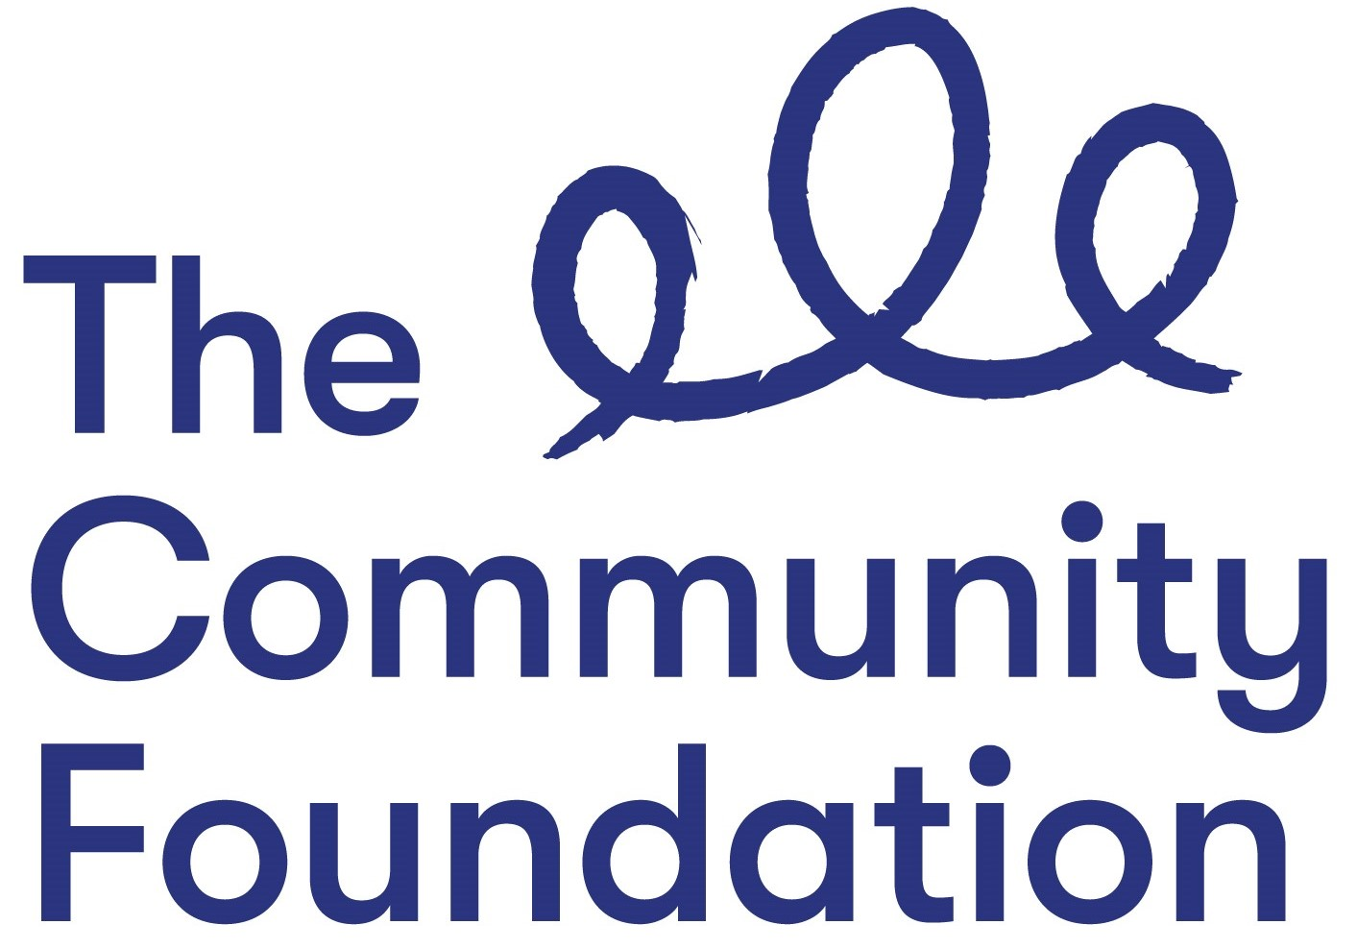

Position: Knowledge and Learning Officer
NJC Points 23 to 25 £27,741 to £29,577
Fixed Term Post up to 31 March 2024

Closing Date: Friday 3rd September 2021 at 12 noon

Ref: KLO/0821

Section 1: PERSONAL DETAILS

The Community Foundation for Northern Ireland is an Equal Opportunities Employer and welcomes applications regardless of sex, pregnancy or maternity, marital or civil partnership status, religious or similar philosophical belief; political opinion, disability, racial group, gender reassignment, sexual orientation or age.
SURNAME: ………………………………………………………………………….

FORENAMES: ………………………………………………………………………

ADDRESS: …………………………………………………………………………..

……………………………………………………….POST CODE: ………………..

TELEPHONE NO: (Home) ……………………….

(Mobile) ……………………………..

EMAIL: ………………………………

QUALIFICATIONS:
Qualification (e.g. GCSE) | Subject | Grade Achieved | Year

FURTHER EDUCATION
Dates University/ Subjects Grade Achieved
From - To FE College etc.

MEMBERSHIP OF PROFESSIONAL ORGANISATIONS AND INSTITUTIONS
EMPLOYMENT HISTORY (please use continuation sheet if necessary)
Start with your present or most recent employment
Dates From - To  (Month & Year) | Name and Address of Employer | Position Held and Brief Description of Duties | Reason for Leaving | Salary

SECTION 2 – JOB RELATED CRITERIA

Please use this section to provide evidence of how your skills, knowledge, experience and/or qualifications meet the requirements of this post by giving examples.

NB: Only applicants who demonstrate that they meet the essential criteria will be shortlisted. Where we receive high volumes of applications, we reserve the right to shortlist those candidates who meet both the essential and desirable criteria.

ESSENTIAL CRITERIA
Qualifications:
At least 5 GCSE’s (Grade A to C) or equivalent, including Maths and English

Experience:
At least 3 years’ experience of working within a role that involves basic research skills, to include sourcing and summarising different types of documents and evidence, identifying and writing up project summaries, and analysing different insights and learning.
At least 3 years’ experience of at least two of the following:
- Research
- Grant making
- Reporting to funders
- Monitoring and evaluation processes
- Project management
- Working with voluntary committees

Experience of using a grants management or customer relationship management system such as Salesforce.

Other Requirements:

Commitment to the Foundation’s vision and values of Generous, Thriving and Together. Please provide a statement that illustrates the skills and qualities you will bring to this role and how you feel you meet our values.

Able to work flexibly, including occasional evenings and weekends, when required.
Committed to working in all areas and communities within Northern Ireland.
Full driving licence and access to a form of transport. Consideration will be given to alternative traveling proposals in respect of applicants with a disability who cannot hold a licence.

DESIRABLE CRITERIA
Qualifications:
A degree, or other third level qualification, in a relevant discipline

Knowledge/Skills:
A working knowledge of Google Workspace (Google Apps)

Do you need a work permit to work in the UK?

REFERENCES:
Please provide details of 2 referees familiar with your work, one of which should be your current or most recent employer.

1. Name and Address 2. Name and Address

Telephone no: Telephone no:
Email: Email:

Can they be contacted prior to interview – Yes No

I certify that all information given is correct. I understand that any false information given may result in any job offer being withdrawn.

Signed:
Date:

APPLICATION FORMS MUST BE SIGNED AND RETURNED BY EMAIL TO:

Email: fotoole@communityfoundationni.org

CLOSING DATE: Friday 3rd September 2021 at 12 noon

All applications must be completed in full and returned by email. CVs will not be accepted or considered by the panel.
Incomplete forms or forms received after the advertised deadline will not be considered.

