Produced by Finbarr Fitzpatrick and Gillian McKee on behalf of
GAUGE IMPACT, 15-17 Grosvenor Road, Belfast BT12 4GN
Commissioned by:

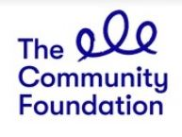

TECHIES IN RESIDENCE PROGRAMME EVALUATION

AUGUST 2021
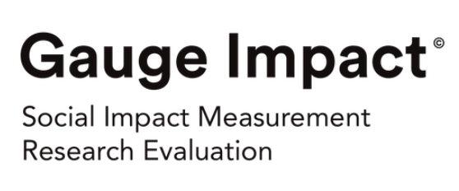
Contents

1.0 Introduction and Background 3
1.1 TiR Programme 2015-21 3
2.0 Strategic Context 6
2.1 The Stimulus for Techies in Residence 6
2.2 The Concept of Tech for Good 7
2.3 The State of the Sectors Today 8
3.0 Methodology 9
3.1 Data Review & Collection 9
3.2 Data Analysis 10
3.3 Limitations 10
3.4 CFNI Innovation & Voice Team 10
4.0 Programme Outputs and Impact 12
4.1 Cycles 1-4 12
4.2 Organisational Impact 12
4.2.1 Versus Arthritis 15
4.2.2 Children’s Law Centre 16
4.2.3 Focus on Family 16
4.2.4 JAM Card 16
4.2.5 Participation and the Practice of Rights (PPR) 17
4.2.6 Mencap 18
4.2.7 Parenting NI 18
4.2.8 Housing Rights 19
4.2.9 Shelter NI 19
4.3 End User Impact 20
4.4 Techies 21
4.5 VCSE sector 22
4.6 The 2020/’21 Cycle 23
4.7 Summary of Results 24
5.0 Findings 25
Achievements 25
5.1 TiR Really Does Provide ‘Tech for Good’ 25
5.2 Stakeholder Impact 25
5.3 Value for Money 26
5.4 Diversity of Organisations Supported 27
5.5 Improvement Over Time 28
5.6 Enablers for Success 28
Lessons Learned 29
5.7 Boundaries, Communication and Clear Guidelines 29
5.8 Support Beyond the Programme 30
5.9 Communication and Collaboration 31
5.10 Digital Priorities for the VCSE Sector 31
5.11 Dual Needs 32
Findings Specific to Cycle 5 32
5.12 Innovate-NI Support 32
5.13 Planning 32
6.0 Conclusions and Recommendations 34
6.1 Future Delivery Model 34
6.2 Programme Duration 35
6.3 Extend Programme Partnerships 35
6.4 Consider a Dual/Feeder Programme 36
6.5 Revolutionise the Model 36
6.6 Tech for Good Think Tank 36
6.7 Employ LEAN Thinking 37
6.8 Measure Impact 37
6.9 Open Data 38
6.10 Financial Support 38
Appendices 39
Appendix 1 – Participant Survey 39
Appendix 2 – Past Participants – Cycles 1-4 43
Appendix 3 – 2020/’21 Cohort of TiR Projects 46

Figures and Tables
Figure 1: The Techies in Residence selection process 4
Figure 2: The key phases of the Techies in Residence Programme 5
Figure 3: Evaluation Framework 11
Figure 4: Organisational Outcomes 14
Figure 5: JAM Card App Downloads Worldwide 17
Figure 6: End User Outcomes 20
Figure 7: How techies described their feelings at the start of the 2020/’21 cohort 22
Figure 8: How techies described their feelings at the end of the 2020/’21 cohort 22
Figure 9: TiR Outputs – 2015-2021 24

Table 1: Geographic Classification of Participants 27

1.0 Introduction and Background
The Community Foundation for Northern Ireland (CFNI) is an independent funding body that ‘connects people who care, to causes that matter’.
For over 40 years, the organisation has been a trusted broker, enabling donors to securely give and impact positively on local communities and issues that most need their help.
Within its current strategy, to 2024, the Foundation has five strategic priorities:
- Inspiring Generosity
- Building Sustainable Communities
- Community Voice
- Thriving after the Conflict
- People on the Edges
In furtherance of the Building Sustainable Communities strategic priority, the Foundation’s Techies in Residence (TiR) programme brings together societal challenges from charities and social enterprises, with digital technology professionals to produce innovative digital solutions, products and services that have potential for scalable social impact. In addition to the direct social impact the programme enables, it aims to build the capacity of participating organisations and demonstrate to the wider voluntary, community and social enterprise (VCSE) sector the benefits of harnessing technology for social purpose.
The 2020/’21 cycle of TiR was the fifth since its establishment by the Building Change Trust (BCT) in 2015. BCT was established in 2008 as a ten-year initiative funded by the Northern Ireland Big Lottery Fund to accelerate the development of the voluntary, community and social enterprise (VCSE) sector in Northern Ireland. BCT’s ten-year funding cycle ended on 31 December 2018, at which point three cycles of TiR had been funded, with 19 VCSE organisations supported through the residency of 19 tech partners.
From 2019, CFNI assumed overall responsibility for the management and strategic development of the programme with Innovate-NI continuing as the lead delivery partner. Comic Relief, who had provided some funding for the third cycle of the programme in 2017/’18, became the main programme funder with a significantly increased contribution for the final two cycles, supporting a further 13 VCSE organisations.
As part of its commitment to continuous improvement, CFNI sought a suitably qualified individual or organisation to conduct an evaluation of the TiR programme. The terms of reference for the evaluation were issued in August 2020 and Gauge Impact was appointed to undertake the evaluation commencing in October 2020. The objectives of the evaluation were as follows
- To assess the results and effectiveness of the 2020/’21 cycle of the Techies in Residence programme.
- To assess the longer-term impact of the programme on organisations, end users and the wider VCSE sector over the course of its 5 cycles since 2015.
- To identify learning in relation to the Techies in Residence model and make recommendations for how future cycles of the programme could be adapted to incorporate these.

1.1 TiR Programme 2015-21
The 2020/’21 cycle of TiR, which concluded in June 2021 was the fifth since its establishment by the Building Change Trust (BCT) in 2015. To date the programme has supported 32 projects. The starting point of each cycle is to facilitate an engagement whereby prospective applicants can explore the challenges for their target beneficiary group(s) and the extent to which digital technology can assist them in addressing these issues.
The process leading to the final selection of projects for the 2020/’21 cycle is illustrated in Figure 1. Design Hops were a new introduction for this cycle, building on the previous practice of running information workshops before the programme launched to encourage applications.
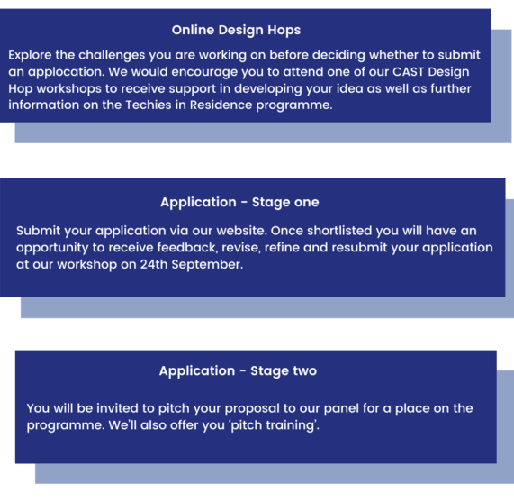
Figure 1: The Techies in Residence selection process
Applicants are assessed on the viability and potential sustainability of the project and the capacity within the organisation to devote the required resources to progress it to (at a minimum) the ‘prototype stage’. Successful applicants are paired with ‘techies’, i.e., a digital technology professional, usually a software developer who could be freelance or an employee of a digital technology business. The techies are attracted via a recruitment campaign and they pitch for the project(s) that most interest them, with the VCSE organisation making the final selection of the techie they feel is best suited to their needs. The resourcing of the individual projects takes the form of a three-way contract between CFNI, the VCSE organisation and the Techie in each case, with CFNI paying a fixed amount to each techie on the achievement of agreed project milestones.
The ‘design’ stage of the project culminates in a two-day workshop/residential (virtual in 2020/’21) during which the pairings agree the scope and key actions for their shared project. Contracts are signed and milestone targets agreed before the ‘residency’ element of the programme commences (see Figure 2). This comprises an intensive 12 week build phase where the VCSE organisation and the techie work closely to produce a working prototype of their product, platform or service. During this period, the different projects receive mentoring from Innovate-NI in addition to having regular opportunities to share and learn from one another.
At the conclusion of the programme, each project team has the opportunity to share its achievements with the others and with the wider VCSE and tech sectors at the Foundation’s Techies in Residence showcase event. At this event they also pitch for a Seed Fund award to allow them to undertake further development and scaling of their product, platform or service.
The Techies in Residence programme operates an ‘open innovation’ approach which embraces the potential for enhanced impact through multiple applications of similar products to a range of societal issues. As such, all the VCSE and techie participants agree to make their prototype products freely available to other social purpose organisations for adaptation and adoption on a ‘share and attribute’ basis.
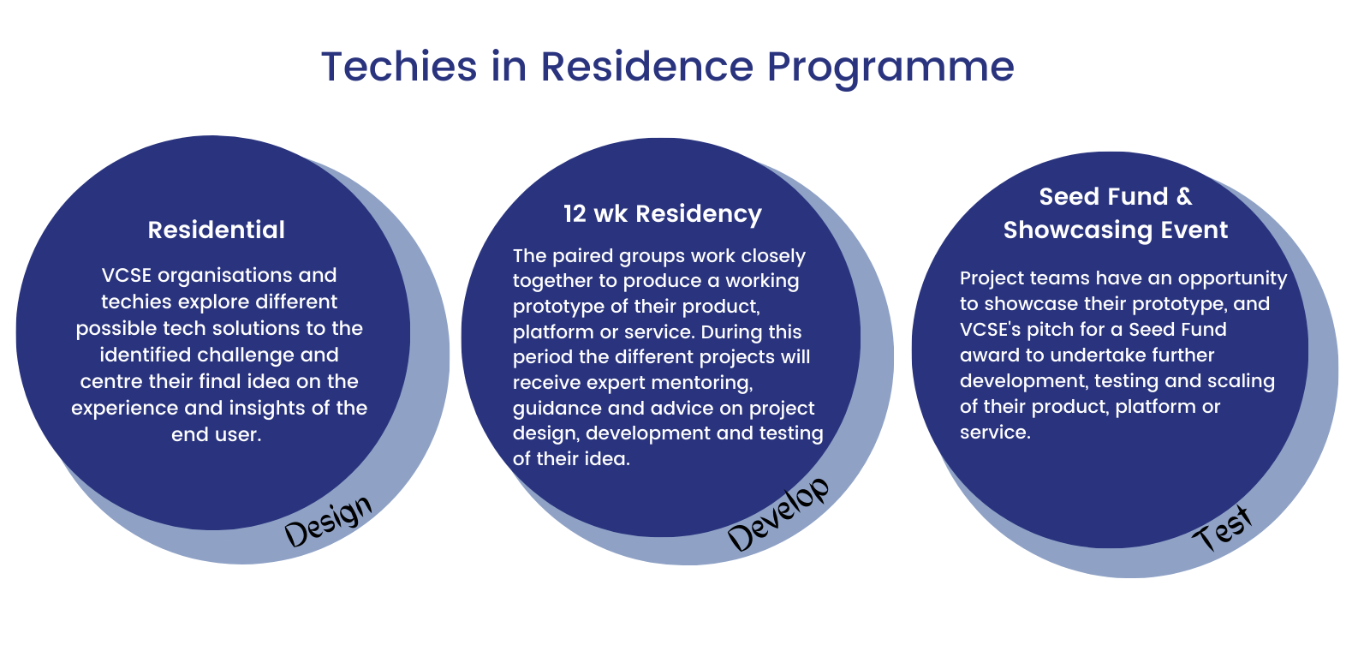
Figure 2: The key phases of the Techies in Residence Programme

2.0 Strategic Context

2.1 The Stimulus for Techies in Residence
The Techies in Residence (TiR) programme was first launched in 2015, at the time procured and hosted by the Building Change Trust (BCT), as part of a wider programme of work around social innovation in Northern Ireland. The initial purpose of TiR was to provide a source of innovation and support to help third sector organisations in Northern Ireland solve societal problems using tech. Embracing the concept of ‘Tech for Good’ that was gaining traction in other parts of the UK, Techies in Residence aimed to create a local community of ‘tech’ experts that would use technology to improve outcomes for the beneficiaries of the VCSE organisations they partnered with during the programme.
When the Building Change Trust concluded its work and closed at the end of 2018, ownership and management of TiR passed to the Community Foundation for NI and it has been delivered with Innovate-NI as delivery partners, completing its fifth cycle in May 2021. Comic Relief has been a funder for TiR since cycle three in 2018/’19, when it was a minor funding partner. In 2020/’21, Comic Relief provided almost £200k towards the programme and its funding has totalled £400k to date.
Around 2014, there was significant interest in the concept of social innovation within Northern Ireland, not only from BCT, who had commissioned research on ‘Growing Social Innovation in Northern Ireland’ in 2013, but from Matrix – The Northern Ireland Science Industry Panel – who produced the ‘Harnessing the Power of Social Innovation’ report. Alongside this, the NI Executive produced its Innovation Strategy for Northern Ireland, which referenced the concept of social innovation and an ambition to develop and grow this over the lifespan of the strategy (2014-2025).
Although the Innovation Strategy refers to the need for social innovation and lists as an action the development of new social innovation accelerator programmes and an intention to work in partnership with organisations like the Young Foundation and the BCT to promote the concept, it does so as a vague allusion and not in any detailed way. Stakeholders to whom we spoke in the course of this evaluation were unable to point to any digital examples of social innovation that could now be linked with the concept of Tech for Good, other than the Techies in Residence programme. The term Tech for Good did not feature in the strategy.
It is fair to say that in 2014, there wasn’t a clear ambition to use tech to achieve or drive social innovation, at least not from government. The Matrix report makes one reference to establishing a collaborative network under the auspices of Invest NI to focus on digital social innovation, but only the BCT and the Young Foundation appear to have grasped the potential for tech to drive social innovation at this time. The Turning up the Dial report commissioned by the BCT and launched in March 2014 acted in many ways as a catalyst for the action that ultimately led to the creation of the TiR programme.
This was a key element of scoping work carried out to explore the concept of Tech for Good and its application as part of a wider programme of social innovation in Northern Ireland by the BCT. Seminars held in April 2014 at the Belfast Technology Conference and NICVA involved a range of organisations, including NICVA, the Young Foundation, Belfast City Council, Social Innovation Camp, Farset Labs and others. A report outlining the discussions at these seminars highlighted responses to the Turning up the Dial research. These responses showed a clear appetite for embracing tech for social good and highlighted a range of considerations around accessibility and attitudes to tech, funding and resources and practical issues to be addressed.
At this point, in 2014, digital social innovation was still a new concept for Northern Ireland and Turning up the Dial was commissioned to help inspire potential stakeholders across Northern Ireland of the potential that digital social innovation in particular could bring to the VCSE sector.
One of the recommendations from this report was the establishment of a ‘Geeks in Residence’ programme as step one in a ‘social innovation spiral’ intending to lead ultimately to systemic change. This idea was refined to create the Techies in Residence programme on which this evaluation is based, and which was launched a year later in 2015.

2.2 The Concept of Tech for Good
Techies in Residence is considered by the Community Foundation for NI and Innovate-NI to be a programme that strives to use tech for social good. The term commonly used and recognised for this is Tech for Good. Although now a widely used term, it has fairly subtly different meanings and applications, such as those below:
“Tech for Good is a community of people, projects, organisations and funders promoting the role of technology to improve social, environmental and economic outcomes.”
Nissa Ramsey, Consultant at Think Social Tech and former Comic Relief Tech for Good Evaluation Lead
“Tech for Good is the intentional design, development and use of digital technologies to address social challenges. It is the combination of the most powerful and flexible tool we’ve ever had and good design approaches that are user-led and test-driven.”
Dan Sutch, Researcher and CEO at the Centre for Acceleration of Social Technologies
Within the UK, key drivers behind the Tech for Good movement are Comic Relief and the Paul Hamlyn Foundation, who, since 2019, have provided over £2.4 million of funding for projects that aim to enable charities to utilise technology to deliver better services. This is the premise upon which the TiR programme was built – supporting charities to use tech to achieve their ‘mission potential’. Prior to this, Nesta provided a stimulus for interest in the topic through its EU-wide initiative focused on digital social innovation between 2013-2019.
The definition of Tech for Good used by CFNI is:
“The use of digital technology to enable new or more effective solutions to social problems or needs.”
On an international level, a Tech for Good Summit was established in 2018 by President Macron of France. Now an annual event, it involves five workstreams – Education, Economic Inclusiveness, Environment, Future of Work and Diversity – to which companies have committed resources and efforts to meet a range of ambitions. In 2020, the Tech for Good Call was launched and now has 80 signatories committed to embracing the potential for tech to be used for positive societal contributions and avoid the potential for negative impacts.
Some uses of ‘Tech for Good’, like this one, are more broad-based, being applied to tech that simply has a social purpose. For the purposes of this evaluation, our definition is more specific to the use of tech to help not-for-profits achieve their aims and achieving cross-sectoral collaboration to expand the knowledge, skills and reach of the VCSE sector through digital applications.

2.3 The State of the Sectors Today
The Voluntary, Community and Social Enterprise sector in Northern Ireland comprises some 6,122 organisations, a workforce of some 53,620 and more than 241,000 volunteers, according to NICVA’s State of the Sector update from February 2020. It can be assumed that COVID-19 has impacted negatively on those figures, but the exact extent of the impact is unknown at the time of writing. What we do know, again thanks to data from NICVA, is that charitable giving decreased by 27% and therefore many charities have been hit hard due to decreased income and significantly reduced opportunities to fundraise in their normal ways due to lockdowns and social distancing restrictions.
These factors provide a specific context for the 2020/’21 TiR programme, whereby VCSE organisations have had to embrace tech and be more innovative than ever before in finding ‘digital’ solutions to meet their charitable objectives during unprecedented times. It seems likely that this focus on tech and digital solutions will be maintained into the future, as the pandemic highlighted the vulnerability of organisations in the VCSE sector that lacked the skills and infrastructure to use tech in delivering their mission.
Over the six years since Techies in Residence was introduced in 2015, the use of tech in wider society has grown significantly. In 2015, there were 38 million users of social networking sites in the UK. By January 2021 this had grown to 53 million users, equating to 78% of the UK population. There were also 65 million internet users in January 2021, with internet penetration standing at 96%, compared with 89% in 2015.
In terms of the tech ‘sector’, the Tech Nation 2021 report shows huge growth in this sector since 2015, with 21k jobs in NI in 2021 and investments of some £45 million in 2020 compared with £13 million in 2015. An article published in the Belfast Newsletter on 16 June 2021 claimed that the burgeoning tech sector in NI employs some 28,000 people and accounted for two thirds of all equity investment in NI in 2020.
Despite the growth in tech roles and companies over the past five years and increased investment in tech, there has been little or no investment in the Tech for Good movement outside of the TiR programme. Although a 2019 report by Tech Nation points to growing numbers of Tech for Social Good companies across the UK, these are largely purpose-driven, for-profit companies that develop tech to address social or environmental issues using a commercial model. As has been outlined previously, our evaluation is focused on Tech for Good that brings digital tech to the VCSE sector to help it achieve its charitable purpose and address societal issues and other examples of that in Northern Ireland have not been unearthed in the course of this evaluation.

3.0 Methodology
This section outlines the methodology used by Gauge Impact to meet the terms of reference for the evaluation. The evaluation commenced with an initiation meeting between the CFNI Innovation & Voice team and the Gauge Impact Evaluation Team to agree the processes and reporting milestones for the evaluation. This was followed by the co-design with CFNI of an evaluation framework to capture the outputs, outcomes and impact for all material stakeholders to be evidenced through the data collection process (Figure 3).

3.1 Data Review & Collection
We employed a mixed-method approach, comprising secondary desk research and both quantitative and qualitative primary data collection through semi-structured interview. A desk-based review of secondary data and information, including existing qualitative research studies, statistical data and policy documentation relevant to Tech for Good and social innovation was carried out. The following resources and research papers formed the basis of the review:
- Montgomery, Pamela & McLaughlin Helen, (2019) Social Innovation NI Programme 2016-2018, Achievements and Learning to Date. Building Change Trust.
- Hostick-Boakye, Sophie (March 2014) Turning up the Dial – Digital Social Innovation in Northern Ireland. Building Change Trust and The Young Foundation.
- Tech for Social Good: Digital Social Innovation Combined Report of Seminars: 3rd April 2014, Belfast Technology Conference,10th April 2014, NICVA.
- Norman Will, Russell Catherine, Clarke Karen, Martin Declan (2015) Growing Social Innovation in Northern Ireland. Building Change Trust.
- Building Change Trust Techies in Residence – Programme Evaluation (2016) Public and Corporate Economic Consultants.
Feedback collated at programme end from participants in the first three cycles of the TiR was made available for this evaluation. Primary data was collected through semi-structured interviews. An interview schedule with a series of predetermined, yet open-ended questions was developed by the Gauge evaluation team and approved by CFNI. The following summarises the data collection activities undertaken between 1 October 2020 – 4 August 2021.
- 20 semi-structured interviews with participants in cycles 1-4 of the TiR Programme, representing a response rate of 80%.
- 7 semi-structured interviews with participants in the 2020/’21 (cycle 5) of the TiR Programme, representing a response rate of 100%. A further 2 participant organisations provided feedback on their experience of TiR via e-mail.
- 11 semi-structured interviews with techies who supported the participant organisations during the five cycles of the TiR Programme.
- 5 semi-structured interviews with organisations selected on the basis of past involvement with BCT or being an umbrella VCSE organisation and/or member of the Tech for Good working group.
- A semi-structured interview with senior personnel at Innovate-NI who were involved in delivering the five cycles of the programme.
- A semi-structured interview with a designated staff member from Comic Relief who funded cycles 3-5 of the TiR Programme.
- A semi-structured interview with the Head of Capacity & Communities at CAST – a programme support partner for the 2020/’21 cycle.
- A survey emailed to the 25 VCSE programme participants from cycles 1-4 to determine status and impact data for their projects (see Appendix 1). Eleven responses were received.

3.2 Data Analysis
Qualitative data analysis was conducted using a thematic approach. Categories were developed, coded, and reduced. Interview data and information from secondary data sources was cross-referenced to identify emergent themes and issues. These were transferred into conclusions and recommendations towards the end of the evaluation, augmented by monthly discussions with the CFNI Innovation & Voice Team who oversaw the evaluation.

3.3 Limitations
In relation to the Evaluation Framework (Figure 3), the main area of limitation was in accessing the end beneficiaries, i.e., those individuals who have used and benefited from the digital innovations developed by VCSE participants on the TiR programme. While some projects did not develop beyond the prototype stage, a number have progressed to live products that are now part of that organisation’s core service offering.
Time elapsed since participation and the subsequent integration of the innovation into their services were identified as the main barriers in identifying beneficiaries by participant organisations. We acknowledge and recognise the absence of lived experience of those who have benefitted from TiR innovations as a limitation for this study. To counter this, we invited participant organisations during the semi-structured interview to articulate, and where possible quantify, the impact of the TiR innovation on their service-users. Furthermore, we designed and circulated a survey to all 25 participants from cycles 1-4, requesting this information, however the response to the question on service user outcomes was limited. We believe a factor limiting the availability and provision of such data may be inadequate data management skills within the VCSE organisations involved.
The five participants (20) in cycles 1-4 who did not participate in the semi-structured interviews cited that the staff who led or worked on the TiR programme internally were no longer with the organisation and the absence of their perspective was a limitation for the evaluation. Similarly, 11 techies from cycles 1-4 did not participate, citing work pressures or failing to respond to emails sent. We acknowledge that this limited the evaluation somewhat but having spoken to six of the VCSE partners for those projects, have no reason to believe the missing feedback would alter the results and findings we have set out here.
A further factor which may be considered to impact the collection of data is the dichotomy between the culture of innovation stimulated and encouraged by the TiR programme and the structured, methodical requirements of data management. For this reason, we have made a recommendation that some commitment to measurement and reporting be factored into future participation (see Recommendation 6.8).

3.4 CFNI Innovation & Voice Team
We would like to acknowledge the guidance and counsel provided by the CFNI Innovation & Voice Team, Paul Braithwaite and Gemma McCaughley, who assisted in shaping the methodology and report, held us to account and retained strategic oversight of the approach.

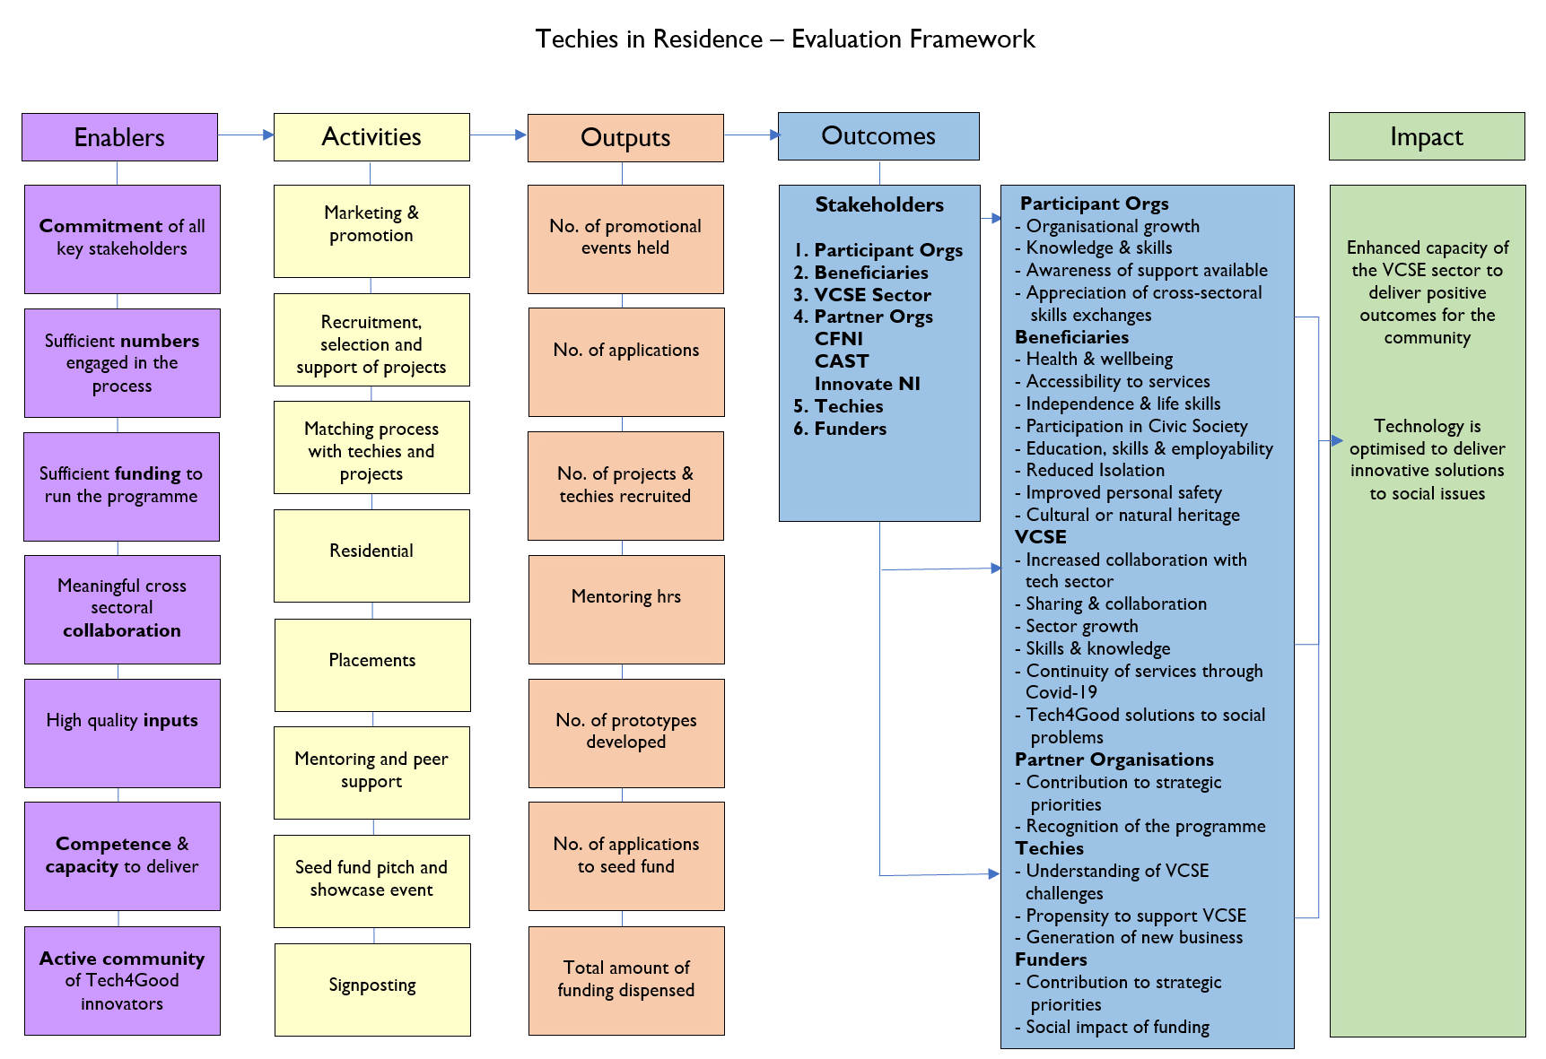
Figure 3: Evaluation Framework

4.0 Programme Outputs and Impact
From initial concept, TiR was aimed at supporting VCSE organisations to explore digital innovation solutions to challenges they are seeking to address for their service-users. By bringing together VCSE organisations and technology partners to develop new digital solutions, it was envisaged that benefits would accrue for people and communities across Northern Ireland. This section will explore the programme impact for organisations, techies, end users and the wider VCSE sector over the course of its five cycles since 2015, based on a thematic analysis of the consultations undertaken with the material stakeholder groups.
As well as looking retrospectively at the outputs and impact from the first four cohorts, we have provided an overview of the 2020/’21 programme as specified in the ToR. In 4.7, we have summarised the outputs in an infographic which provides a visual aid to the key outputs across all five cycles.

4.1 Cycles 1-4
Appendix 2 provides an overview of the 25 organisations that participated in TiR over the course of the first four programme cycles – ranging from large UK-wide to small community-based organisations. The main Key Performance Indicator (KPI) for the TiR programme was that all organisations supported would, after the 12-week techie residency, have a prototype in place which they could pitch at the seed funding event, or in the case of cycle 1, before seed funding was introduced to the programme, use to attract further funding and investment elsewhere. This was achieved by all 25 organisations supported, with the minimum number of projects supported in any one cycle being six (cycle 1) while the maximum was nine (cycle 4).
11(44%) of the projects developed during TiR cycles 1-4 are ‘in active use’ with seven (28%) ‘still in development’. Four (16%) are ‘dormant for now’ with the status of the remaining three (12%) unknown due to their non-engagement with the evaluation. Nine out of the 11 projects in ‘active use’ were successful in securing seed funding, as were five out of the seven ‘still in development’, none of the four ‘dormant for now’ programmes received seed funding. While success in securing seed funding appears to be a strong enabler for further progression, differences in expectations between techies and VCSE organisations was cited as a barrier for one of the dormant programmes. “We wanted an app but the techie felt that we should develop a website. This basic concept was changed throughout the programme and didn't complete as expected”. (See Sections 5.6 & 5.7 for further discussion of enablers & barriers)
There was some evidence to suggest that ‘dormant for now’ may not mean for perpetuity. Development of Advice NI’s app to help people ensure access to benefits, pension and tax credits entitlements stalled due to the lack of additional funding, however they remain committed to the idea in the future. “We were unable to attract further funding for our project but are still working to help address issues of financial capability and digital inclusion and will at some point revisit the app and develop it further”.
Diverse themes encompassing some of the most complex and challenging issues facing organisations in the VCSE sector, such as mental health, disability, homelessness, access to rights, managing chronic conditions, and integration, were addressed by the TiR projects in cycles 1-4

4.2 Organisational Impact
Organisational impact was assessed through a survey (See Appendix 1) and semi-structured interviews with participants, 20 out of the 25 participants in cycles 1-4 engaged through one or both of these mediums. Impact was evident on a number of levels. For those organisations that self-selected their programme as ‘dormant’, there was still considerable learning and development accrued. “Our knowledge and awareness of Tech for Good increased significantly, it (TiR) transformed our mindset towards digital development, I also think it made us more resilient to COVID-19 as we were already doing stuff online through the learning from TiR”.
Where the organisation was unsuccessful in securing seed funding, respondents cited the valuable experience gained in developing their message and pitch. “The pitch challenged us to explore the perceived benefits not just of our innovation but also our wider services. While we were unsuccessful, we subsequently tweaked some of our marketing and promotion and have been successful in other funding bids.”
“Pitching is not the norm in the community and voluntary sector and while it was daunting, we gained great experience and are now much more confident in our message. We have pitched on a number of occasions since to corporates and have been successful.”
Of the seven programmes ‘still in development’, four hope to launch within the next year. Centred Soul have the digital infrastructure in place and are awaiting specialist legal advice on safeguarding issues that may present through the peer-to-peer chat room for those with perinatal issues, which can be accessed via the website.
The uHub Therapy Centre respondent indicated that after the seed funding stage, they detected deficiencies in the functionality of their website which they had to address by sourcing technical expertise using funding they secured from the Executive Office and engaging an intern from Belfast Met to help them rebuild the site. They are now at an advanced stage of development and expect to launch their mental health support website in late 2021. The Old Library Trust received €100,000 of European funding for further development of their digital resources to address child obesity which they hope to launch in early 2022.
Techies in Residence supported Specialisterne NI to take autistic people's messages to new audiences using Virtual Reality (VR) and 360 degree videos to convey what it can be like for a person with autism to be at a reception desk, in the office kitchen or canteen, in a stand-up meeting or sitting in an open plan office. During lockdown the VR and 360 degree videos were used over Zoom to inform companies and organisations about the experiences of autistic people in Northern Ireland workspaces. They have been shown to autistic people who are getting ready to start or continue careers as part of Specialisterne NI's job seeking support. The next stage of development is the launch of a full online training solution which shares what autistic people want others to know with more people.
Another project in the ‘still in development’ category, the Women’s Aid Federation Northern Ireland (WAFNI) website ‘Love not Love’ has a domain but has not yet launched. An organisational review prompted the decision to utilise the website to enhance the upgrading of the WAFNI Post Primary Programme – Heading for Healthy Relationships. This was a long-standing programme that has been used by all Women’s Aid groups for direct delivery in services, schools, youth settings etc for many years but required a total upgrade. This work has started with a full review by all eight Local Women’s Aid groups on the programme content and aims.
Figure 4 presents the organisational outcomes referenced by those who completed the participant survey.

Figure 4: Organisational Outcomes
Although the numbers responding to this question in the survey are low, this is not a concern, as the interviews with participants drilled further into these findings and confirmed what has been outlined below.
The cultural shift towards digital referenced in the survey was also a consistent theme to emerge in the participant interviews, with 85% of the total participant sample indicating that TiR was a catalyst for cultural change within organisations, leading to a greater appreciation of the potential of digital technology. One contributor referenced TiR being the catalyst for a ‘Digital First’ strategy within their organisation, where opportunities to use technology to improve the outcomes for service-users and efficiencies were part of day-to-day operations and strategic planning.
Another cultural shift evidenced was a recognition of the importance of innovative and robust co-creation and co-production processes to ensure that the technological solution could meet the needs of service-users. While the Children’s Law Centre had an existing Youth Advisory Panel, eight out of the ten other live projects pointed to increased service-user involvement in the design and testing process.
“We knew that we had only one chance at this, so it was absolutely essential that current and potential service-users were involved in the testing. This ranged from 1-1 testing to focus group discussions. This group continues to be consulted on updates to the app.”
“Even before TiR, we were looking at service-user involvement as a strategic priority but beyond evaluation and surveys, we did not know where to take it. TiR prompted us to move quickly on it by getting service-users involved in the testing, they really enjoyed it and we have continued to engage them on other non-digital service developments in the organisation.”
While such cultural shifts may have happened organically through natural organisational growth and development, the vast majority (90%) of respondents felt that it was expedited through the additional capacity and learning facilitated by TiR.
The enhanced skills and knowledge outcome reported in Figure 4 was augmented further in the participant interviews. Contributors highlighted that pre-TiR they had an interest in exploring how to use technology more effectively to improve outcomes for service-users but were unsure of the starting point for such a process. “We have always had an interest in developing technology in the organisation, but we really had no idea of where to start in terms of connecting our service-users to digital supports.”
Respondents did not immediately identify with the term Tech for Good at project inception, however as the programme evolved, their understanding of this concept as distinct from digital development was enhanced. There was also variation in relation to where participant organisations felt they were at in terms of digital capacity at the outset, with 25% rating their organisation as “being digitally savvy” while 75% felt that there were digital deficits in their organisations, due primarily to a lack of resources. Given this finding, without the intensive support of the TiR programme and the collaborative relationship with their techie, it is unlikely that the majority of participants would have had the confidence or internal capacity to proceed with the projects that were developed.
“Like many voluntary agencies we do not have a dedicated IT, Web Designer, or general branding design staff team and quite often this work is picked up by staff members so the opportunity to have funds to access professional expertise and skill to develop a website with a solid approach to listening to the subject matter experts to ensure key messages are clear was a first for our organisation This was the major benefit of the fund as multi-media platforms are now the major communication tools for the whole organisation, an aspect that certainly played out during the first Covid-19 lockdown as we adopted and initiated various communication platforms to ensure women, children and young people could still access vital support”.
To measure change in skills and knowledge during the 2020/’21 cycle, a self-assessment poll was carried out at the outset and again at the end of the programme. In this, the organisations rated themselves an average of 3.11 out of 5 at the start and 3.56 at the end in relation to their level of skill in technology. In the same end of programme poll, a question was asked regarding the degree to which the TiR Programme had met their expectations. On a scale of 1-10, the average was 7.67, with six of the nine participants (two organisations were represented with two people each), scoring 8 or above.
Among the 11 organisations that have progressed to product launch and development, many are now reaching more service-users across a wider geographical area than previously. The following sub-sections provide further insights into the story of change for a sample of the programmes whose tech for good solution are in ‘active use’.

4.2.1 Versus Arthritis
The Versus Arthritis app (The Arthritis Tracker) which supports young people to manage this chronic condition, now has in excess of 10,000 users since its launch in 2018. Arthritis Tracker allows users to quickly rate their symptoms and wellbeing and provides a summary over time of pain severity, joints impacted, medication side effects, energy levels, activity, sleep and emotions. This can help users to learn more about their condition, review how they’re doing and make changes in their lifestyle to facilitate improvement.
Versus Arthritis estimate that there are currently around 12,000 people under the age of 16 with Arthritis across the UK, hence the number of people using their app represents a significant proportion of the Arthritic population of young people in the UK. This is a cohort that had been traditionally hard to reach for the organisation and with the information collated through the app, users are now managing their condition more effectively and are experiencing an improved quality of life. The app is very valuable for young people when attending a review with their consultant or GP, as they can use the data from the app to communicate how their condition has impacted them in the period since their last review.
To ensure the end product would be truly impactful, young people were at the heart of the design and development of the Arthritis Tracker. Teens and young adults living with arthritis were invited to get involved and share their ideas. This community of young people gave honest feedback, helped with testing and highlighted what mattered most to them. “We were undecided between a website or an app. A young person highlighted the problems that they had in telling their consultant how they have been feeling. That was the lightbulb moment for us to go for the app.”
Parents and health professionals were also consulted, which helped to build the app in a way that focuses on areas of day-to-day life that could be affected by arthritis symptoms like sleep, activity levels and emotions. Versus Arthritis are also in the process of developing an adult version of the app to support people to manage their Arthritis.

4.2.2 Children’s Law Centre
The Children’s Law Centre’s developed a chatbot for young people under 18 to communicate about their rights in respect of health, education, training and employment and other relevant topics, and access legal advice if required. Since January 2020, it has attracted 5,045 individual users with 32,445 messages sent and received in this time period. The work of the Children's Law Centre is guided and informed by the views of children and young people, particularly their youth advisory panel. This panel was tasked with generating ideas based on the findings of research informed by surveys of more than 1,000 young people.
One of the big headlines from the research was that young people were saying “We don’t know our rights. We are not getting educated in schools, we want information in a form that we can use, we want it online, don’t just give us leaflets.”
The advisory panel came up with the idea of a non-linear chatbot that could provide instant answers to legal questions in youth friendly language. They formed part of a control group for the protype development and testing phases and a key finding was that the application of technology would make the subject of rights and advocacy more accessible and attractive to young people.
The chatbot has enhanced the reach and accessibility of the Children’s Law Centre for Young People beyond their more traditional service-user base, which would be parents contacting them on rights-based issues concerning their children. Outcomes identified anecdotally by the Children’s Law Centre staff for the chatbot users included increased awareness of their rights, enhanced capacity to advocate on their own behalf and for positive change in the lives of children and young people. Additional funding for the ongoing development and promotion of the chatbot has been secured from the Legal Education Fund, the Department of Education and the Executive Office.

4.2.3 Focus on Family
Operating for over 19 years in an area of high deprivation, Focus on Family, based in Coleraine is the first nurturing and development centre in Ireland. Its aim is to provide support to a diverse cross-section of the local population by developing relationships and engaging people in activities that meet their ongoing, changing needs. They provide a range of family and community support programmes including childcare, nurturing, domestic abuse, skills, therapies and community events.
Focus on Family were participants in the 2016/’17 TiR programme (cycle 2) and with the added investment from the seed funding, developed a technical resource that provides interpretation for multiple audiences – adults, teachers with pupils and families with young children – with different interests e.g., specialist environmental, general, and educational. They developed QR codes at the Cornfield Project in Coleraine to help boost visitor numbers and used the seed funding to upload lesson plans for children so that schools could visit the Centre. Over the past two years 1,000 visitors, comprising those who have used the QR trail and visiting groups of children accessing the educational resources on site, have accessed the facilities.

4.2.4 JAM Card
The NOW Group’s JAM Card allows people with a learning difficulty, autism or communication barrier to tell others they need ‘Just A Minute’ discreetly and easily. Those with a communication barrier are often reluctant or unable to tell others about their condition. JAM Card allows this to happen in a simple, effective, non-verbal manner. Packaged as a small card that people can have in their pockets or wallets, the TiR programme enabled this concept to go digital through the design of an app. A graduate from the first cycle of TiR, the JAM Card app has over 10,000 downloads across the UK, Ireland, Europe & North America (See Figure 5). While it did not receive seed funding directly from TiR as this wasn’t a feature of the programme in cycle 1, it did subsequently attract funding from Lottery and Nominet which was critical to its scaling up.
Recent evaluation data from a sample of 250 JAM Card app users in 2020/’21 made available to this evaluation found that, 55% used the app at least once each week, with 20% using it every day, 22% using it 2-3 times per week and 30% using it once each month. The cumulative impact of this usage was amplified by the finding that 65% of the sample felt that having the app made it easier for them to speak in public places due to the increased appreciation facilitated by the app. Over 60% of the sample felt that the app had made their life better “I've been given more time and patience in shops that are usually busy and rushed, especially at the checkout. One example is in Aldi, the cashiers usually don't go as fast because they know I'll get overwhelmed.”
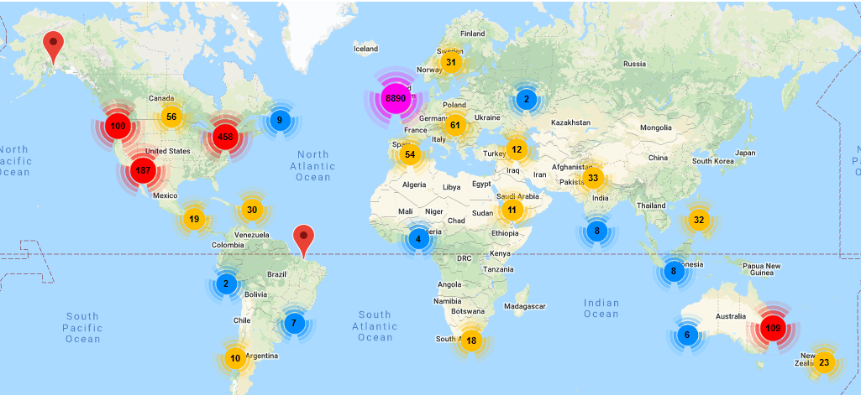
Figure 5: JAM Card App Downloads Worldwide

4.2.5 Participation and the Practice of Rights (PPR)
PPR joined the Techies in Residence programme in 2018/’19. PPR support marginalised people to assert their rights in practical ways and make meaningful social and economic change in their communities. They support families and individuals to submit human rights complaints to the Department for Communities and the Northern Ireland Housing Executive (NIHE). PPR worked alongside their techie – Creative Workers Collective, to create an app – Housing Rights Watch, to educate individuals on their rights and to encourage and facilitate the effective reporting of problems. PPR indicated that they were ‘digitally focussed’ and had engaged in some in-house coding and software development prior to TiR. Crucially, TIR gave them an opportunity to take digital to another level within their work through rigorous testing.
With the assistance of the seed funding, the app was launched in late 2019 and to date there have been 500 downloads which have translated into 300 complaints. Many of these involved complaints around the denial of homeless status and the app, alongside the support of PPR staff, has enabled individuals to be designated as homeless, which mandates the (NIHE) to support them in accessing emergency accommodation. Most homeless people have limited or no support networks and will spend weeks, months and years in hostels waiting for recognition. PPR target hostels as a touchpoint for access to homeless people and promotion of the app to ensure that they are aware of and claim their rights.
PPR continue to adapt and improve the app, which is now in its ‘3rd or 4th iteration’, demonstrating how responsive providers must be to changes in the needs or circumstances of their client group. This requires ongoing research, development and testing which can be resource intensive and some additional funding has been leveraged from the Human Rights Fund “The methodology is sound – we just have to keep trying to securing funding resources to update and ASAP as needs are changing.”

4.2.6 Mencap
Mencap NI participated in the 2017/’18 TiR programme and with the added impetus from the seed funding, worked with C60 Architects in Belfast to use virtual reality (VR) 360 to support greater participation by people with a learning disability in society. This involved using an inter active virtual experience accessible through their website to replicate real life situations to build people’s capacity to be more independent. The testing phase involved a user group of people with learning disabilities navigating their own homes using the VR experience. This user-led process meaningfully influenced product development and moved the developers away from their initial idea of an app to the integration of VR into the Mencap website.
The offering has now evolved through ongoing collaboration with C60 who have used VR to create the ‘Glider Experience’ with Translink which involved people with learning disabilities testing access to the Glider virtually. This helped to ensure compliance with Disability Discrimination Act (DDA) legislation. They have also worked with Ulster Rugby to create such an experience for those wishing to attend games in the Kingspan Stadium. Future plans include rolling VR out in cinemas, leisure centres and estate agents. Mencap have also applied the learning and innovation from their NI experience to a VR asset-based community development innovation with Leeds City Council.
The most high-profile local application of the VR experience has been the work with the NI Electoral Commission to ensure people with learning disabilities are not disadvantaged in pursuing their right to vote. This involves an interactive virtual experience replicating a polling station, to show people what to do when they go to vote for the first time. This was designed to reduce people’s anxiety and develop confidence about what to do when voting. The impact is evident in the following quote.
“I wanted to vote the last time, but I was not sure what to do and was a bit nervous. Going through it all on the screen just makes it so much easier to understand and you can experience what you have to do at each point before you vote. So now I will vote for the very first in my life and I will do it by myself, I feel excited and proud that I will vote just like everyone else in Northern Ireland.”
While acknowledging that the evolution of the VR initiatives discussed above owes some attribution to the original TiR concept, Mencap did highlight that they were already advanced “75% there with the technology” and had established a strong working relationship with C60 Architects.

4.2.7 Parenting NI
Graduates of the 2017/’18 programme, Parenting NI worked with their techies Kippie, to create an app which offers tips and support to parents. The app is free to download for both Android and Apple users and offers a range of tips on topics such as emotions, behaviour, digital parenting and friendships. It has links to information such as what parent support programmes are available and a direct link to the charity’s freephone support line.
Their relationship with the techie has continued over the past three years through the design and development of updates to the app and its interface with the Parenting NI website. In addition to the app, they also now do monthly podcasts for (and involving) parents. Participants in some of their parenting programmes informed the content of the app and parents continue to be consulted on updates. The app is designed to replicate the content of parenting programmes such as ‘Parents Plus’ and ‘Strengthening Families’ and reflects the information and support needs of parents at all stages in the life of their children from early years through to leaving school.
As a regional organisation, the app has helped to increase Parenting NI’s reach and connection with people who weren’t ready to contact them directly. An important part of the brief was to destigmatise the act of asking for help as a parent, so they wanted to make something that looked fun as well as providing useful information. The TiR programme was led internally by a member of the Senior Management Team who managed the programme from conception through to launch and implementation.

4.2.8 Housing Rights
Another 2017/’18 TiR completer who were successful with the seed fund pitch, Housing Rights garnered the need for an initiative to increase awareness among private renters through their helpline. As was common across many TiR projects, they were initially undecided as to whether to opt to design an app or something that was more web-based. It was decided that Stage 1 of the process would be to develop a website to prototype stage which would help people to navigate the private rented system.
Seed funding enabled Housing Rights to build a new website Smart Renter which is distinct from their organisational website. It was launched in July 2019 and to date has an estimated 5,000 visitors. It includes an online repository of information and guidelines to help private renters manage their tenancy and engage with the Housing Rights helpline.
TiR provided Housing Rights with the opportunity to be innovative in a sector that is heavily dependent on Department for Communities (DfC) and NIHE funding “This is not something that we could have applied to the Department for.” In seeking to expand their website offering to include a portal where individual users can set up an account, Housing Rights find themselves requiring additional investment to transition to this next stage. “We are in discussions with senior leadership on where our project sits within the grand scheme of our new digital strategy and organisational priorities. I think there is a recognition now that if we want to continue to develop and promote their needs to be a commitment to fully resourcing it.”

4.2.9 Shelter NI
Shelter NI’s mission is to promote and facilitate the provision of sufficient, decent and affordable homes to end long-term homelessness and eliminate poor housing. Through their helpline and client engagement, Shelter identified a gap in provision for elderly and disabled people who own their own home and therefore don’t have a landlord or perhaps family members to coordinate any maintenance or refurbishment of their home. This situation can leave them very vulnerable to rogue traders.
Shelter NI - Find a Trader (gabletraders.org) went live in 2019 funded by the TiR seed fund and the Supporting People (SP) Innovation fund. It is a website where people can source builders who have met the due diligence requirements carried out by Shelter NI and though this is a significant resource investment by Shelter, the efficiencies are recognised. “Were it not for TiR, we would still be doing everything manually regarding the trusted trader scheme.” The registry of builders currently only includes those based in the North West, though they hope in time to expand this to cover all of Northern Ireland.

4.3 End User Impact
The additional 33,000 end users reached through Apps, websites and chatbots as referenced in Section 4.2 is a conservative estimate based on usage data supplied by seven out of the 11 digital products currently in active use. It is likely that this figure would be much increased with the current data from the other four products in active use. The corollary of this increased end user reach is that there are more young people with arthritis and who are unaware of their rights, parents, people with learning difficulties and mental health issues, people who are homeless due to not knowing their rights, and vulnerable private renters and homeowners accessing digital supports.
However due to the absence of baseline, intervention and post-intervention metrics we cannot quantify the difference that such access has made to their lives. As a result, it may be beneficial to build into the programme in future, a request for baseline data and to encourage participants to track such metrics to the best of their ability. It would also be helpful to carry out regular evaluations of the programme rather than retrospectively requesting such information, when it is much harder to source.
Evaluation of end user impact derived from digital products is more complex and challenging than that of face-to-face service delivery given the volumes involved (10,180 Jam Card Apps, >10,000 Parenting Apps, >5,000 chatbot users and the associated challenges of engaging a statistically valid sample size. The anonymity and lack of direct access to technology users also creates a barrier in accessing more qualitative feedback and assessment.
While recognising the importance of evaluation and impact measurement in securing further funding, the majority of VCSE participants were immersed in product development and did not have the time and resources for robust evaluation.
“One of the positives of TiR was its lack of focus on immediate outputs and outcomes which contrasts with many other funders. Our priority is the on-going development and updating of the website and while impact measurement is important for business cases, it is the next stage for us.”
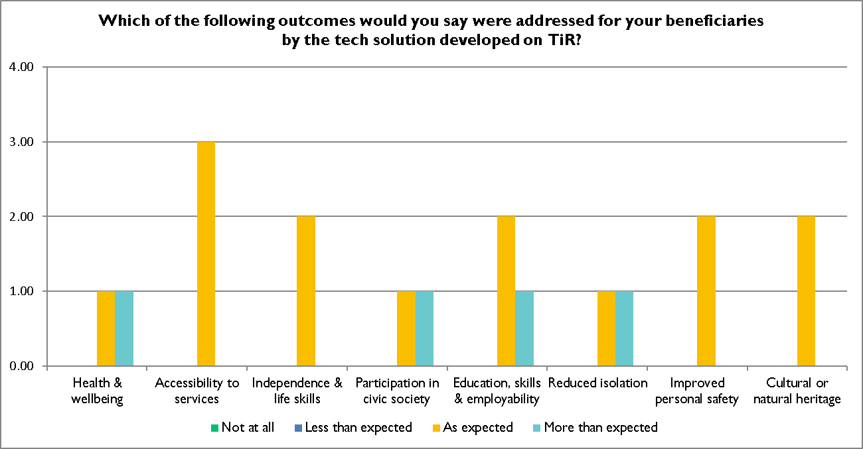
Figure 6: End User Outcomes

To gain insights into participant perspectives on outcomes achieved for their beneficiaries, a question was included in the survey relating to beneficiary outcomes. Relating back to the Evaluation Framework provided in Figure 3, the listed outcomes link to the Community Foundation’s key outcome themes, allowing us to track to what degree TiR enabled the achievement of these outcomes. Unfortunately, more respondents to the Survey skipped this question than answered it, limiting the usefulness of the data provided. One reason for this may be that participants have not for the most part tracked their beneficiaries in relation to these outcomes. As outlined above, it may therefore be worth requesting that future participants do this as a condition of the TiR programme (see Recommendation 6.8).

4.4 Techies
Almost all of those techies interviewed talked about having learned on the TiR programme. Whether it was as a result of over-promising and learning to better manage expectations or actual learning about societal issues or adopting and using new tech, it was clear that the learning provided on TiR is not limited to the VCSE sector and that mutual benefit is had from the programme for both participants and techies.
Ciaran Harley of Zoo Creative said “We now get contacted by a level of client that wouldn’t have happened before TiR and we’re not daunted by that. It’s helped move us into a ‘different league.”
The different types of learning gained by techies, could be categorised under 1) Skills; 2) Relationships; 3) Self-development.
Often techies get to work on one highly focused and niche element of a project, and they rarely get to experience the full range of what’s involved from start to finish. A third of interviewees pointed to that being a great benefit for them, pushing them out of their comfort zone and making them learn beyond their current skills-base.
On the relationships side, over 60% of the techies pointed to making connections and getting both personal and commercial benefit from the networks and relationships they developed during the programme. One organisation that took part for the first time in 2020/’21 described it as “acting like a springboard to open up various potential projects and relationships with other organisations.”
The same person talked about how, in the commercial sector, they are normally brought in as consultants and regarded as experts, whereas in working with the VCSE sector, the approach was much more collaborative, with the techies seen as valued partners. VCSE organisations want to be involved and they bring their own subject-expertise to the table, so it’s a more balanced relationship than the usual client/consultant one.
That aspect of learning to be more flexible, to listen and take input has clearly helped different tech participants to grow their confidence and the competitive element of the programme was described by one as “helping everyone to up their game.” Perhaps this element could be highlighted more in marketing the programme to potential tech participants in the future.
It was interesting to note the change in attitudes over the course of the programme for the 2020/’21 cohort. At the start and end of the programme, we used an online platform to ask a few questions and gauge how both the VCSE participants and techies were feeling. Figure 6 below shows how the techies felt at the outset of the programme, while Figure 7 shows the responses received towards the end of the 12-week techie residential.
It is clear from this that the positive sentiments expressed at the outset were not lost during the 12-week programme, but rather channelled into appreciating the benefits of taking part in the process, with rewarding the most common feeling, expressed by 5 out of the 7 respondents.
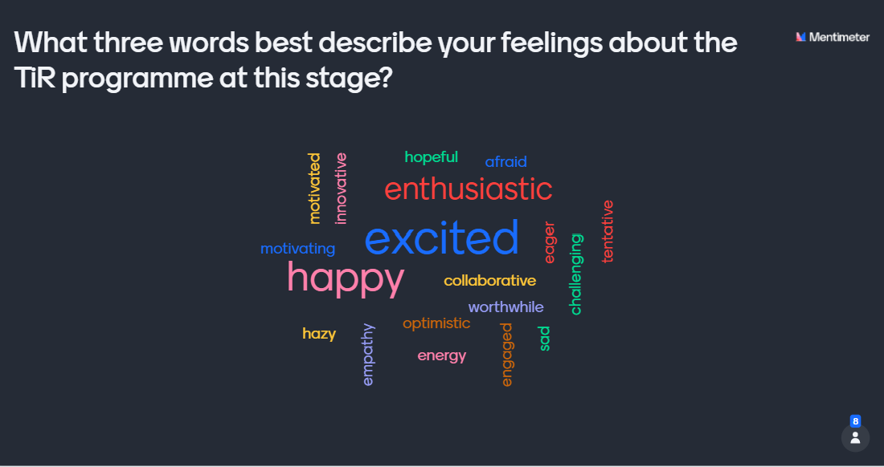
Figure 7: How techies described their feelings at the start of the 2020/’21 cohort

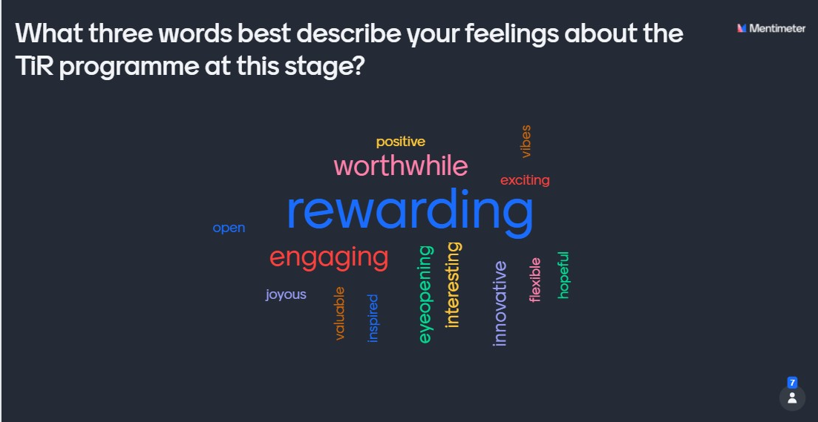
Figure 8: How techies described their feelings at the end of the 2020/’21 cohort

4.5 VCSE sector
One can reasonably extrapolate that by supporting and furthering the mission and skills of 32 VCSE organisations, the wider sector has benefited to some degree. As people move jobs within the sector, one could fairly assume they will take their learning and experience with them to help benefit the new organisation. This is, however, conjecture based on reasonable assumptions rather than backed up with robust evidence.
Beyond the participating organisations themselves, it was difficult to identify wider impact on the VCSE sector. Whilst all the stakeholder organisations interviewed believed the programme to be valuable and wished to see it continue and indeed grow, most expressed some degree of disappointment that the concept of Tech for Good had not been more widely embraced and used to further the mission potential of the VCSE sector as a result of a stimulus from TiR.
Potential still exists to achieve that wider engagement and interest in the Tech for Good movement, and it seems reasonable to expect, as has been pointed out by a number of those interviewed, that the impact of COVID-19 on the digital footprint of the sector, might help generate further interest and action in this area. The challenge is sourcing sufficient funding to resource and meet this ambition and interest.

4.6 The 2020/’21 Cycle
The 2020/’21 TiR cycle was one of the most heavily resourced of all five cycles with £67,000 available in seed funding to enable organisations to further test, refine and launch their prototypes. This was partly made possible by the lack of a residential element at the outset and the showcase event at the end moving online as a result of COVID-19 restrictions. The money normally budgeted for these elements was diverted to provide more seed funding for participants.
The transition to online delivery necessitated for the 2020/’21 cycle enabled the programme to be delivered safely and provided access to digital skills and resources at a time when the ability to use digital for day-to-day delivery was more fundamental than ever. That said, applications were lower in 2020/’21, perhaps indicating that priorities were diverted by the pandemic away from innovation and towards doing ‘business as usual’ better using digital technology. Indeed, the uncovering of digital skills gaps within the sector as a result of Covid was alluded to by a number of the sector bodies during interviews.
CFNI agreed a new partnership with the Centre for the Acceleration of Social Technology (CAST) for the 2020/’21 cycle. As part of the UK-wide Catalyst collaborative, part-funded by Comic Relief and led by CAST, a number of ‘Design Hop’ events were delivered in NI and these were used as a launchpad for TiR cycle 5. Only three of the seven organisations that took part in the Design Hops went on to participate in TiR, perhaps indicating that having explored further, some organisations weren't ready for the programme at this stage. It would be hoped that those who didn’t proceed will be making preparations with a view to applying next year. CAST also provided support to techies with a workshop around ‘Openness and Reuse’, in line with the open-source ethos of the programme.
A key issue for organisations exploring digital transformation can be securing the support of trustees, who may often lack the knowledge needed to support staff and understand the potential of digital technology adoption for their organisation. Through the partnership with CAST, a new programme element was trialled in 2020/’21 offering ‘Exploring the Role of Digital for your Charity’ training in the form of workshops or individual learning sessions to board members of the successful applicant charities.
As has been mentioned, due to COVID-19 restrictions, cycle 5 was delivered exclusively online and while there were benefits such as reduced travel time and associated costs, some participants did feel that remote delivery impeded the development of relationships between participating organisations. The value accrued from meeting like-minded professionals face-to-face and the potential for peer support has not been realised. The role of Innovate-NI has been crucial in maintaining participant focus and momentum in the transition to online delivery. Participants were split as to the merits of the online showcase and pitch versus face-to-face. They recognised the value of developing the videos in advance and many felt that their experience of working and communicating remotely for the year in advance of the pitch event meant that it was less daunting for them. Some felt that there was less of a sense of occasion attached to remote as opposed to a live event where there may be more of an ‘adrenalin rush’ On balance however there was enough to suggest that future showcase events could be online as part of a blended delivery approach.
Appendix 3 provides details of the seven participating organisations and their respective techie partner, plus an outline of their proposed project. Specific themes addressed by the 2020/’21 cohort which were not prevalent in cycles 1-4 were, older people, inter-generational, refugees, and employability.

4.7 Summary of Results
The key outputs and outcomes of TiR over the five cycles to date are presented in Figure 9 below.
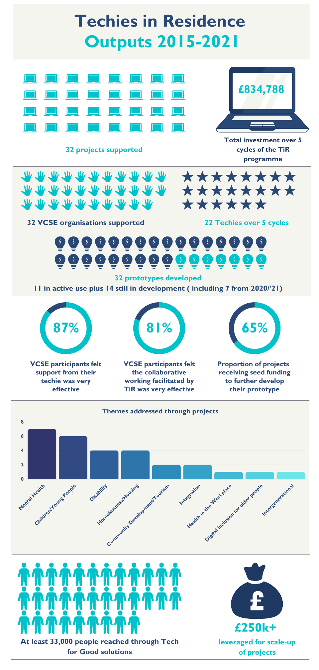
Figure 9: Key Outputs of Techies in Residence, 2015-2021

5.0 Findings
The following outlines the key findings distilled from the stakeholder consultations and review of programme data. We have loosely grouped these under Achievements (5.1 – 5.6) and Lessons (5.7 – 5.11), with some (5.12 & 5.13) relating specifically to the 2020/’21 programme.

Achievements

5.1 TiR Really Does Provide ‘Tech for Good’
TiR is the only programme of its kind in Northern Ireland that focuses on harnessing technology for social impact and one of the very few that supports genuine collaboration between the private sector and the VCSE sector. Many of the projects that have emerged from the process may not have emerged through a traditional grants-only approach with a focus on more immediate outputs and outcomes.
The majority of programme participants are extremely positive about the good the programme does and the opportunity it provides, both for the tech community to learn more about and contribute towards finding solutions for societal issues, and for the VCSE sector to open itself to the possibility of tech solutions to the problems they seek to address.
In a number of cases, the participating techies were being exposed to issues around accessibility etc for groups in society they’d never had engagement with and there was good learning for most of them as a result. One techie referred to how he’d had his “eyes opened to some of the issues people deal with that you know nothing about!” The same person also talked about how you “go the extra mile for clients in this sector because the causes matter.” There’s a real sense of doing good through tech that many interviewees referred to as ‘rewarding’.
Katherine Rowlandson from Kippie CIC, who took part in 2017/’18 and again in 2020/’21 said:
“I think it’s a really good initiative. Supporting Tech for Good and making these sorts of connections can make a big difference to some of the smaller charities.”
One interviewee, Andrea Thornbury, who at the time of her engagement with TiR worked with NICVA and the NI Open Government Network, talked about the positive impact TiR has had through projects like the JAM Card and the Parenting NI website, which stemmed from participation in the programme. She summed the value up by saying:
“TiR creates the space for creativity and the capacity within the sector to allow this to flourish.”
Techies and VCSE stakeholder groups alike were clear that the programme does have a valuable role to play. Indeed, many of those interviewed felt that it was more important than ever following Covid – both because it had exposed the shortcomings of many VCSE organisations when it comes to using technology to deliver their mission and because, as a result, the sector is likely to be more open to the potential benefits of tech and keen to explore its potential.

5.2 Stakeholder Impact
TiR was a catalyst for cultural change within organisations towards a greater appreciation of the potential of digital technology and the importance of innovative and robust co-creation and co-production processes. Some of this cultural change can be attributed to the enhanced knowledge and awareness of the potential for Tech for Good fostered through participation in TiR.
For those organisations who did not progress beyond the prototype stage, there was still learning and development accrued through enhanced digital skills and an increased awareness of their value. Participants indicated that the changed mindset towards ICT made their organisation more resilient to COVID-19. Where the organisation was unsuccessful in securing seed funding, respondents cited the valuable experience gained in developing their message and pitch (see 4.2).
Through the organisations that have progressed their product to being in active use, in excess of 33,000 additional people in need have been reached. Organisations have also been successful in securing additional funding (in excess of £250,000) to scale up their digital innovations. Funding sources included the Supporting People (SP) Innovation Fund, Comic Relief, the National Lottery Community Fund, European Funding, Human Rights Fund, legal Education Fund, Nominet Trust and the Department for Communities (DfC) COVID-19 support funds. Contributors felt that their experience and the impact of TiR positioned them more effectively for securing such funding.
Where participants are the NI branch of a wider UK-wide organisation (Versus Arthritis, Mencap, Barnardos), colleagues in other regions have watched with great interest to determine whether the learning and impact could be replicated across the UK. This had led to the application by Mencap of VR 360 technology within an asset-based community development initiative in Leeds and plans for Versus Arthritis to develop an app for adults with Arthritis across the UK.
There was also some evidence emerging that TiR innovations could have multiple applications, thus adding value to the resource-constrained environment of the VCSE sector. The Focus on Family project developed a technical resource that provides interpretation for multiple audiences – adults, teachers with pupils and families with young children – with different interests e.g., specialist environmental, general, and educational. It developed QR codes at the Cornfield Project to help boost visitor numbers and used the seed funding to upload lesson plans for children so that schools could visit the Centre.
Staff who worked alongside the techie in product development were upskilled through monitoring and observing the work, for some it created a niche within their organisation, and they now have responsibility for digital service development.
Techies highlighted the impact that they accrued through improved skills, relationships and self-development. Often techies get to work on one highly focused and niche element of a project, and they rarely get to experience the full range of what’s involved from start to finish. A number of interviewees pointed to that being a great benefit for them, pushing them out of their comfort zone and making them learn beyond their current skills-base.
On the relationships side, almost two thirds of techies interviewed pointed to making connections and getting both personal and commercial benefit from the networks and relationships they developed during the programme. They highlighted that the TiR approach was much more collaborative than within the private sector, with the techies seen as valued partners. VCSE organisations want to be involved and they bring their own subject-expertise to the table, so it’s a more balanced relationship than the usual client/consultant one.

5.3 Value for Money
The programme results in section 4.7 provide an overview of the key outputs and outcomes of the TiR programme. A total of £834,878 was invested in the programme over the five cycles with 32 organisations funded to develop their Tech for Good solution. The number of projects ‘in active use’ and close to being launched, numbers reached through the Tech for Good solutions, stakeholder impact and the amount of additional funding leveraged to scale up are further indicators of value for money. It would therefore appear that TiR has delivered value for money, especially considering the potential improved future, health & wellbeing, social, economic and personal development outcomes for those that access the Tech for Good solutions.
Any value for money analysis must be cognisant of deadweight, displacement and attribution. Deadweight is framed around the question ‘what would have happened anyway in the absence of TiR?’ The dearth of Tech for Good solutions referred to in the earlier sections of this report and the prevailing view among VCSE leaders that it is an area that requires further investment suggests that in the event that TiR had not been available, there would have been very few alternatives available to VCSE organisations to fund Tech for Good initiatives. Displacement relates to the question: ‘Were there any activities with the same outcome displaced by the interventions of TiR?’ There is no evidence to suggest that TiR displaced any alternative intervention that might have delivered equivalent outcomes.
Attribution speaks to the question: ‘Who else contributed to the achievement of the outcomes?’ While organisations such as Mencap and PPR were actively developing Tech for Good solutions, TiR funding provided resources to accelerate this development, which would have been difficult for them to access elsewhere. For many others, Tech for Good was an aspiration, with no capacity or resources in place to progress.
The prevailing view among the participant organisations was that given their experience of other VCSE & statutory funding streams, many of the projects that have emerged from the TiR process may not have emerged through a traditional grants-only approach where the focus is often on more immediate outputs and outcomes. The time and input of staff from participant organisations must be recognised as contributing to positive outcomes, however most highlighted that their increased capacity and learning would not have been possible without the input of the techie.
75% of VCSE participants felt that there were digital deficits in their organisations prior to TiR, due primarily to a lack of resources. Given this finding, it is unlikely that the majority of the organisations would have had the confidence or internal capacity to proceed with the projects in the absence of the TiR stimulus.

5.4 Diversity of Organisations Supported
TiR has supported a diverse range of organisations over the five cycles, ranging from small community-based initiatives to large UK-wide organisations. Table 1 provides a further illustration of the range of organisations supported. 16 of the organisations supported are NI Regional, with a further three NI Regional but part of a UK-wide organisation. Nine are based in the North West, with six of these in Derry/Londonderry. One is Ireland-wide with three locally based in North Belfast, North Down & Ards & Mid & East Antrim. The Tech for Good solutions developed by the local initiatives when live can be used by people across Northern Ireland.
The theme of diversity continues with the issues that the TiR digital solutions were designed to address. These were mental health, independent living for people with disabilities, money and debt advice, young people’s rights, optimising community assets, bereavement, human rights and living with chronic conditions.
Classification | Number
NI Regional | 15
NI Region (UK-Wide Organisation) | 3
Ireland-Wide | 1
North-West Region of NI | 3
Local (Derry/Londonderry) | 6
Local (Newry, Mourne and Down) | 1
Local (North Belfast) | 1
Local (North Down & Ards) | 1
Local (Mid & East Antrim) | 1

Table 1: Geographic Classification of Participants

5.5 Improvement Over Time
Those techies who have taken part two or more times over the five cycles of TiR were able to point to improvements they witnessed in the organisation and development of the programme during that time.
One techie, who had taken part in an early cohort, referred to feeling ‘over-managed’ by the project partners and even ‘untrusted’ at that early stage, but felt that their later involvement was more enjoyable and that they’d earned the trust of the programme partners. This is likely to be down to a degree of ‘newness’ and uncertainty about the programme from partners and participants alike at that early stage.
Early cohorts pointed to a lack of clarity around the process and relationships between the various partners, but again, those that took part in the early stages and again in the last year or two, felt the process was slicker and that early problems had largely been ironed out as the partners had learned from and improved processes along the way.
Although at first the impact of the coronavirus pandemic on the programme was expected to be negative, preventing partners from meeting at all face-to-face during the 2020/’21 cohort, in fact some positives came from the situation, including adjustments that a number of participants would like to retain in the future. Almost all the techies interviewed for example felt that moving to online meetings was more efficient and enabled better engagement and communication through weekly Zoom calls, which didn’t tend to happen so regularly either face-to-face or by phone. The efficiency and time saved was also seen as a benefit of the online-only version of the programme this year, though some did say they missed the opportunities to develop better bonds and understanding of their partners that the in-person engagement offers. The value accrued from meeting like-minded professionals face-to-face and the full potential for peer support was not realised, and therefore it is reasonable to conclude that a blended approach would be the best compromise for future programmes, enabling the best of both models to increase both efficiency and effectiveness (see Recommendation 6.1).
Most techies felt the residential option at the start of the programme was important to retain and should always be held in person in the future where possible, though two did question the personal time commitment required for this and the ‘family-unfriendliness’ of a residential. Others, when they realised that the programme savings in 2020/’21 from NOT holding a residential or showcase event in person enabled the higher seed fund amounts at the end of the programme, wondered if, on balance, it was worth reviewing the need for these in the future.
In summary, refinements made year on year to the TiR programme have been positive and well-received and the organising partners should endeavour to listen to feedback, learn and improve as a matter of good practice going forward. It is noteworthy that seven out of the 11 projects ‘in active use’ were participants in the 2017/’18 and 2018/’19 programmes which suggests that improvements and feedback implemented from the first two cycles of the programme had a positive impact on the sustainability of future programmes.

5.6 Enablers for Success
The TiR programme is designed to facilitate and support organisations to develop their digital idea to prototype stage. The main Key Performance Indicator (KPI) for the TiR programme of having a prototype to be pitched at the seed funding event or used to attract further funding after the 12-week techie residency was met by all 25 organisations in cycles 1-4. For some it provided the opportunity and resources to test out ideas or action conversations that had been happening internally for quite some time. For others such as Mencap and Practice and Participation of Rights (PPR) who were already working on Tech for Good initiatives, it facilitated an acceleration of progress and impact and aligned with existing campaigns to address marginalisation and social exclusion.
Nine out of the 11 projects in ‘active use’ were successful in securing seed funding, as were 5 out of the 7 ‘still in development’ from the previous cohorts, while none of the 4 ‘dormant for now’ programmes received seed funding. The impact of the additional seed funding was highlighted as a critical enabler for progression. It enabled prototypes to be tested and to become live in the guise of websites, chatbots, downloadable apps and the application of VR 360. For those projects that did not progress beyond the prototype stage, a lack of resources was identified as the primary causation factor. The importance of access to additional funding to progress beyond prototype stage was recognised in the 2020/’21 cycle where all participants were granted some seed fund capital. Access to funding from other philanthropic and statutory agencies referenced in 5.2 has also been a crucial enabler in scaling up and updating the products in response to new and emerging need.
In most cases, the organisation retained the services of the techie throughout the seed funding phase, which enabled continuity and relationships to be strengthened. Four organisations reported that they are still working collaboratively with their techie on product development. The importance of commitment by the senior leadership to Tech for Good and having a focal driver for the TiR initiative within the organisation from the senior leadership team was also emphasised.
The most successful organisations in sustaining the impact of TiR have been able to utilise and develop skills among their staff to manage and expand their digital offerings. “We can now manage content and upload internally as a result of the experience and knowledge that I gained from working with the techie.”

Lessons Learned

5.7 Boundaries, Communication and Clear Guidelines
Seven of the 11 techies interviewed felt there was still room for further improvements to the process of clarifying what’s expected from them and the VCSE partners and setting clear boundaries and guidelines at the outset.
Where projects have been less successful or ended in any way negatively, it has tended to be because the expectations of both partners were either mismatched or not fully enough explored at the outset. Often a third sector organisation can be very clear on what it needs, but unwilling to accept that either their solution is not technically possible, or that it is not feasible within the remit, timescales and budget that TiR can offer. This led to participants feeling a lack of ownership which compromised the relationship with the techie. “We felt that the techie had all of the control due to their specialist knowledge and it felt like it was their (the techie’s) project rather than ours.”
In other examples, the VCSE organisation can sometimes expect to receive the full package of support from their techie, from content development and editing/proofing to the digital solution itself. Some techies felt that this was unreasonable and involved them spending precious time on aspects of the project that they weren’t best placed to assist with and having less time to focus their skills and talents where they needed to be.
Not adequately addressing issues like these when they arise can lead to frustration and can affect productivity and progress. The feeling from some techies interviewed was that more could be done at the early stage with support from the project partners, to overcome and avoid such issues.
The need for preparation was something that came out time and again in the interviews – even from those who had completed the programme a number of times. Experiences of the preparedness of the VCSE organisations differed widely and while one could be extremely organised and have a solid team working on and engaging with the project, another might have a small or no staff team, limited understanding of the potential tech has to help them or may be tunnel-visioned in what they want and unwilling to accept the limits of the project if they have a specific goal in mind.
Anecdotally, it seems that a particularly strong-willed or inflexible VCSE leader, especially if s/he is the only one engaged in the project, can make it a little harder to make progress within the framework of the TiR programme. At least four of the techies suggested that it would be beneficial to spend more time before the partnering is cemented, exploring options and ideas between the cohort of techies and VCSE organisations to enable more sharing and ideation and help prevent poor matches being made. Admittedly, this has happened only a few times over the years.
One techie did suggest building in time after the initial matching but before the project fully gets underway to help get the VCSE organisation fully prepped and ready to go, as their experience this time was frustrating. Being matched with a single-employee organisation appears to have highlighted several limitations in terms of both partners being on the same journey and with similar levels of motivation. A mismatch between the two can impede progress and cause frustration.

5.8 Support Beyond the Programme
There is a perceived lack of clarity on ‘completion’ of the project by some techies. Those who receive seed funding are left to work things out with the VCSE organisation and may have to tender again to be considered for the second stage. Because this is beyond the scope of TiR, there is no support network in place, certainly not for the techies, and at least one felt this was “very one-sided”, particularly for those that operate as sole traders without access to legal support etc.
The idea was mooted of something as simple as sending an email to say “congratulations on completing the Techies in Residence programme” – a form of closure to help tie up any loose ends.
Some of the projects that receive further seed funding struggle to take their project all the way to attract investment and there’s a feeling that the lack of structured support at this stage is a factor in projects not fully progressing to completion of a working, publicly available product. Given the leveraging of £250k of additional funding by some participants, it seems clear that some may need more support than others.
Kyle Gawley, who took part in the first cycle in 2015/’16 (before seed funding was introduced), supporting TAMHI, said:
“What would be really good for the VCSE organisations would be if TiR could provide access to further funding opportunities. Momentum gets lost when the programme is over if there’s no further money to take the project further.”
There was also a suggestion that other models, such as providing a one-year placement for a tech student rather than an intensive 12-week programme, might provide greater sustained support for the VCSE organisation, plus a useful learning placement for the techie, perhaps allowing the programme to move beyond the innovation element to provide wider tech support to build the skills and capacity of the VCSE partner during the period (see Recommendation 6.5). This approach of using an intern to build functionality has been adopted by uHub Therapy Centre as they progress their website to launch stage.
VCSE organisations are the target audience for CFNI and most of the TiR participants are on CFNI mailing lists and receive sector updates; however, there does not appear to have been a tailored follow-up communication channel established between CFNI and TiR participants to update on progress. Facilitating this might enable CFNI to highlight to programme completers the importance of capturing the impact of the TiR programme on their beneficiaries and encourage them to share case studies and stories of achievement (see Recommendation 6.8).

5.9 Communication and Collaboration
Almost half of the techies talked about there being potential for greater collaboration and sharing between them at the early stage of the project and even throughout. There is a desire from some techies, perhaps particularly those that are lone workers, to use the programme to engage with, share and learn from other techies. Some felt that this year the digital element and increased use of communications channels such as Slack, was helpful in this regard, but thought it could have been taken even further if there was more group work, even just at the early stage.
One suggestion discussed with a few of the interviewees was to consider theming the programme each year so that all the projects were on a similar topic, such as mental health or climate change/ environment for example. While this was received positively by those who heard it, one techie did point out the potential danger of losing quality on the projects simply because they met the tighter thematic brief, which was a fair point. For those that were in favour however, there was a feeling that it would aid cross-collaboration and creativity around a shared theme and that they themselves might learn more by working more intensively on a theme across the whole programme.
A small point, raised directly by one techie, but loosely alluded to by others, was a perception that Innovate-NI and CFNI may not always be fully aligned in their own approach and communications and that this can be somewhat confusing for the techies. e.g., when it comes to staged payments and work plans, CFNI may be more rigidly sticking to the project plan, when sometimes a degree of flexibility may be required to allow for developments and changes as the project progresses. In this case, the important thing is for both organisations to be aligned in their approach so mixed messaging is not received by participants.

5.10 Digital Priorities for the VCSE Sector
A few techies mentioned the fact that basic tech skills are still lacking across much of the VCSE sector, with few organisations having in-house tech roles and often using older equipment and investing sparsely in skills training for employees. This lack of expertise, capacity and infrastructure was also highlighted by the participant organisations.
To this end, there is a perceived need for investment in digital upskilling across the sector, exacerbated by the divisions the pandemic laid bare. This was expanded upon further in some of the interviews with stakeholder organisations. One such organisation talked about the need for ‘levelling up’ within the charity sector and the impact of ‘digital poverty’, particularly in rural areas, where connectivity is often poor.
Improved understanding of tech and the scope and limitations of what digital can offer would help both in managing expectations from the VCSE partners and potentially in using and maintaining the solutions that are developed for them beyond the life of the TiR programme.
There was certainly a view that the innovation aspect is still highly relevant and positive and should not be lost. One interviewee talked about the programme exploring the ‘mission potential’ of tech to help VCSE organisations meet the needs of their users and felt strongly that this was still valid.
It is worth noting however that the pace of change in the past year in terms of embracing technology to maintain business as usual, has widened the gulf between those with the equipment and skills to use it and those for whom technology has not been a priority investment area. Some standard digital support to help organisations work more efficiently is needed in pockets around NI at this stage. Whether this is something beyond the remit of CFNI and Innovate-NI to work on as an adjunct to TiR, or perhaps a precursor to taking part, is worth consideration. If nothing else, it could help organisations get more from the programme, by upskilling them before they take part.

5.11 Dual Needs
From the perspective of the VCSE stakeholder organisations interviewed – NIVCA, CO3, Rural Community Network and Belfast City Council, this point about dual needs was the strongest message and came from all those interviewed. The need for greater investment in infrastructure and skills was raised and all felt that Covid had amplified this need by shining a spotlight on the inadequacies of many VCSE organisations when it comes to the technology they own and their ability to use it to deliver their services.
By the same token, all felt that the need for creativity and innovation in this space was still as valid as ever and that in an ideal world, funding would be available to support both. One interviewee called for an expansion of the current programme to facilitate both innovation and support the capacity and skills needed to build stronger foundational knowledge of the potential of tech, while another likewise called for funding for innovation projects and also support for general IT infrastructure and skills.
Inclusion, empowerment and upskilling were referenced as being important to help ‘level up’ the VCSE sector when it comes to digital technology. Although the use of technology in wider society has grown significantly over the lifetime of the TiR programme, there are still inequities in terms of access and skills, particularly when it comes to age or rural vs urban contexts.
A UK-government-funded project is currently underway which involves the Rural Community Network in Northern Ireland. This is investing £5 million in exploring business models to provide the structure needed to support connectivity and underpin the transformation that digital can bring to rural communities. Tech for Good as a concept is very much at the heart of the discussions, as the pandemic has shown that connectivity is more important than ever in supporting societal issues around health, education and more.

Findings Specific to Cycle 5
Six out of the seven 2020/’21 VCSE participants participated in semi-structured interviews with the evaluation team, as did six of the techies (only two of whom were new to the programme). Many similar themes emerged in relation to – diversity of organisations, testing digital ideas, learning and development up to prototype stage, the need for additional pre-programme support and technical jargon training and the requirement for specialist legal advice in relation to the contractual obligations and ownership of intellectual property. The findings outlined to this point include input from participants in all five cycles. In addition, the following two findings from the 2020/’21 cohort are noteworthy:

5.12 Innovate-NI Support
A recurring theme identified by the participant organisations was the importance of the Innovate-NI support. The weekly meetings facilitated by Innovate-NI between participants and techies ensured that momentum was quickly generated and was maintained throughout the 12-week period. The meetings also provided a useful sounding board for discussion of ideas and ensured a common understanding of expectations and outcomes. “It kept us honest and focussed, at first I thought that weekly meetings were unnecessary, but they were crucial in keeping us all on track and meeting the deadlines that we agreed at the outset. They were also valuable for sharing ideas and highlighting anything that we felt needed to be refined or changed.”

5.13 Planning
Each of the 2020/’21 participant organisations consulted has a clear plan as to how they will spend their seed funding and the associated timelines. For most, this will involve further testing and user involvement. Some are working on a sustainability plan which will involve responsibility for the management of the Tech for Good innovation being integrated into the function of service or business development. Access to seed funding for each organisation will ensure that the project remains a priority for the organisation over the next year. There was less evidence of planning in relation to the seed fund phase of the programme for those in cycles 2-4.

6.0 Conclusions and Recommendations
All the evidence gathered during the course of this evaluation points to an ongoing need for the Techies in Residence programme. To that end, our key recommendation is that the programme should continue. That said, we have suggestions for potential improvements to make the programme even more relevant and valuable in 2022 and beyond.

6.1 Future Delivery Model
As was outlined by a number of the techies, more time at the outset to prepare both partners, clarify expectations and the requirements of each stage of the process would be beneficial. To date, VCSE organisations have only taken part once, while a number of the techies have participated multiple times, giving them a better appreciation of the process and how it works. The management of expectations for first time participants in particular is an important area, as insufficient time spent at the outset can and has on occasion led to frustrations on one or both sides.
The role of Innovate-NI as a ‘neutral’ project manager was felt by those interviewed to be an important one and helpful when an ‘honest broker’ is needed to smooth any bumps in the relationship between partners or clarify and manage unreasonable expectations.
Prepping the VCSE organisation on their responsibilities as part of the partnership and ensuring they don’t make unrealistic demands of their techie should be prioritised by the project partners. Consideration should also be given to employing an editor/proof-reader who can work with each partnership to provide support with content, proofing etc where the VCSE organisation has neither the skills nor capacity to undertake this role themselves. This would reduce pressure on the techie, allowing them to focus on using their skills for digital creation and ensuring a higher quality outcome for all involved. Two editors/proof-readers could comfortably cover up to four projects each and they could be retained on a consultancy basis, allocating x days over the course of the programme.
As was outlined in 5.5, there were benefits to efficiency and collaboration gained from the online-only model required for delivery in 2020/’21, but also a compromise on developing rich relationships between partners. For that reason, a blended delivery approach which mixes face-to-face engagement with online should be developed for future programmes. The benefits of being able to engage a wider audience and more high-profile speakers for the showcase event due to its being online and the resultant cost-savings of this which were then available for reinvestment to the participant organisations would suggest that element of the programme should retain a digital format.
Many of the techies pointed to a desire for more opportunity to collaborate and work as a team as part of the programme. The use of Slack as a communication channel this year helped to a degree, and we would recommend continuing this even when it is possible to meet face-to-face again. A number of techies would be keen to collaborate further and work as a ‘pool’ for a longer period of time before being allocated a specific project to focus on. This would be in line with the intention to be more ‘open source’ and collaborative and in keeping with the spirit of Tech for Good.
While guidance and advice were available throughout the programme in relation to General Data Protection Regulations (GDPR) and privacy, the need for expert legal advice in respect of Intellectual Property (IP) was highlighted and should be factored into future programme content. The prevailing understanding among the participants who engaged with the evaluation was that the IP Rights were jointly owned by the participant organisation, the techie and CFNI. This is indeed the legal position, as written into contracts and covered at the annual residential, but further clarity would be beneficial to fully apprise participants of the extent to which they can make changes and modify the product in the future and whether they can licence the product to third parties.

6.2 Programme Duration
The current programme format involves a 12 week ‘placement’ of a techie with a VCSE organisation to design and test a prototype that helps the charity address an existing problem faced by it or its users. Whilst this length works well for most of the techies, allowing them to be creative and push the project on reasonably quickly, some expressed frustration at delays caused by their VCSE partner being unable to make critical decisions quickly enough to meet the milestones and allow the project to progress smoothly. Feedback from some of the 2020/’21 cohort also pointed to the benefit of additional time this year between the matching and start of the programme, which provided an additional ‘buffer’ and ‘breathing space’ before the project started.
It may be worth considering stretching the programme by up to four weeks to provide this additional ‘cushion’ between initial exploration of ideas and commencement of the project. This would mean the same amount of work, but a longer period of time over which to complete it. Some of this time could be used for additional preparation and priming of both partners to improve mutual understanding of roles, expectations, potential outcomes and the process, as outlined in 6.1.

6.3 Extend Programme Partnerships
The involvement in 2020/’21 of CAST as a collaborator was welcomed by many of those taking part and brought an added dimension to the programme given their experience and knowledge of Tech for Good. We would recommend continuing this collaboration and exploring the potential to gain more from CAST’s reach and expertise by engaging with other Tech for Good communities through their involvement if possible. This could be valuable in further embedding the Tech for Good ethos within the NI innovation ecosystem and potentially sparking more projects in this area in the future.
Additionally, it may be worth exploring the potential to engage the Rural Community Network (RCN) in future programmes. There are two reasons for this:
- The projects coming forward for TiR support tend to be concentrated in Belfast and Derry/Londonderry, with very few from rural areas. RCN could help promote the programme to more rural organisations and encourage them to consider signing up.
- RCN is currently engaged in a major project to explore connectivity and how digital tech can transform rural communities. Tech for Good is a part of this UK-wide project and TiR would be a good fit, providing fertile ground for exploring potential projects that would meet that brief.
While the Community Foundation for NI and Innovate-NI are doing excellent work as project partners, extending the collaboration to engage other organisations can only be good for helping the Tech for Good concept percolate and reach further and wider than it has to date.
It is worthwhile also considering the potential for deeper engagement with the private sector in the organisation and delivery of TiR. Given the growing importance of the tech sector to Northern Ireland, engaging a key tech company in the programme, potentially as a funding partner, would be beneficial in extending awareness and understanding of the Tech for Good concept beyond the third sector and those techies who participate in TiR. To date, the engagement of larger tech companies as participants has been limited and it may be that this isn’t the best fit in terms of a role for a larger tech company within the TiR structure.
As part of their CSR/ESG however, a larger tech company could invest financially in supporting the programme and growing the Tech for Good ecosystem in Northern Ireland.
Positioning future iterations of TiR to optimise funding from the private tech and philanthropic sectors could provide the sustainability required to develop a rolling three-year programme which would remove the uncertainties and challenges that are attached to annual programmes. Comic Relief’s wider Social Tech programme may present the best opportunity for future philanthropic funding, though NI-specific programmes may need to be developed as part of a wider UK partnership.

6.4 Consider a Dual/Feeder Programme
Given the extensive feedback on the need for further investment in digital infrastructure and skills within the VCSE sector, a key recommendation would be to develop a second programme that could be used to prepare and feed into TiR. This programme would be about developing the capacity and skills of the VCSE sector to improve their understanding and capabilities in relation to tech. Funding permitting, it could also help provide upgraded equipment and infrastructure to underpin the ability of the sector to engage fully in and benefit from the potential of tech. This would help mitigate the concept of ‘technical debt’ referred to by Stephen Gray of NICVA, whereby VCSE organisations get involved in digital projects without the knowledge and skills to understand and maintain them once the project ends.
Such a programme would help strengthen the foundations on which TiR is built, by giving the VCSE organisations more capacity and capability to take their prototype further and potentially secure the funding to develop it fully after TiR. This might be shaped like a four to six-week programme where a techie goes to a charity and spends time understanding them, their capacity, resources and goals and identifies and present solutions to help them achieve what they need in a better, more useful way. Training, empowerment and capacity-building would be a big element and by the end the organisations would be more open to the potential of Tech for Good and the TiR programme.

6.5 Revolutionise the Model
Although TiR does work in its current format, one option would be to completely change the model, combining the need for infrastructure, skills and innovation by providing one year placement opportunities for computing undergraduates with VCSE organisations.
This programme would have the advantage of providing extensive digital support over a 12-month period, so enabling an audit of systems, processes and use of digital by the VCSE organisation alongside a specific 3-month project that follows the Tech for Good innovation model adopted by TiR.
This is something that could be explored in partnership with QUB, who seek placement opportunities for students between their 2nd and 3rd years. This would cost a little more than the current programme in order to provide a sustainable income for the student during that year, but not substantially more. It would also be important to provide tech mentors for the student during the year, but this is potentially something that larger tech companies might consider as part of their CSR, as it would require just 1-2 hours per week and would be excellent development and societal impact for the company and the mentor they put forward. uHub therapy centre, participants in the 2017/’18 programme are currently availing of the services of an intern.

6.6 Tech for Good Think Tank
Whilst mutual sharing and learning activities amongst the projects is encouraged during the core part of the programme, this should be extended into the Seed Fund period. Furthermore, appropriate learning opportunities outside Northern Ireland should be sourced to enable programme participants to engage with the wider Social Tech/Tech for Good movement at UK/Irish and European level. This could be achieved through hosting a workshop locally with input from outside speakers and/or a group learning visit to a key conference or initiative in UK/Ireland/ Europe. This could also provide the opportunity to connect with Comic Relief’s wider Social Tech programme.

At a more macro level, there is scope to bring together third sector organisations to share and learn from each other re: what tech solutions they have tried and what works. This could be done online, opening access to organisations from across the UK/Ireland and further afield. CAST would be a valuable source of contacts for such an event and the findings could be harnessed and shared with key funders/decision-makers and government in Northern Ireland to stimulate further interest in Tech for Good.
This idea was shared by Kate Clifford of RCN, who experienced it being used by the health service – Project Echo – to bring together GPs from across the globe to share with and learn from each other. Using a similar approach to Tech for Good and initiating it here in Northern Ireland could be a valuable stimulus to increasing awareness and interest and potentially further projects in this space in the future.

6.7 Employ LEAN Thinking
It has been noted, particularly by Techies who have taken part on two or more occasions during the course of the TiR programme, that refinements and changes each year have helped improve their experience on the programme. It seems that a process of continual review may already be in place, so our recommendation is for a further formalisation of that process, perhaps extending it to incorporate LEAN thinking. This is a tool that is in place elsewhere within the Community Foundation for NI – particularly within its grant-making team – and that has achieved excellent results, particularly in ensuring the organisation’s preparedness for responding quickly and efficiently to COVID-19.
Evaluations and feedback are solicited from both the VCSE and techie participants each year as part of the process. These take place at three milestones within the programme, with the same questions asked each time. It may be beneficial to refine some of the questions to make them more stage-specific rather than repeating the same questions each time. In addition, undertaking a full LEAN review of the processes in place for the TiR programme would help ensure it is as efficient and effective as possible. Internal support within CFNI would undoubtedly be available to learn from existing good practice in this area.

6.8 Measure Impact
While we recognise that the nature of the TiR programme is such that it will take time to achieve and evidence impact, future participants should be offered the opportunity to avail of a workshop on impact measurement to capture the outcomes for stakeholders both during and post programme. The evaluation framework illustrated in Figure 3 provides the template for the evaluation of future TiR programmes and data collection tools (questionnaire surveys, semi-structured interviews) should be framed around questions to elicit the data required to evidence impact for all stakeholder groups.
As a result, it may be beneficial to build into the programme in future, a request for baseline data and to encourage participants to track such metrics to the best of their ability. It would also be helpful to carry out regular evaluations (annual or bi-annual) of the programme rather than retrospectively requesting such information, when it is much harder to source. This would help address some of the limitations faced in undertaking a five-year review.
The follow-up communication channel between CFNI and TiR participants referenced in 5.8 to update on progress would enable CFNI to highlight the importance of capturing the impact of the TiR programme on their beneficiaries and encourage them to share case studies and stories of achievement.

6.9 Open Data
The Northern Ireland Executive has recently published its Open Data Strategy and will be increasingly making public sector data freely available for public use. It has already launched its first Open Data Challenge to facilitate this, however the main likely beneficiaries are the private sector with most of the VCSE sector ill-equipped to take advantage of this opportunity to create public benefit. CFNI should intensify discussions with the NI Department of Finance around a collaboration between Techies in Residence and its roll out of the next round of the Open Data Challenge. This could mean encouraging future TiR participants to make use of open public sector data during or after the development of their prototypes and making the most of the support provided through both programmes to create greater overall impact.

6.10 Financial Support
Future TiR programmes should include some resource support for smaller community-based organisations to meet the staffing costs associated with supporting the techie throughout the 12-week residency. The criteria attached to this support could be based on thresholds in relation to organisational turnover and staffing numbers. In some cases, the bigger organisations might be able to progress their innovation without the seed funding, hence future seed fund criteria should reflect those organisations/groups that could benefit the most from additional seed funding.

Appendices

Appendix 1 – Participant Survey
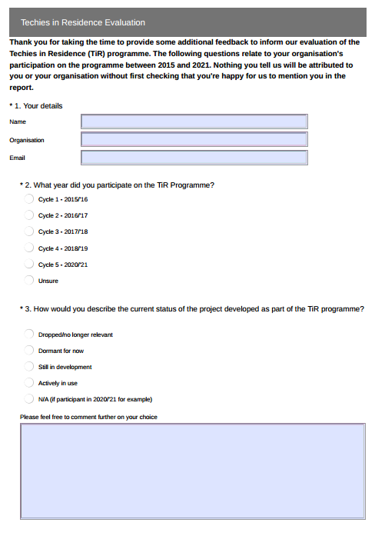
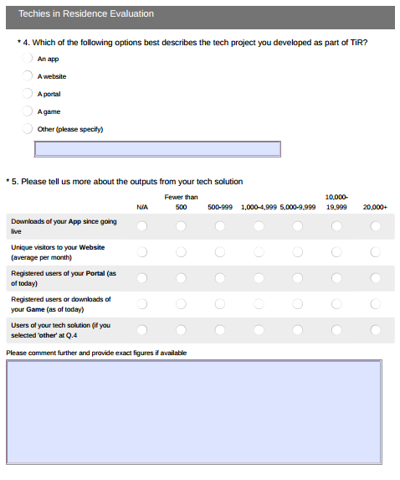

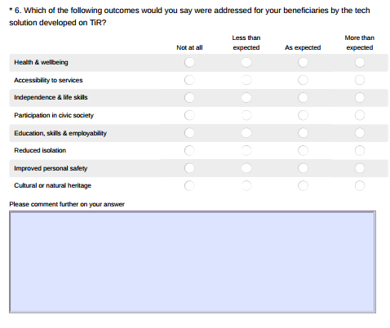
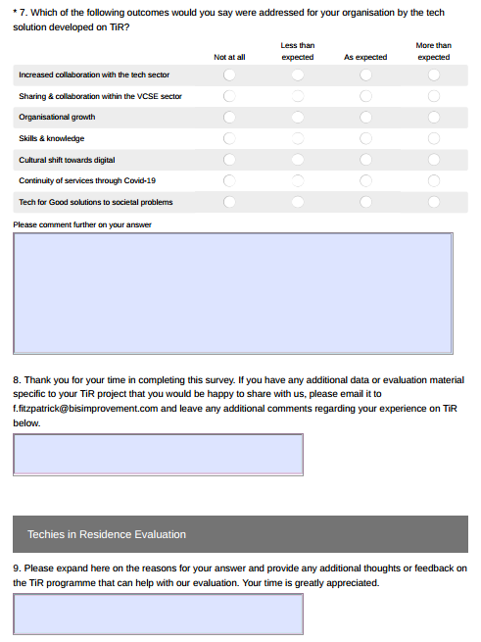

Appendix 2 – Past Participants – Cycles 1-4
Cycle | Project and Organisation | Techie | Seed funding | Evaluation  Participant | Current Status | User Data | Reach
1 (‘15/’16) | NOW Group  Just a Minute (JAM) Card – App for people with a learning difficulty | Creative Metrics | N/A | Yes | In active use | 10,180 Apps downloaded worldwide | UK, Ireland & Beyond
1 (‘15/’16) | NICVA | Kainos | N/A | Yes | Dormant | N/A | NI – Regional
1 (‘15/’16) | TAMHI  Mental Health app | Get Invited | N/A | Yes | Still in Development | Product has not launched yet | North Belfast
1 (‘15/’16) | Aware  Mental health resources | Invisible Building | N/A | Yes | Dormant | N/A | NI – Regional
2 (‘16/’17) | Arthritis Care (now Versus Arthritis)  App for Young People to communicate with professionals about their Arthritis | Blackstaff Games | Yes | Yes | In active use | 10,187 Apps downloaded | UK-Wide
2 (‘16/’17) | Greater Shantallow Area Partnership  Northlands Town Heritage Trail app | Oli | Yes | Yes | In active use | 1,080 downloads | Derry/ Londonderry
2 (‘16/’17) | Women’s Aid Foundation | Aerona Software | Yes | No | Still in Development | N/A | NI-Wide
2 (‘16/’17) | Specialisterne Northern Ireland | Logic Earth | Yes | No | Still in Development | N/A
3 (‘16/’17) | Focus on Family  QR trail and educational resources on site | Digital Key | Yes | Yes | In active use | 1,000 visitors using the QR trail and children accessing the educational resources on site | North West NI
4 (‘16/'17) | Old Library Trust Healthy Living Centre  Child Obesity learning resources & app | Learning Pool | No | Yes | Still in Development | N/A | Derry/ Londonderry
3 (‘17/’18) | Children’s Law Centre  Chatbot for young people under 18 to engage about their rights and source legal advice if required | Keith Maxwell | Yes | Yes | In active use | Total no. users since Jan 2020 = 5,045. Total no. messages sent and received = 32,445 | NI-Wide
3 (‘17/’18) | Housing Rights  SMART Renter Website | Zoo Creative | Yes | Yes | In active use | 5,000 website visitors  www.smartrenter.org since launch in June 2019 | NI-Wide
3 (‘17/’18) | Parenting NI  App for Parents | Kippie CIC | Yes | Yes | In active use | App launched Sept 2018  No figures available | NI-Wide
3 (‘17/’18) | Shelter NI  Trusted trader website | Zoo Creative | Yes | Yes | In active use | (gabletraders.org) 500 users | North West
3 (‘17/’18) | uHub Therapy Centre  One stop shop resource for people with mental health issues in the North Down & Ards area | Damgeo | Yes | Yes | Still in Development | N/A | North Down & Ards
3 (‘17/’18) | Drake Music | Oin Interactive | No | No | Unknown | N/A | NI-Wide
3 (‘17/’18) | Your Derry | Metadeck | No | Yes | In active use | N/A | Derry/ Londonderry
3 (‘17/’18) | Mencap  VR to help people with learning difficulties manage within their home | C60 | Yes | Yes | In active use | VR integrated within the main organisational website | UK Wide
4 (‘17/'18) | Belfast Unemployed Resource Centre  App to inform and assist migrants when they cross the border from NI to ROI | iTeam | No | Yes | Dormant | N/A | NI-Wide
4 (‘18/'19) | Advice NI  App to address issues of financial capability to ensure people access their benefit entitlements | Metadeck | No | Yes | Dormant | N/A | NI-Wide
4 (‘18/'19) | Centred Soul  A confidential online environment to connect those marginalised by perinatal mental health issues | Damgeo | Yes | Yes | Still in Development | N/A | NI-Wide
4 (‘18/'19) | Foyle Parents & Friends Association  App to help people with learning difficulties access areas routes in Derry/Londonderry | Zoo Creative | Yes | Yes | Still in Development | N/A | Derry/ Londonderry
4 (‘18/'19) | Participation & Practice of Rights  App to support families and individuals to submit human rights complaints | Creative Workers’ Collective | Yes | Yes | In active use | N/A | NI-Wide
4 (‘18/'19) | Our Future Foyle  Online toolkit for families and members of the public dealing with issues relating to suicide, search and recovery on the River Foyle | UsFolk | No | No | Unknown | N/A | Derry/ Londonderry
4 (‘18/'19) | Proud & Include Youth  App for young people on their transitions service to access information on personal development | Damgeo | No | No | Unknown | N/A | NI-Wide

Appendix 3 – 2020/’21 Cohort of TiR Projects

Project | Description
Northern Ireland Chest, Heart & Stroke (NICHS) and  Johan Gant Consulting Ltd | NICHS aims to reduce disconnection and isolation between community health champions volunteers active in the workplace through a communication and information sharing platform.
Mid & East Antrim Agewell Partnership (MEAAP) and  Damgeo | MEAAP aims to reduce digital barriers isolated Older People face connecting to online community groups and support through a remote access app that will provide easy access to vital community online services.
Young Enterprise Northern Ireland (YENI) and  Zoo Creative | (YENI) aims to address low education and employability skills with young people through a Virtual Reality (VR) problem solving game that develops enterprise and employability skills.
Linking Generations NI (LGNI) and  Metadeck | (LGNI) aims to reduce social isolation, poor mental health and a societal disconnection between older and younger people through a bespoke platform that can be used to deliver intergenerational activities online.
Aurora Counselling and  Kippie CIC | Aurora aims to equip parents with knowledge and tools to support their child’s emotional health and wellbeing at home while awaiting counselling through the Kidz Xpress app with two main sections: Parentland – a library of useful content for parents and Kidz Xpress – an interactive therapeutic storytelling section for parent and child together.
Barnardos and  Invisible Building | Barnardo’s aims to promote self-advocacy enabling refugee families to report housing issues to their landlord independently through a bilingual reporting platform.
St. Columb’s Park House and  Access Heritage | St. Columb’s Park House aims to address social, emotional and mental health related to the societal disconnect from nature, for all ages through a virtual reality nature tour of the grounds at St. Columb’s Park House.

Growing Social Innovation in Northern Ireland – Will Norman, Catherine Russell, Karen Clarke and Declan Mackin, April 2013
Harnessing the Power of Social Innovation to drive the Northern Ireland Economy, Matrix, September 2014
Innovation-Strategy-2014-2025_2_0.pdf (economy-ni.gov.uk)
Innovation-Strategy-2014-2025_2_0.pdf (economy-ni.gov.uk) pp21
Turning up the Dial: Digital Social Innovation in Northern Ireland, Sophie Hostick-Boakye, March 2014
Building Change Trust, Tech for Social Good: Combined report of Seminars, April 2014
https://www.nesta.org.uk/project/digital-social-innovation/
Tech for Good
State of the Sector | NICVA
UK: number of social network users 2015-2025 | Statista
Digital in the United Kingdom: All the Statistics You Need in 2021 — DataReportal – Global Digital Insights
Digital 2015: The United Kingdom — DataReportal – Global Digital Insights
Tech sector received 67% of NI’s total equity investment in 2020 | Belfast News Letter
Lewis-Beck, M. S., Bryman, A. & Liao, T. F. (Eds.) (2004). The SAGE encyclopaedia of social science research methods (Vols. 1- 3). Thousand Oaks, CA: SAGE Publications
A UK survey conducted by Mencap in 2014 found that 70% of people with a learning disability say they intended to vote in the 2015 general election, however, 60% said they found the process of registering to vote too difficult.
This is a competitive fund that aims to support improvements to the delivery of Supporting People Programme. Existing Supporting People providers can bid for support to help them improve their delivery of the Supporting People Programme
Based on data provided by seven of the 11 Tech for Good solutions that are ‘in active use’
This figure does not include the 7 ‘still in development’ projects from the 2020/’21 cohort.

