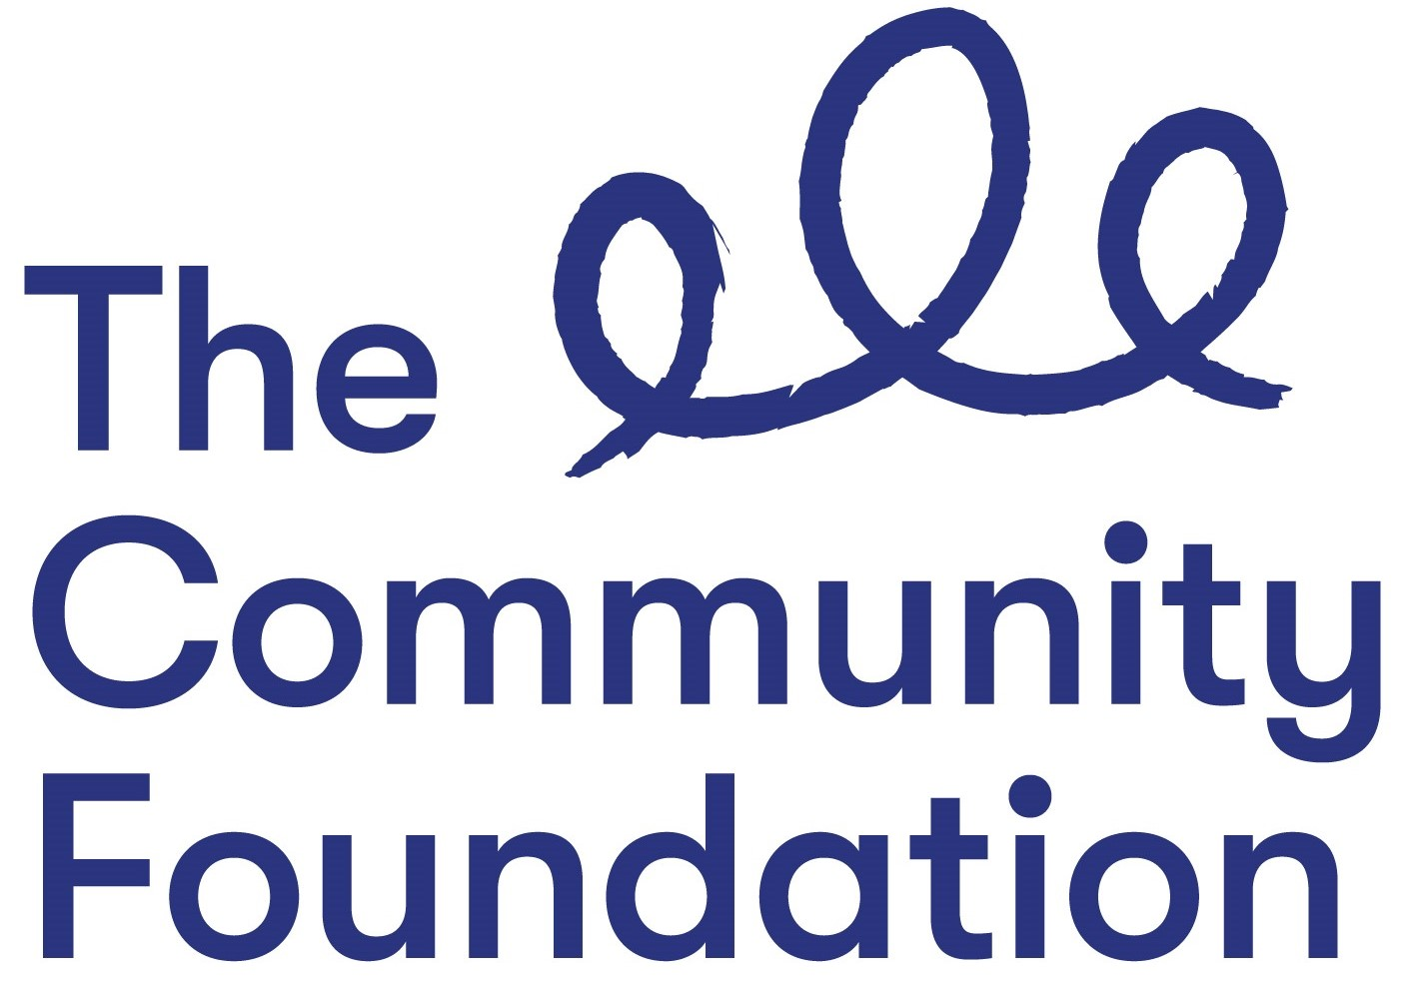

Position: Grants Coordinator - Health Funds
NJC Points 29-32 £32,910 to £35,745

Closing Date: Monday 7 June 2021 at 4.00 p.m.
Ref: GC/0521

Section 1: PERSONAL DETAILS

The Community Foundation for Northern Ireland is an Equal Opportunities Employer and welcomes applications regardless of sex, pregnancy or maternity, marital or civil partnership status, religious or similar philosophical belief; political opinion, disability, racial group, gender reassignment, sexual orientation or age.
SURNAME:

FORENAMES:

ADDRESS:

POST CODE:

TELEPHONE NO: (Mobile)

EMAIL:

QUALIFICATIONS:
Qualification (e.g. GCSE) | Subject | Grade Achieved | Year

FURTHER EDUCATION
Dates University/ Subjects Grade Achieved
From - To FE College etc.

MEMBERSHIP OF PROFESSIONAL ORGANISATIONS AND INSTITUTIONS
EMPLOYMENT HISTORY (please use continuation sheet if necessary)
Start with your present or most recent employment
Dates From - To  (Month & Year) | Name and Address of Employer | Position Held and Brief Description of Duties | Reason for Leaving | Salary

SECTION 2 – JOB RELATED CRITERIA

Please use this section to provide evidence of how your skills, knowledge, experience and/or qualifications meet the requirements of this post by giving examples.

NB: Only applicants who demonstrate that they meet the essential criteria will be shortlisted. Where we receive high volumes of applications, we reserve the right to shortlist those candidates who meet both the essential and desirable criteria.

ESSENTIAL CRITERIA
- A good standard of education, including at least 5 GCSE’s (Grade A - C) including Maths and English.

- At least 4 years experience of building strong external relationships with keys stakeholders

- At least 4 years’ experience of at least four of the following:

- Grant assessment (applications assessed independently and presented to a panel)
- Grant management of funds of over £500,000
- Reporting to funders
- Monitoring and evaluation processes
- Project management
- Working with voluntary committees
- Knowledge of the community and voluntary sector, particularly the issues that the sector is facing

- The ability to communicate orally and in writing in a clear and concise manner, including writing reports;
- Strong IT skills including experience of using IT systems to implement, manage and monitor processes and workloads;
- The ability to draw out the policy implications of complex programmes;

- Highly effective organisational and time management skills.

- We require someone who is enthusiastic and motivated and who is committed to the Foundation’s vision, mission and values of Generous, Thriving and Together: Please provide a statement that illustrates the skills and qualities you will bring to this role and how you feel you meet our values.

- Available to work occasional evenings and weekends.

DESIRABLE CRITERIA

- Degree in relevant discipline

- Experience of using grants management or customer relationship management systems such as Salesforce;

- Experience of procurement and managing tender processes;

- Line management experience;

- Experience of working or volunteering in a charity;

- Knowledge/experience of the health sector, either statutory or voluntary/community

Do you need a work permit to work in the UK?

REFERENCES:
Please provide details of 2 referees familiar with your work, one of which should be your current or most recent employer.

1. Name and Address 2. Name and Address

Telephone no: Telephone no:
Email: Email:

I certify that all information given is correct. I understand that any false information given may result in any job offer being withdrawn.

Signed: Date:

APPLICATION FORMS MUST BE SIGNED AND RETURNED BY EMAIL TO:

fotoole@communityfoundationni.org

CLOSING DATE: Monday 7 June 2021 at 4.00 p.m.

All applications must be completed in full, signed and returned by email. CVs will not be accepted or considered by the panel.
Incomplete forms or forms received after the advertised deadline will not be considered.

