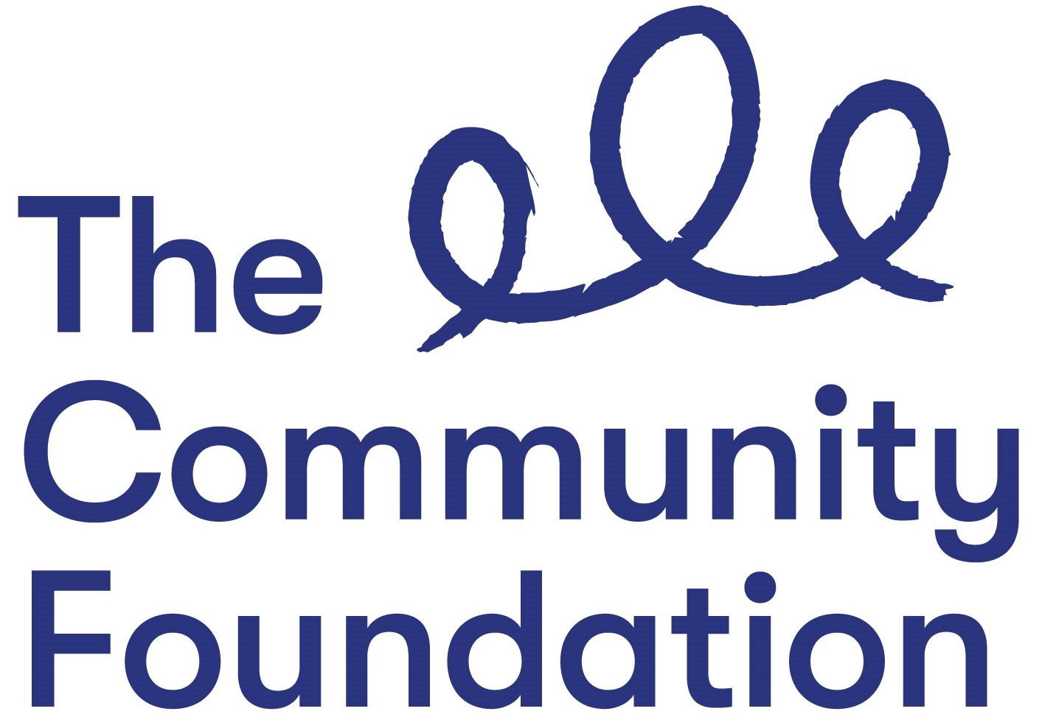

Position: Development Officer - Peace Impact Programme
- NJC Point 32 - £35,745

Closing Date: 5 November 2020 at 12.00 noon

Ref: DOPIP/1020

Section 1: PERSONAL DETAILS

The Community Foundation for Northern Ireland is an Equal Opportunities Employer and welcomes applications regardless of gender, marital or family status, religious belief or political opinion, disability, race or ethnic origin, nationality, sexual orientation or age.
SURNAME: ………………………………………………………………………….

FORENAMES: ………………………………………………………………………

ADDRESS: …………………………………………………………………………..

……………………………………………………….POST CODE: ………………..

TELEPHONE NO: (Mobile) ……………………………..

EMAIL: ………………………………

QUALIFICATIONS:
Qualification (e.g. GCSE) | Subject | Grade Achieved | Year

FURTHER EDUCATION
Dates University/ Subjects Grade Achieved
From - To FE College etc.

MEMBERSHIP OF PROFESSIONAL ORGANISATIONS AND INSTITUTIONS
EMPLOYMENT HISTORY (please use continuation sheet if necessary)
Start with your present or most recent employment
Dates From - To  (Month & Year) | Name and Address of Employer | Position Held and Brief Description of Duties | Reason for Leaving | Salary

SECTION 2 – JOB RELATED CRITERIA

Please use this section to provide evidence of how your skills, knowledge, experience and/or qualifications meet the requirements of this post by giving examples.

NB: Only applicants who demonstrate that they meet the essential criteria will be shortlisted. Where we receive high volumes of applications, we reserve the right to shortlist those candidates who meet both the essential and desirable criteria.

ESSENTIAL CRITERIA
A degree or other third level qualification in a related discipline

At least 8 years experience of working within a community development role/setting, 5 of which have been recent and paid.

Significant recent experience (over 5 years) of dealing with sensitive or contentious issues within a community development setting.

At least 5 year’s recent experience of establishing good working relationships with community groups; statutory agencies; government departments;

3 years line management experience
Experience of working across a range of areas, communities and ‘constituencies’ within Northern Ireland

Committed to the Foundation’s vision, mission and values:

Personal Statement: Please provide a statement that illustrates the skills and qualities you will bring to this role and how you feel you meet our values of Generous, Thriving and Together

.

A demonstrable interest in peacebuilding and community development

The ability to work well as part of a team

Full driving licence and access to a form of transport. Consideration will be given to alternative traveling proposals in respect of applicants with a disability who cannot hold a licence.

DESIRABLE CRITERIA

Understanding and application of the Outcomes Based Accountability Model

Relevant experience of using a CRM database.

Do you need a work permit to work in the UK?

REFERENCES:
Please provide details of 2 referees familiar with your work, one of which should be your current or most recent employer.

1. Name and Address 2. Name and Address

Telephone no: Telephone no:
Email: Email:

I certify that all information given is correct. I understand that any false information given may result in any job offer being withdrawn.

Signed:
Date:

APPLICATION FORMS MUST BE SIGNED AND RETURNED BY EMAIL TO:

fotoole@communityfoundationni.org

CLOSING DATE: 5 November 2020 at 12.00 noon

All applications must be completed in full, signed and returned by email. CVs will not be accepted or considered by the panel.
Incomplete forms or forms received after the advertised deadline will not be considered.

