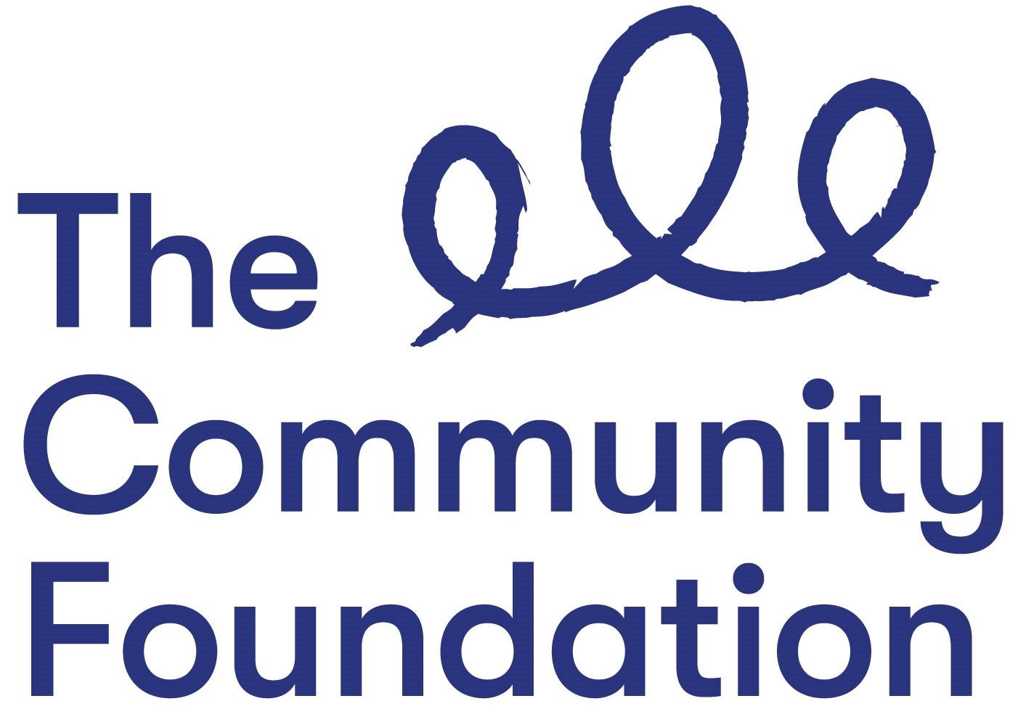

FAIR EMPLOYMENT MONITORING QUESTIONNAIRE: Private & Confidential

Ref. DOPIP/1020

We are an Equal Opportunities Employer. We do not discriminate against our job applicants or employees and we aim to select the best person for the job. We monitor the community background and sex of our job applicants and employees in order to demonstrate our commitment to promoting equality of opportunity in employment and to comply with our duties under the Fair Employment & Treatment (NI) Order 1998.

You are not obliged to answer the questions on this form and you will not suffer any penalty if you choose not to do so. Nevertheless, we encourage you to answer these questions. Your answers will be used by us to prepare and submit a monitoring return to the Equality Commission, but your identity will be kept anonymous. In all other regards your answers will be treated with the strictest confidence. We assure you that your answers will not be used by us to make any decisions affecting you, whether in a recruitment exercise or during the course of any employment with us.

Community Background:
Regardless of whether they actually practice a religion, most people in Northern Ireland are perceived to be members of either the Protestant or Roman Catholic communities.

Please indicate the community to which you belong by ticking the appropriate box below:

I am a member of the Protestant community:

I am a member of the Roman Catholic community:

I am not a member of either the Protestant or the Roman Catholic communities:

If you do not answer the above question, we are encouraged to use the residuary method of making a determination, which means that we can make a determination as to your community background on the basis of the personal information supplied by you in your application form/personnel file.

Gender: Please indicate your sex by ticking the appropriate box below:

Male: Female:

Note: If you answer this questionnaire you are obliged to do so truthfully as it is a criminal offence under the Fair Employment (Monitoring) Regulations (NI) 1999 to knowingly give false answers to these questions.

PLEASE RETURN WITH YOUR APPLICATION FORM.

