
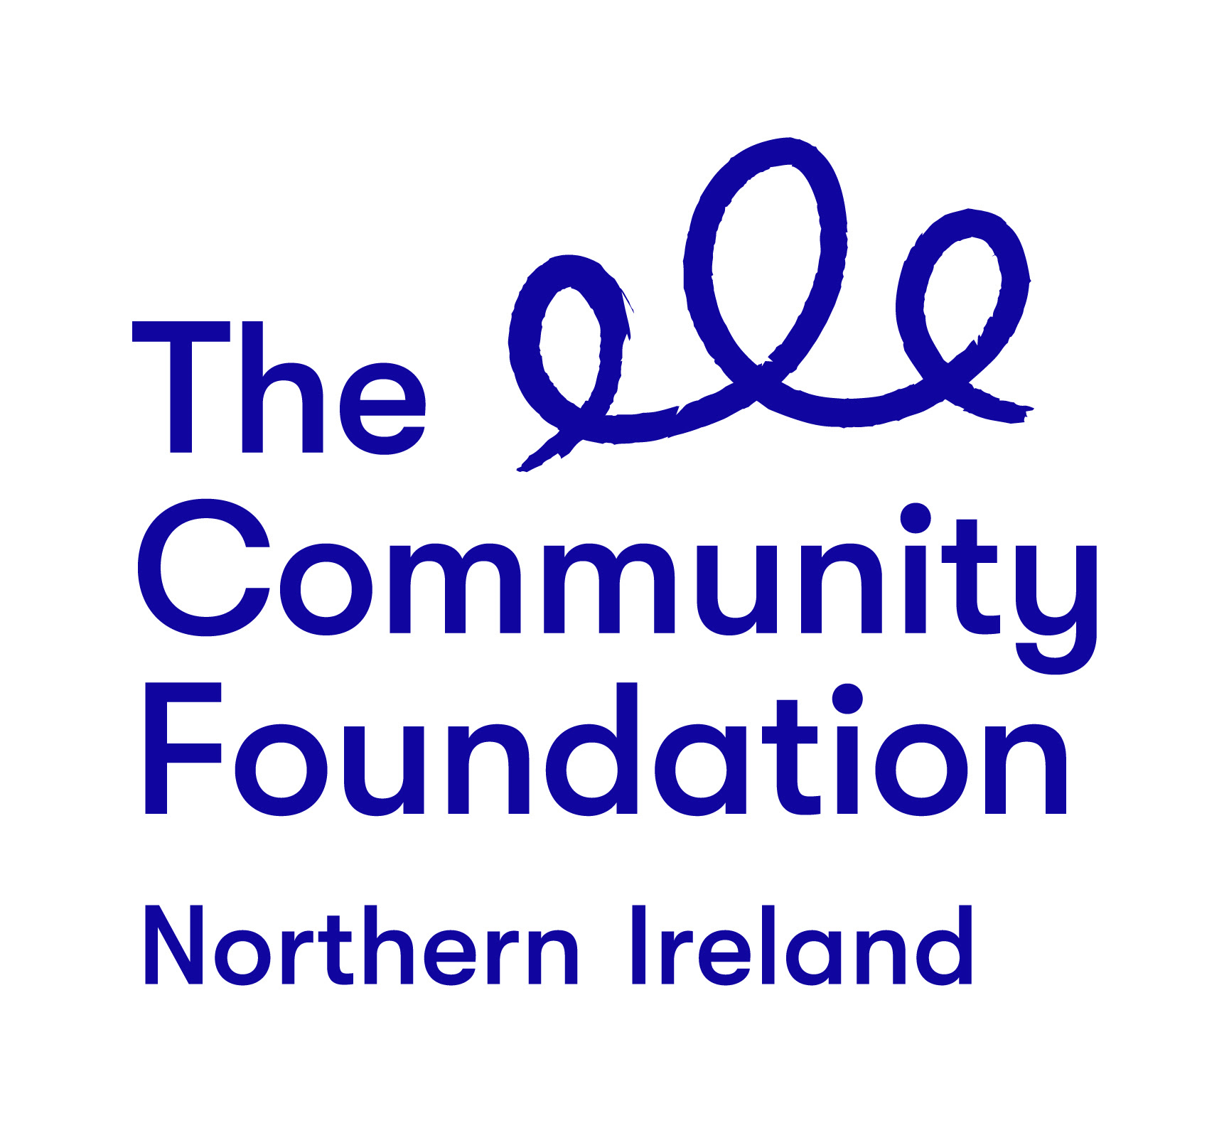

Terms of Reference

Support Organisation or Group of Consultants

Comic Relief Programme

June 2020

Background to the Community Foundation for Northern Ireland

Connecting People Who Care With Causes That Matter.

For over 40 years the Community Foundation for Northern Ireland has been an independent, grant making trust, inspiring generosity and achieving impact.
We work to make a valuable contribution to a society where everyone can prosper and live in peace. We encourage and support those who want to give and empower the local community to effect change.
The Foundation is one year into a five year strategic plan guided by the following key priorities

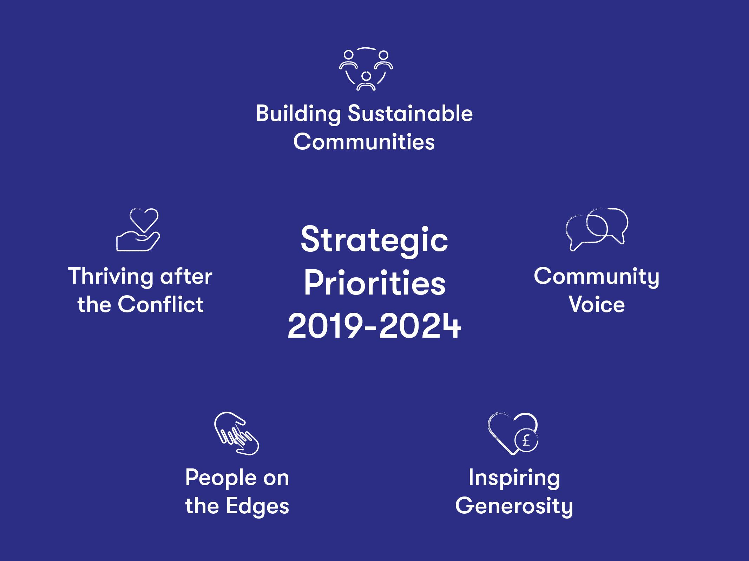

The Project
Comic Relief Programme
- Background:
As people, communities and wider society slowly recovers and rebuilds towards the “New Normal” Comic Relief and the Community Foundation for Northern Ireland are mindful of the issues that need to be addressed as we move along this recovery journey. Many people and communities have endured hardship, loss, grief, isolation, inequity and social injustice.
The focus of the programme will be to both recognise and address the issues around social injustice and inequity that have been further unmasked as a result of the Covid-19 restrictions, and how best we can continue to support the generosity of individuals and communities, in a way that as we #Build Back Better, we collectively contribute to developing a more caring, equitable and inclusive society that rebuilds, renews and brings hope for the future.
Following the success of the BBC’s “Big Night In” fundraising event which raised funds for both Comic Relief and Children in Need, the Community Foundation for Northern Ireland was grant-aided by Comic Relief to support communities in their efforts to rebuild, recover and move towards the “new norm”. The Community Foundation is utilising this award to support the phase two of Coronavirus Community Fund and a dedicated Comic Relief Programme. The focus areas of the Comic Relief Programme are as follows:
Child Food Poverty: As many jobs have been lost and/or household incomes reduced, many families are struggling to feed their children with nutritious meals that are the foundation for good health in their early years of development. The Programme wishes to support community based responses that can address this issue in a way that can be sustained long after the grant has been spent. This will be delivered through an open call for applications process.
Child Digital Poverty: As school learning will be in a different format for the foreseeable future with a mixture of class based and remote learning, if the digital divide persists this will further increase educational inequalities, limiting the potential of children to maximise their skills and talents. The Programme seeks to support community based responses that will reduce these inequalities in a way where resources can be shared both within a home and/or a wider community setting. This will be delivered through an open call for applications process.
Gender Based Domestic Violence: It is well documented that due to the restrictions on movements which has led to families having to spend much more time together within the home setting that this has led to increased incidents of domestic violence against women and in cases against men. The Programme seeks to support community based responses which can assist women, men and children in their respective recovery journeys that builds confidence, resilience, self-worth and value. This will be delivered through both an open call for applications process and a solicited approach which will focus on domestic violence against men.
Taking Care of Returning Back to School: The return to school will be different this year than what children, parents and staff will have ever experienced before and we should take steps to ensure that these returns are handled in a sensitive and appropriate manner. Things that need to be taken into account include many of the issues detailed in the following linked document:
https://www.seainclusion.co.uk/post/the-many-problems-of-returning-to-school
The Programme seeks to support community based responses that assist in this return to school experience in a way that supports children, parents/guardians and staff to rebuild relationships which provides the best educational environment and experience for children. This will be delivered through a solicited approach working with a number of selected schools and communities.
Responding to Loss and Grief: Common to all communities in Northern Ireland has been the inability to support families who during this crisis have been and continue to grieve at the loss of a family member. As restrictions ease the Programme would like to support actions that provide opportunities for communities to come together to acknowledge the loss and grief experienced by all within the community as a result of family death which may or may not directly as a result of the Covid-19 virus. This will be delivered through an open call for applications process.
LGBTQ+ Community: As the Covid-19 crisis unfolded additional inequalities have been revealed and many questions have been raised as to what this has meant for the LGBTQ+ community that were already some of the most vulnerable in society. The Programme seeks to support community based responses that initially identify the inequalities that have been compounded by the crisis and initiate actions that seek to actively address these issues. This will be delivered through an open call for applications process.

Refugees and Asylum Seekers: As one of the most vulnerable sectors and potentially invisible sectors in our communities the impact of Covid-19 in terms of being able to avail of face to face support, access to digital technology, food and services has further added to this vulnerability, invisibility and inequality. The Programme seeks to support communities in supporting refugees and asylum seekers tackle these issues so that they can play a part in building a Northern Ireland that is more welcoming, caring and inclusive. This will be delivered through a solicited approach.
Racial Equality: Never before has the issue of racism been more globally highlighted and both the Community Foundation and Comic Relief wish to renew our efforts to support communities to eliminate such prejudice, hatred and bigotry from our society. In doing this we recognise that we have to lead by example and the Programme seeks to support organisations who wish to be involved in leading on tackling and rooting out racism. The aim of this part of the Programme is to leave a legacy which sees a shift in fundamental structures across the charity sector, where our sector, leaders and decision-makers reflect the communities that we work with. This will be delivered through a solicited approach working with a number of selected schools and communities.
All of the above themes link to the Strategic Areas of Comic Relief; Children Surviving and Thriving, Global Mental Health Matters, Fighting for Gender Justice, and A Safe Place To Be.
As indicated, the Programme will include both open grant calls with pre application support, and wider programmatic support; especially within the focus areas where a solicited/target approach is being recommended, and given the specialism of the theme and expertise needed to assist the Foundation in this work. Within the Foundation this is recognised as our Grant + approach.
To support the Grant + approach all organisations applying to the Programme will do so in the understanding that, should a grant be awarded, they will commit to engaging in a wider Programme of learning, reflection and evaluation. This would include the following:
- Maximum of 2 peer learning/reflection events with other organisations who have been funded under the particular theme (this could be either via zoom or if circumstances permit via face to face meeting)
- Working with the appointed support organisation or group of consultants to draw out impact and learning from the programme supported that contributes to Practice to Policy publications
- Host, if selected, a good practice – Seeing is Believing event for CFNI trustees and/or other Programme grantees
- Take part in the final Programme learning and celebration event.
The Role of the Appointed Organisation/Consultants
Given the Foundation’s desire to deliver the Programme through a Grant + approach, we are seeking to recruit a skilled organisation/or two or more consultants working together. The appointed organisation/consultants will work alongside Michael Hughes, Head of Building Sustainable Communities in a way that utilises the Comic Relief investment to maximise the contribution of those with the lived experience in the issues, so that they can realise their full potential to change lives, (as individuals and communities), and influence further programme and policy initiatives.
This is a time-bound Programme, with all grants to be awarded by 31st May 2021. The Foundation, however, expects that all awards will be made by February 2021.
As awards are made, the Foundation wishes to work with grantees to develop wide and deep evaluation/learning opportunities, which result in a series of Practice to Policy publications, aimed at bringing forward sets of recommendation for future societal change, and which contributes to ongoing work that #ShiftsThePower and #BuildsBackBetter.
3.1 Required Outputs:
- Scope out issues relevant to the specific focus area of Domestic Violence Against Men, Taking Care of Returning Back To School, Refugee and Asylum Seeker and Racial Equality which support a solicited based approach to appropriate organisations working in these areas that can be made by the Foundation between September and October 2020.
- Develop a digital evaluation methodology and support grantees in the use of the tools which assist in the collection of data that provides storytelling opportunities for both the Foundation and Comic Relief.
- Organise and deliver a minimum of 16 grantee learning/reflection/sharing workshops either via the use of digital platforms and/or face to face meetings where physical distancing and safety of grantees/participants can be assured. It will be the responsibility of the appointed organisation or group of consultants to meet the costs of these workshops which should be included as part of the overall tender price.
- Develop and produce 8 Practice to Policy publications (one for each theme) in electronic format.
- Support the Foundation to organise and deliver minimum of 4 Good Practice - Seeing is Believing Visits.
- Support the Foundation to organise and deliver the final Programme learning, sharing and celebration event in a way that meets with government guidelines on physical distancing at that time.

3. 2 Delivery Timeline
Contract will commence on the day of appointment, which is expected to begin in July 2020, and finish on Friday 25th June 2021.
July 2020 | Recruitment of Organisation/Consultants
Aug - Oct 2020 | Scoping of specific focus group themes to facilitate solicited based approaches to appropriate organisations
Sept-Oct 2020 | Development of digital evaluation methodology for grantees
Oct 2020 - Mar 2021 | Provide support to grantees in the use of the evaluation methodology
Nov 2020 - April 2021 | Delivery of minimum of 16 grantee learning/reflection/sharing workshops
Nov 2020 - April 2021 | 4 Good Practice - Seeing is Believing events
May 2021 | Final Programme Learning, Sharing and Celebration event
June 2021 | Production and delivery of 8 Practice to Policy publications in electronic format

4. Selection Criteria
The organisation or group of consultants will be selected for their ability to demonstrate a high quality, flexible and rigorous approach that offers value for money to the Community Foundation. You should highlight your suitability to fulfil the brief using examples of contracts you have worked on over the last three years.
4.1 Pass or Fail Criteria
- Work undertaken in relation to carrying out community engagement, group facilitation and support - evaluative data methodologies which include collection and analysis of the data collected, event planning, policy development and report writing. Examples within the last 3 years should be drawn upon.
- The skills and experience of the people who will be used to undertake this work. Examples of their skills and experience within the last 3 years should be drawn upon.
- The mechanisms by which the organisation will ensure consistency and standards of approaches across all elements of the work required.
- Capacity to complete the work over the specified timeframe.
4.2 Weighted Scoring Areas:
Criteria | Score
Understanding of the operating context and ethos of the Community Foundation for Northern Ireland | 5%
Methodology | 50%
Understanding of the importance of lived experience in their active participation and contribution to programme delivery, evaluation and policy development | 30%
Value for money | 15%

The organisation or group of consultants appointed will report in the first instance to the Community Foundation’s Head of Building Sustainable Communities.
Making a Response
You should respond to the invitation by supplying a maximum 10 page proposal, via one electronic copy, sent to mhughes@communityfoundationni.org that should inter alia include the following components:
- Your understanding of the brief
- Your proposed approach for the delivery of the required outputs, bearing in mind the weighting criteria as detailed at 4.2
- Confirmation that you will fulfil all the tasks and deliver the outputs in the timeframe outlined
- Who will be involved in the work with their respective CVs, and who will be the lead contact for the organisation or group of consultants, that will be responsible for reporting back to the Foundation’s Head of Building Sustainable Communities
- A statement of experience detailing your work in this area
- Budget breakdown
- The names and addresses of two clients for whom you have completed similar assignments (detailing the nature of the work undertaken for them)

- The contract price for this work, which must be inclusive of VAT and travel, is circa £25,000. We anticipate this equating to 55-60 days. Organisations should price accordingly to gain a competitive advantage.

It is anticipated that the appointed organisation or group of consultants will have access to all the necessary resources required to enable them to fulfil the assignment, and in developing the tender will take due cognisance of the contents of NI Executive Pathway to Recovery Plan, and any subsequent amendments, that may be required, if there is a recurrence of the Covid-19 virus.

Further Information

Contact: Michael Hughes Head of Building Sustainable Communities
Email: mhughes@communityfoundationni.org
Queries will only be accepted by email
Closing Date
The closing date for receipt of submission which should be emailed to mhughes@communityfoundationni.org is 12 noon Friday 3rd July. Submissions received after the closing date will not be considered.
Note that the Community Foundation is not obliged to appoint the lowest or any tender.

