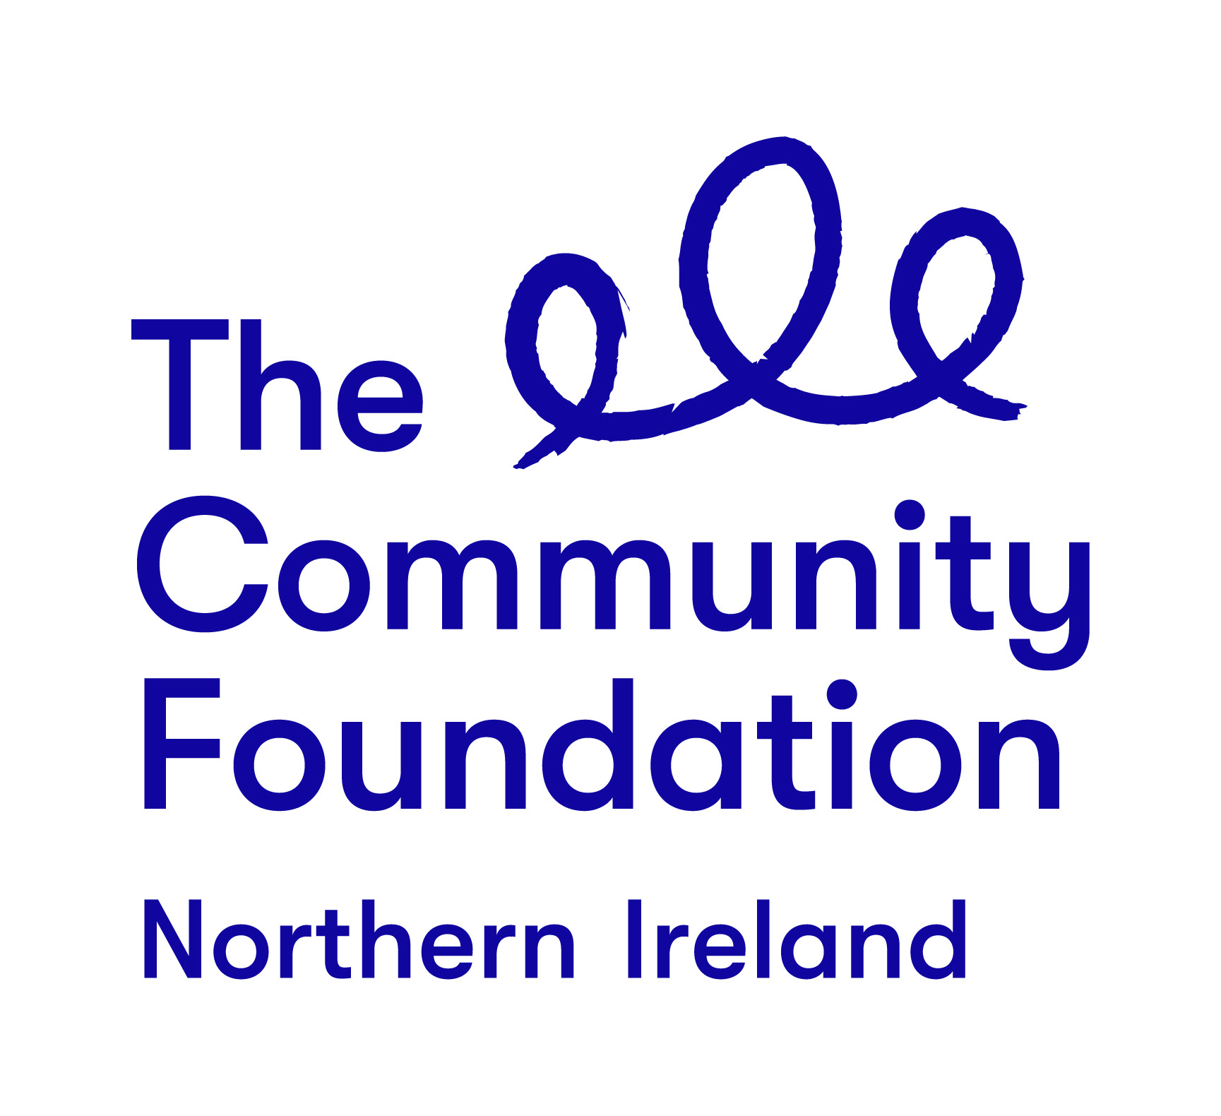
Terms of Reference

BUILDING LEADERS, BUILDING PEACE:
A GRASSROOTS LEADERSHIP PROGRAMME

PROGRAMME MENTORS

February 2020

Background to the Community Foundation for Northern Ireland

“Connecting People Who Care With Causes That Matter”

For over 40 years the Community Foundation for Northern Ireland has been an independent, grant making trust, inspiring generosity and achieving impact.
We work to make a valuable contribution to a society where everyone can prosper and live in peace. We encourage and support those who want to give and empower the local community to effect change.
The Foundation is entering an exciting new phase in our work guided by the following strategic priorities:
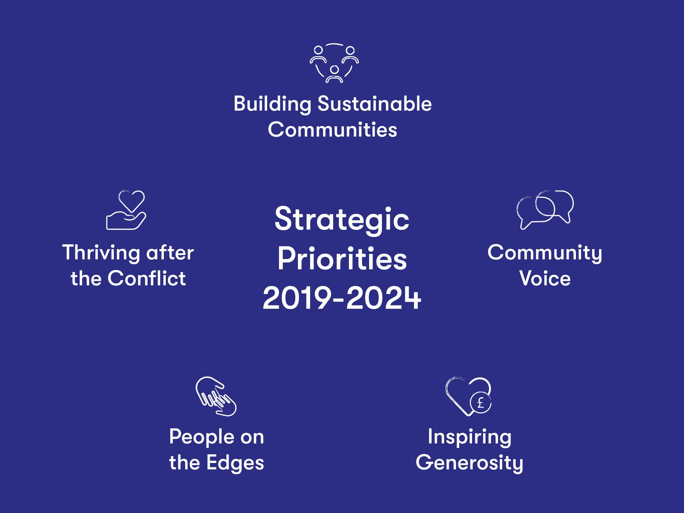

The Project
1.0 Background:
Twenty years on from the Good Friday Agreement, Northern Ireland has come a long way. However, the implementation of the Agreement and its commitment to the protection and vindication of rights is incomplete.
Sectarianism continues and Northern Ireland remains a divided society. Our schools, our housing and even our sports remain separated. We live alongside one another but not together. Dealing with the legacy of over 40 years of conflict remains one of our greatest challenges, yet society has tended to shy away from addressing it. The existing peace is marked by the absence of violence and conflict, rather than the positive presence of trust, understanding and respect.
In a society where everyone can prosper and live in peace; Community Foundation will encourage and support those who want to give and empower the local community to effect change. Our 2019-2024 strategy has two key focus areas; achieving impact, which refers to our grant making and other direct work and; inspiring generosity, where we can help people and organisations to give more and more effectively. In thinking about the impact we want to achieve, Community Foundation has identified the need to step up efforts in the following manner:
- Building sustainable communities - we so often see that local communities are way ahead in the innovative, cohesive and positive changes they are making. We will work to support more sustainable, entrepreneurial, innovative work by small organisations and in local communities
- Community voice - increasingly, people feel like their voice isn’t being heard; democracy at a global and local level needs support and re-vitalising. We will work with to help communities find their voice and use it
- Thriving after the conflict - we believe that some of the communities still struggling with the effects of the conflict have the potential to thrive and we will work to support groups, leaders and potential leaders in those communities to make that happen
- People on the edges - we always look out for those who are caught in the margins of society; in particular the refugee and asylum seeking community, the more vulnerable in the LGBT community, the travelling community and we will work to support organisations who build capacity in these communities
In line with our strategic objectives and as part of our work over the next five years, Community Foundation is delivering a Grassroots Leadership Programme. The Building Leaders, Building Peace programme represents a key element of this work. It aims to develop leadership and build capacity among grassroots activists in communities that feel excluded from the peace dividend with no previous access to programmes like this. Taking a group approach, we will bring activities together to address division, segregation, prejudice and hate, which impact community cohesion and hold communities back (more information regarding the programme and potential participants is provided at Appendix 1)
1.1 Overview of the Programme
The overall goal of the Building Leaders, Building Peace: A Grassroots Leadership Programme, is to develop leadership and build capacity amongst grassroots activists in communities that feel excluded from the peace dividend. Comprising both individual and group methods, we will achieve this goal through a range of activities in three annual cycles (2019-2020, 2020-2021, 2021-2022). We will target between 15 - 20 participants per cycle and provide a 9-12-month programme to include a range of elements:
- Two residentials
- Study and learning visits
- OCN level 1 and 3 training and development with a focus on leadership and conflict transformation
- Individual mentoring and coaching to help participants reflect on their current leadership capacity and to develop and grow this capacity to become confident, progressive transformative leaders moving forward
2.0 The Role of the Appointed Mentors
The Community Foundation is seeking to recruit skilled and experienced mentors who will work alongside Community Foundation staff to support the development of participants of Building Leaders, Building Peace: A Grassroots Leadership Programme.
Mentors will work with participants on a one to one basis over the course of the programme. They will have experience and capability to mentor in line with participant’s individual needs. They will identify when either mentoring or coaching is most effective and use these techniques in a manner that can maximise their impact. They will provide face to face, monthly sessions to participants so they will:
- Reflect on their existing leadership skills
- Reflect on attitudes, perceptions, views and opinions (their own and those within their community) that may hinder the development of their leadership skills
- Identify areas for personal development and growth
- Identify a number of leadership development goals, the methods in which these can be achieved and then support participants to work towards achieving them
Mentors will support participants to explore the context for their work, reflect on learning taking place across the programme and to reflect on how both relate to their leadership development. Mentors will complete regular progress reviews in partnership with participants and provide Community Foundation with key information in relation to same. Community Foundation will provide all necessary proformas etc.
Community Foundation anticipates that mentoring will take a broader view of the person and will involve the passing on of any relevant knowledge, expertise and experience of mentors to appropriately support the professional growth of participants. It will help them to think about their professional development in the longer term and to identify ways in which this development can take place during and well beyond the programme. Coaching will be shorter term in nature. It will be provided in shorter cycles and will focus on specific professional areas/issues that can practically be developed by participants during the lifespan of the programme. It will focus on achieving specific, immediate goals.
2.1 Required Outputs:
- Commence mentoring work from April 2020 for a period of up to 12 months thereafter
- Attend part of a three-day participant induction residential in Belfast that will take place sometime week beginning Monday 20th April 2020
- Provide face to face, month to month participant sessions incorporating both mentoring and coaching approaches. Sessions must take place at a location suitable to participants
- Provide mentoring services in a confidential manner (mentors will adhere to confidentiality requirements as will be detailed in a programme service level agreement)
- Provide reports to Community Foundation at key times regarding participant development and progress
- Raise any issues with Community Foundation staff in good time and in a professional manner
- Ensure monthly invoicing for services and attach all relevant documentation
- Provide services throughout the year, in line with the cost parameters detailed
- Meet with Community Foundation staff and programme evaluators a minimum of twice per year
- Attend other relevant meetings with Community Foundation staff at key times

3.0 Delivery Timeline
Contract will commence early April 2020 and complete the end of February 2021. Contracts may be extended, dependent upon future needs of the programme. This will be discussed with mentors as year one completes.

Date | Key Action(s)
April 2020 | - Recruitment of mentors  - Programme participant induction residential and attendance by mentors for part of this
April 2020 to February 2021 | - Provide monthly mentoring and coaching sessions  - Attend meetings with Community Foundation staff, as required  - Provision of monitoring and progress reporting to Community Foundation  - Attend meetings with Community Foundation staff and programme evaluators (minimum 2 meetings)
Jan to Feb 2021 | - Review of services provided with Community Foundation staff  - Potential extension of contract  - End of year monitoring and progress report to Community Foundation

4.0 Selection Criteria
Mentors will be selected for their ability to demonstrate a high quality, flexible and rigorous approach that offers value for money to the Community Foundation. You should highlight your suitability to fulfil the brief using examples of coaching and mentoring you have provided in a community setting as detailed at 4.1.
4.1 Pass or Fail Criteria
- At least two years recent experience of providing both mentoring and coaching in a similar capacity and a relevant qualification (ideally Level 5 coaching, mentoring, management, leadership etc.). Examples of skills and experience within the last two years should be drawn upon where a relevant qualification has been achieved.
OR

- At least five years recent experience of providing both mentoring and coaching in a similar capacity. Examples of skills and experience within the last five years should be drawn upon where a relevant qualification has not been achieved

- Demonstration of the approach to both mentoring and coaching and how best these techniques will be used to maximise benefit to participants throughout the programme

- Capacity to complete the work to the expected level over the specified timeframe and within price parameters
4.2 Weighted Scoring Areas:
Criteria | Score
Experience, capability, qualifications | 40
Approach and methods | 40
Capacity and price | 30

All mentors appointed will report, in the first instance, to the Community Foundation’s appointed programme contact, Lorraine Morrissey McCann via email lorraine@communityfoundationni.org
Making a Response
You should respond to the invitation by supplying a proposal, electronically, to lorraine@communityfoundationni.org that should inter alia include the following components:
- Your understanding of the brief;
- Your experience and proposed approach for the delivery of the required outputs, bearing in mind the pass or fail criteria at 4.1 and weighting criteria as detailed at 4.2
- Confirmation that you will fulfil all the tasks and deliver the outputs in the timeframe outlined
- A copy of your CV must be included as well as copies of all relevant qualifications
The contract price for this work is £50.00 per face to face session; the session price is inclusive of VAT and travel. Sessions must last a minimum of 50 minutes face to face time. Up to two sessions per month can be provided, dependent upon the needs of individual participants. Accurate time sheets for sessions must be completed and signed off by both mentors and programme participants each month and attached to all invoices. Mentoring/coaching time will be reviewed by Community Foundation staff throughout the programme.
A flat rate of £75.00 per half day (up to 3.5 hours) will be paid to mentors to attend all programme related meetings with Community Foundation staff and programme evaluators. This rate includes travel time and associated costs.
We anticipate mentors to have between one and three programme participants to support per month. There may be occasions when mentors and coaches will have a larger number of participants; this will be discussed in advance.
It is anticipated mentors will have access to all the necessary resources required to enable them to fulfil the assignment. Community Foundation staff will provide copies of all relevant proformas in relation to confidentiality, consent, monitoring and evaluation. On occasion meeting rooms and access to desk space at the Community Foundation’s offices may be available by prior arrangement.

Further Information
Contact: Lorraine Morrissey McCann
Email: lorraine@communityfoundationni.org
Queries will only be accepted by email. Community Foundation will endeavour to answer all questions in an expedient manner. Answers to queries will be provided by email and will be shared with all interested parties for fairness and expediency.
Closing Date
The closing date for receipt of submission; these should be emailed to lorraine@communityfoundationni.org no later than Friday 28th February 2020 at 12pm. Submissions received after the closing date will not be considered.
Note that the Community Foundation is not obliged to appoint the lowest or any tender.

Appendix One:

Participant Criteria

Programme Information

The programme aims to support the development of emerging community leaders whose work is focussed on the regeneration of interfaces and/or communities where more concentrated peacebuilding efforts are needed. It will help develop their confidence and capacity to address division, segregation, prejudice and hate; issues which impact on community cohesion and hold communities back. It has been designed and will be facilitated by Community Foundation Northern Ireland, an organisation with a long-standing history steeped in peacebuilding and conflict transformation activities.

Commencing in 2020, the programme will target 15-20 individuals per year from a range of communities across Northern Ireland. Each programme will last 12 months, and participants will receive a range of support and development opportunities including:

- Completion of OCN Level 1 & 3 in Community Development delivered by highly experienced facilitators and trainers
- One-to-one mentoring provided by highly qualified and experienced coaches and community leaders. Mentoring will take place throughout the programme and will support participants to explore and develop their individual leadership style and skills
- Study visits to develop peace building and leadership knowledge and understanding
- Completion of Community Foundation’s Power Analysis Tool Kit
- Access to a range of local and international leaders who will share their experience to aid learning and development
- Networking, not only with fellow participants, but with a range of organisations and agencies across the region
Participant Criteria

- Participants will be 18 years and over
- They will have a keen desire to challenge themselves and to build their resilience and confidence to help transform local communities
- They will have a willingness to work with people from across political and religious divides and view this as an opportunity to learn, develop and grow
- They will have been involved in some form of conflict transformation and/or peace building work in the last 12-24 months, either in a voluntary or paid capacity
- They will be committed to completing the programme and will have the support of the community-based organisation they are attached to
Timeframes

Recruitment for the 2020 cohort of participants will commence in March 2020. After completing an A4 expression of interest and submitting to CFNI, participants will be invited to meet with a member of the programme team to further explore their readiness and compatibility. Each programme will commence with a three-day team building and induction residential with fellow participants. Recruitment for years two and three will take place between January and March of those years.

For further information please contact Lorraine Morrissey McCann via email: lorraine@communityfoundationni.org

