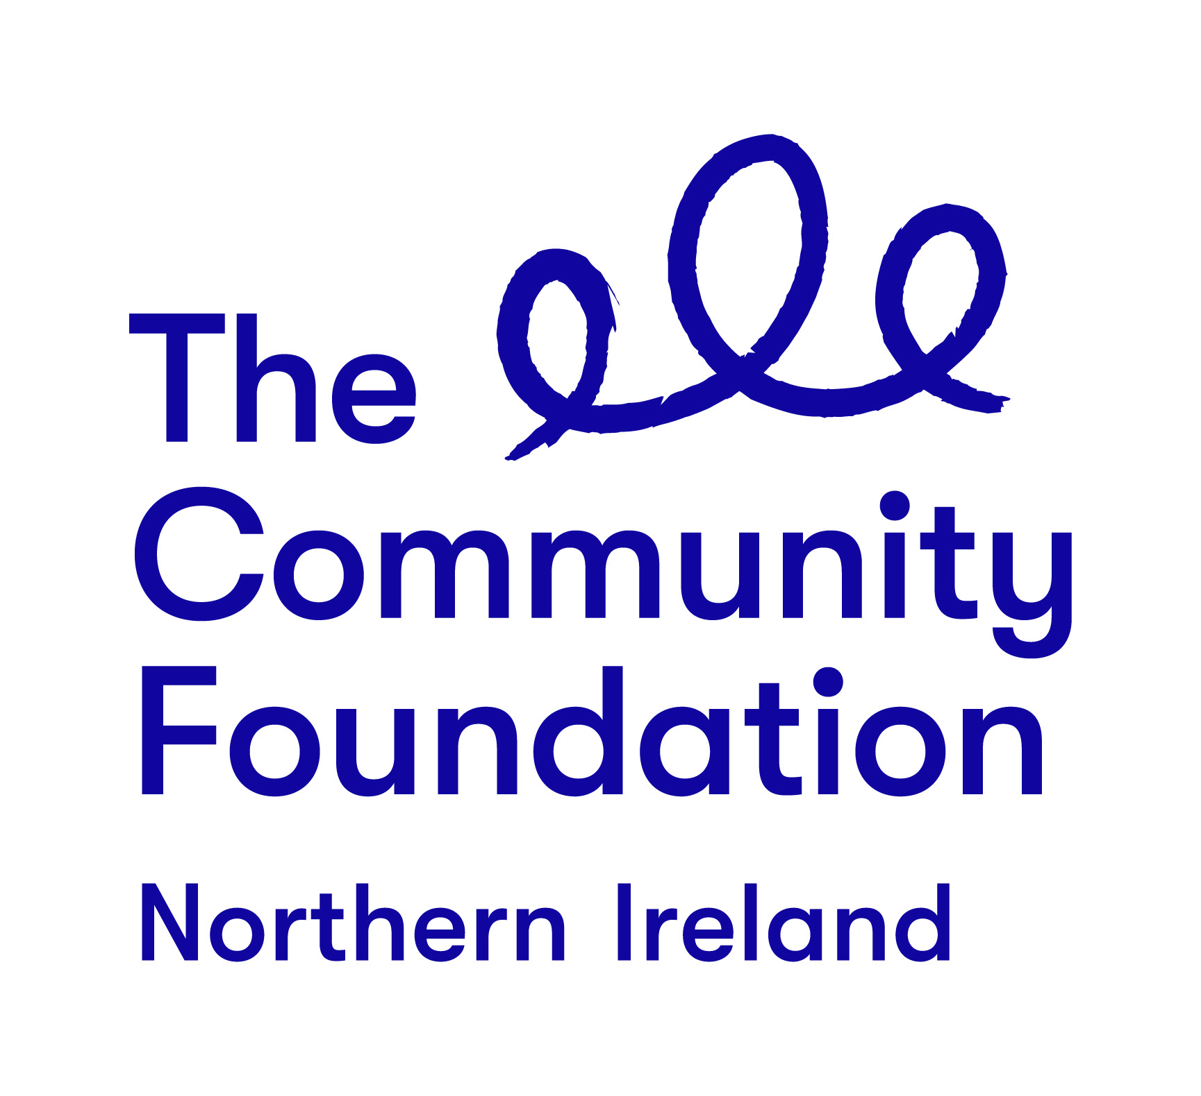
Terms of Reference

BUILDING LEADERS, BUILDING PEACE:
A GRASSROOTS LEADERSHIP PROGRAMME

DELIVERY OF OCN 1 & 3 COMMUNITY DEVELOPMENT (leadership / conflict transformation focus)

February 2020

Background to the Community Foundation for Northern Ireland

“Connecting People Who Care With Causes That Matter”

For over 40 years the Community Foundation for Northern Ireland has been an independent, grant making trust, inspiring generosity and achieving impact.
We work to make a valuable contribution to a society where everyone can prosper and live in peace. We encourage and support those who want to give and empower the local community to effect change.
The Foundation is entering an exciting new phase in our work guided by the following strategic priorities:
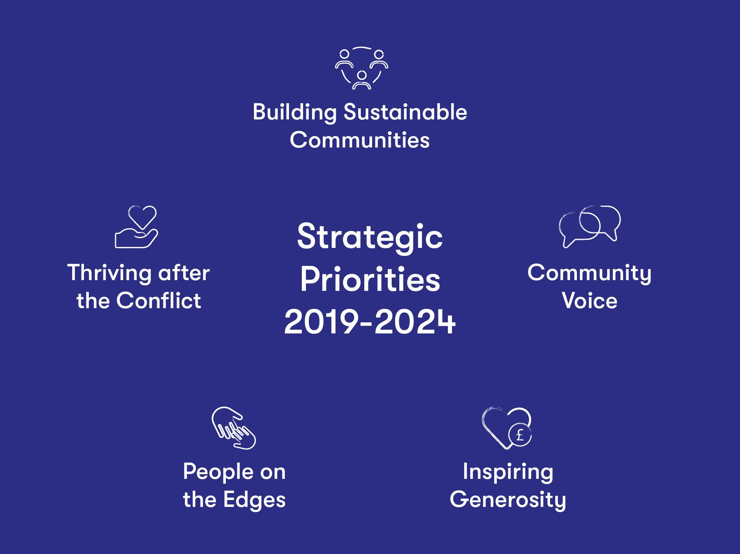

The Project
1.0 Background:
Twenty years on from the Good Friday Agreement, Northern Ireland has come a long way. However, the implementation of the Agreement and its commitment to the protection and vindication of rights is incomplete.
Sectarianism continues and Northern Ireland remains a divided society. Our schools, our housing and even our sports remain separated. We live alongside one another but not together. Dealing with the legacy of over 40 years of conflict remains one of our greatest challenges, yet society has tended to shy away from addressing it. The existing peace is marked by the absence of violence and conflict, rather than the positive presence of trust, understanding and respect.
In a society where everyone can prosper and live in peace; Community Foundation will encourage and support those who are compelled to empower the local community to effect change. Our 2019-2024 strategy has two key focus areas; achieving impact, which refers to our grant making and other direct work and; inspiring generosity, where we can help people and organisations to give more and more effectively.
In relation to impact of our work, Community Foundation has identified the need to step up efforts in the following manner:
- Building sustainable communities - we so often see local communities are way ahead in the innovative, cohesive and positive changes they are making. We will work to support more sustainable, entrepreneurial, innovative work by small organisations in local communities
- Community voice - increasingly, people feel like their voice isn’t being heard; democracy at a global and local level needs support and re-vitalising. We will work to help communities find their voice and use it effectively
- Thriving after the conflict - we believe that some of those communities still struggling with the effects of the conflict have the potential to thrive. We will work to support groups, leaders and potential leaders in those communities to make that happen
- People on the edges - we always look out for those who are caught in the margins of society; in particular the refugee and asylum seeking community, the more vulnerable in the LGBT community, the travelling community and we will work to support organisations who build capacity in these communities

1.1 Overview of the Programme
In keeping with our strategic focus, Community Foundation is delivering a Grassroots Leadership Programme. The Building Leaders, Building Peace: A Grassroots Leadership Programme represents a key element of our work over the next five years. It aims to develop leadership and build capacity among grassroots activists who operate in communities that feel excluded from the peace dividend. These activists will have had little to no previous access to programmes like this. Taking a group and individual approach over three annual cycles (2019-2020, 2020-2021, 2021-2022), we will support participants to address division, segregation, prejudice and hate, which impact community cohesion and hold communities back (participant criteria document is provided at Appendix 1). Each year we will target between 15 - 20 participants and provide a 9-12-month programme to include a range of elements:
- Two residentials
- Study and learning visits
- Networking
- OCN level 1 and 3 Community Development courses with a focus on leadership and conflict transformation
- Individual mentoring and coaching to help participants reflect on their current leadership capacity and to develop and grow this capacity to become confident, progressive transformative leaders moving forward
2.0 Delivery of OCN Levels 1 & 3 (with a focus on leadership and conflict transformation)
The Community Foundation is seeking an experienced, skilled organisation to help develop programme participants into competent, confident, transformative leaders for the future. We want to start this journey through the delivery of OCN 1 and 3 Community Development courses. Whilst we are keen that core community development modules need to be delivered so participants can successfully achieve qualifications and build strong community development understanding, practices, principles and approaches, it is important these courses help support the development of leadership knowledge, skills and capacity. Programme participants will be selected because they are working in a conflict transformation and peacebuilding manner. The content of the courses must have strong synergy with the overall aim of the programme and its key components, as listed earlier in this document.
When submitting tender information, organisations must explain how they intend to provide a cohesive learning experience that incorporates community development, leadership and conflict transformation across both OCNs. It is important they illustrate all relevant experience of providing learning across all three.
All participants will receive one to one mentoring and coaching throughout the programme (these services are being tendered for separately). The aim is to support participants to:
- Reflect on their existing leadership skills
- Reflect on attitudes, perceptions, views and opinions (their own and those within their community) that may hinder the development of their leadership skills
- Identify areas for personal development and growth
- Identify a number of leadership development goals, the methods that enable these to be achieved and to support participants to work towards achieving them
Learning and insight obtained through community development courses will form a key feature of discussion during mentoring and coaching sessions.
  - Required Outputs:
- Within two weeks of the awarded tender, the successful organisation must meet with Community Foundation NI staff to finalise and agree leadership and conflict transformation learning throughout OCN Levels 1 & 3 including any specific modules to be included in relation to these areas
- Commence OCN level 1 Community Development April 2020 (first day of course delivery will take place on day three of programme participants induction residential in Belfast week beginning Monday 20th April 2020; dates are currently being finalised and will be discussed with the successful organisation at the earliest opportunity)
- Complete OCN Level 1 Community Development by end May 2020
- Commence OCN Level 3 Community Development in June 2020 to be completed by mid-October 2020
- Provide regular reports to Community Foundation at key times regarding participant development and progress
- Raise any issues with Community Foundation staff in good time and in a professional manner
- Provide copies of any relevant qualifications of any trainers and facilitators involved in the delivery of both courses
- Support programme monitoring and evaluation by meeting with Community Foundation staff at the end of both courses to reflect on the impact of the learning experience
- Attend meetings with programme evaluators andCommunity Foundation staff at key times

3.0 Delivery Timeline
The contract will commence March/April 2020 and complete the end of February/March 2021, in line with overall programme dates. Contracts may be extended into years two and three. This will be dependent upon the evaluation of results of the community development courses and will be discussed with the organisation as year one completes.

Date | Key Action(s)
April 2020 | - Meet with Community Foundation staff to finalise course content incorporating community development, leadership and conflict transformation subject areas  - Attend day three of participant induction residential and commence OCN Level 1 delivery on day three of this residential
April – end May 2020 | - Delivery of OCN Level 1 Community Development  - Complete delivery of OCN Level 1 Community Development  - Attendance at meetings with Community Foundation staff, as required  - Provision of monitoring and progress to Community Foundation
June – Mid October | - Delivery of OCN Level 3 Community Development  - Complete delivery of OCN Level 3 Community Development  - Attendance at meetings with Community Foundation staff, as required  - Provision of monitoring and progress to Community Foundation
March 2020 to February 2021 | - Monitoring Evaluation Learning (MEL)  - Provide an update on learnings and reflections on completion of OCN Level 1, suggesting any refinements which need to be made to programme approach and delivery as you move into OCN Level 3  - Attend 2 MEL meeting with the programme evaluators per year  - Provide an update on learnings and reflections on completion of OCN Level 3, suggesting any refinements which need to be made to programme approach and delivery for future cohorts  - Overall end of year monitoring and progress report to Community Foundation  - Potential extension of contract

4.0 Selection Criteria
Organisations will be selected for their ability to demonstrate an effective, high quality, flexible and rigorous approach that offers value for money to the Community Foundation. You should highlight your experience and capacity to fulfil the brief using examples of similar work you have provided in a community setting as detailed at 4.1.
4.1 Pass or Fail Criteria
- At least four years recent experience of delivering OCN Levels 1 & 3 in Community Development
- Provision of CVs for any trainers and facilitators who will provide services as part of the programme (please only include information which has relevance to the context, scope and nature of this programme)
- Confirmation of capacity to complete the work over the specified timeframe
- Full breakdown of costs, including VAT if applicable
4.2 Weighted Scoring Areas:
Criteria | Score
Experience & capacity | 30
Approach | 35
Costs & Value for Money | 35

The organisation appointed will report, in the first instance, to the Community Foundation’s programme contact, Lorraine Morrissey McCann via email lorraine@communityfoundationni.org
Making a Response
You should respond to the invitation by supplying a proposal, electronically, to lorraine@communityfoundationni.org that should inter alia include the following components:
● Your understanding of the brief;
● Your proposed approach for the delivery of the required outputs, bearing in mind the weighting criteria as detailed at 4.2
● Confirmation that you will fulfil all the tasks and deliver the outputs in the timeframe outlined
● A copy of CVs must be included
● A statement of experience detailing your work in this area
- Two referees who can be contacted about your work
This will be fixed contract. Delivery of years 2 & 3 will depend upon performance and evaluation of year one.
The successful organisation will ensure they have access to all the necessary resources required to enable them to fulfil the assignment within the agreed annual contract price. Resources, handbooks etc. provided by the successful organisation should be of high quality and training facilities (provided in an accessible location) should also be of high quality. Community Foundation expects the successful organisation to provide refreshments for programme participants, including lunch. These costs and the costs related to room hire and all other programme resources must be incorporated into the overall price provided in the returned tender document.
Further Information
Contact: Lorraine Morrissey McCann
Email: lorraine@communityfoundationni.org
Queries will only be accepted by email. Community Foundation will endeavour to answer all questions in an expedient manner. Answers to queries will be provided by email and will be shared with all interested parties for fairness and expediency.
Closing Date
The closing date for receipt of submission; these should be emailed to lorraine@communityfoundationni.org no later than 12PM ON FRIDAY 28TH FEBRUARY 2020. . Submissions received after the closing date will not be considered.
Note that the Community Foundation is not obliged to appoint the lowest or any tender.

Appendix One:

Participant Criteria

Programme Information

The programme aims to support the development of emerging community leaders whose work is focussed on the regeneration of interfaces and/or communities where more concentrated peacebuilding efforts are needed. It will help develop their confidence and capacity to address division, segregation, prejudice and hate; issues which impact on community cohesion and hold communities back.

The programme has been designed and will be facilitated by Community Foundation Northern Ireland, an organisation with a long-standing history steeped in peacebuilding and conflict transformation activities.

Commencing in 2020, the programme will target 15-20 individuals per year from a range of communities across Northern Ireland. Each programme will last 12 months, and participants will receive a range of support and development opportunities including:

- Completion of OCN Level 1 & 3 in Community Development delivered by highly experienced facilitators and trainers
- One-to-one mentoring provided by highly qualified and experienced coaches and community leaders. Mentoring will take place throughout the programme and will support participants to explore and develop their individual leadership style and skills
- Study visits to develop peace building and leadership knowledge and understanding
- Completion of Community Foundation’s Power Analysis Tool Kit
- Access to a range of local and international leaders who will share their experience to aid learning and development
- Networking, not only with fellow participants, but with a range of organisations and agencies across the region
Participant Criteria

- Participants will be 18 years and over
- They will have a keen desire to challenge themselves and to build their resilience and confidence to help transform local communities
- They will have a willingness to work with people from across political and religious divides and view this as an opportunity to learn, develop and grow
- They will have been involved in some form of conflict transformation and/or peace building work in the last 12-24 months, either in a voluntary or paid capacity
- They will be committed to completing the programme and will have the support of the community-based organisation they are attached to
Timeframes

Recruitment for the 2020 cohort of participants will commence in March 2020. After completing an A4 expression of interest and submitting to CFNI, participants will be invited to meet with a member of the programme team to further explore their readiness and compatibility. Each programme will commence with a three-day team building and induction residential with fellow participants. Recruitment for years two and three will take place between January and March of those years.

For further information please contact Lorraine Morrissey McCann via email: lorraine@communityfoundationni.org

