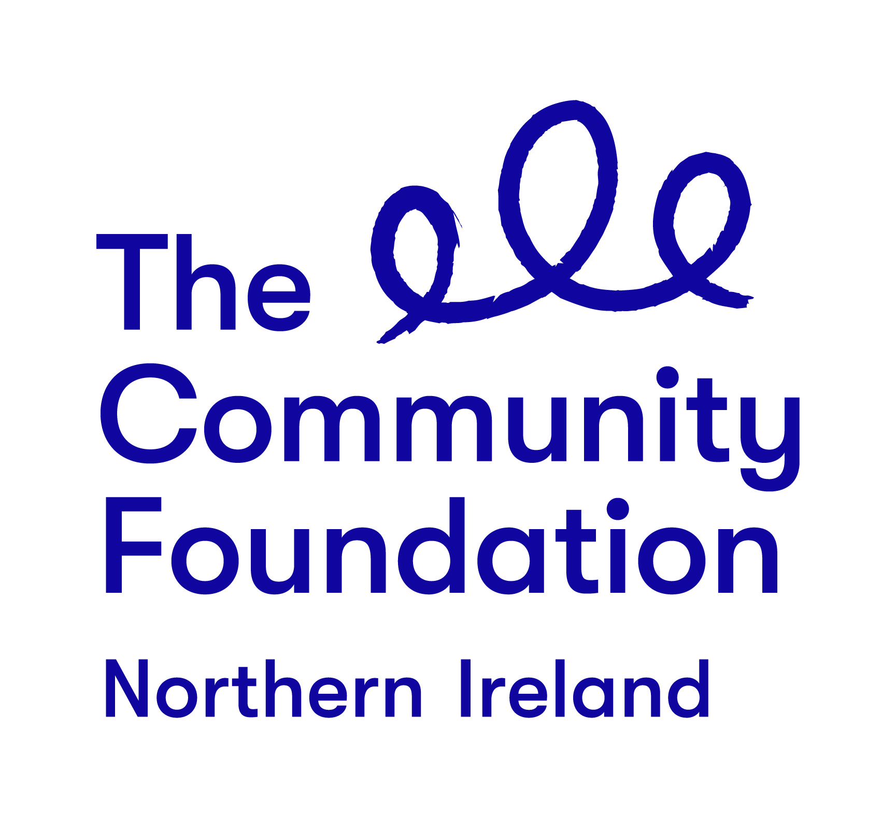

Terms of Reference

“Select Group of Capacity Building Mentors”

Jan 2019

1.0 Background to the Community Foundation for Northern Ireland

1.1 Vision

The Community Foundation for Northern Ireland connects people who care to causes that matter. For over 40 years the Community Foundation has been a trusted, secure means through which donors choose how, when and where they give, by helping them to set up funds, supporting them to make grants and to see the impact of their donations on local communities in greatest need.

1.2 Values

We work together and with others in line with our values - generous, thriving and together.

Generosity:

We encourage generosity in everything we do; we look out for each other; we deal with everyone with compassion, empathy and understanding. We are flexible in how we work with staff, donors and grantees.

Thriving:

We see the potential within both our staff and the communities we work in and are committed to help both reach their full potential.

Together:

We will only make the change we want to see together. We value participation, working with others and bringing people together.

2 The Role

2.1 Role Name: Freelance Capacity Building Mentors

2.2 Context and Purpose: The Community Foundation is recruiting a pool of mentors to deliver capacity building support to VCSE organisations. Alongside new funding, bespoke capacity building for grantees will be available to the VCSE in 2020/21,
The key role of mentors recruited will be to provide bespoke support to organisations around needs identified such as Strategic Planning, Impact Measurement, Income Generation, Financial Management, Governance, Business Modelling, Pitching and Storytelling. Mentors will work with organisations on a one to one level and deliver tailored capacity building support.

3 Capacity Building Support

The Community Foundation is made up of talented individuals who share a passion for connecting people who care with causes that matter.

We are looking for a pool of 5 - 7 experienced Freelance mentors to join us. The role is flexible in terms of hours, and will be negotiated with the VCSE partner in each case. Reasonable travel costs will be reimbursed.

The rate of remuneration will be £350 / Day or £1,200 per group.
Support will be on an ad hoc freelance basis, however, we anticipate that there will be a need for approximately 30 hours (Up to four days) of support per group and that mentors will deliver support to up to five groups.

We anticipate mentors selected will begin working for the Foundation in 2020/21. A training/briefing session of 2 - 3 hours will be provided by the foundation and a requirement of accepting any contract. .

4. Requirements

The support will include:

- Participating in a training session with the Foundation
- Meetings and support for VCSE organisations and key members of staff,
- Write up of findings

Please note that appointed mentors will be required to use their own laptop, which must have up to date anti-virus software installed.

5. Delivery Timetable

From April 2020 to March 2021 initially. The Foundation will retain a pool of mentors/facilitators for further work as and when required.

6 Selection Criteria

Mentors will be selected for their ability to demonstrate their experience in providing capacity building support to VCSE organisations within the areas of Strategic Planning, Impact Measurement, Income Generation, Pitching and Storytelling, Tendering and Grant Applications, Financial Management, Governance and Business Modelling. To join the select list you should provide evidence of dates and levels of experience, and of whom you have provided this support to

6.1 Pass or Fail Criteria

Work to be undertaken in relation to supporting organisations indicting your approach and delivery and learning expected. Recent examples should be drawn upon and confirmation given of capacity to deliver the work over the specified timeframe.

7 Making a Response and Closing Date

You should respond to the invitation by supplying a maximum 2 page proposal, via one electronic copy, sent to shealy@communityfoundation by 21 February 2020

Please indicate in your response the areas of capacity building you wish to be considered for. More than one category can be indicated.

Please note the maximum budget available for this work is £1,200 per beneficiary. Capacity building support will be bespoke to each group and is not expected to require more than 30 hours in each case.

The Budget also includes writing up of any supporting documentation for the Foundation

8 Further Information

Contact: Siofra Healy, Director of Philanthropy
Email: shealy@communityfoundationni.org

