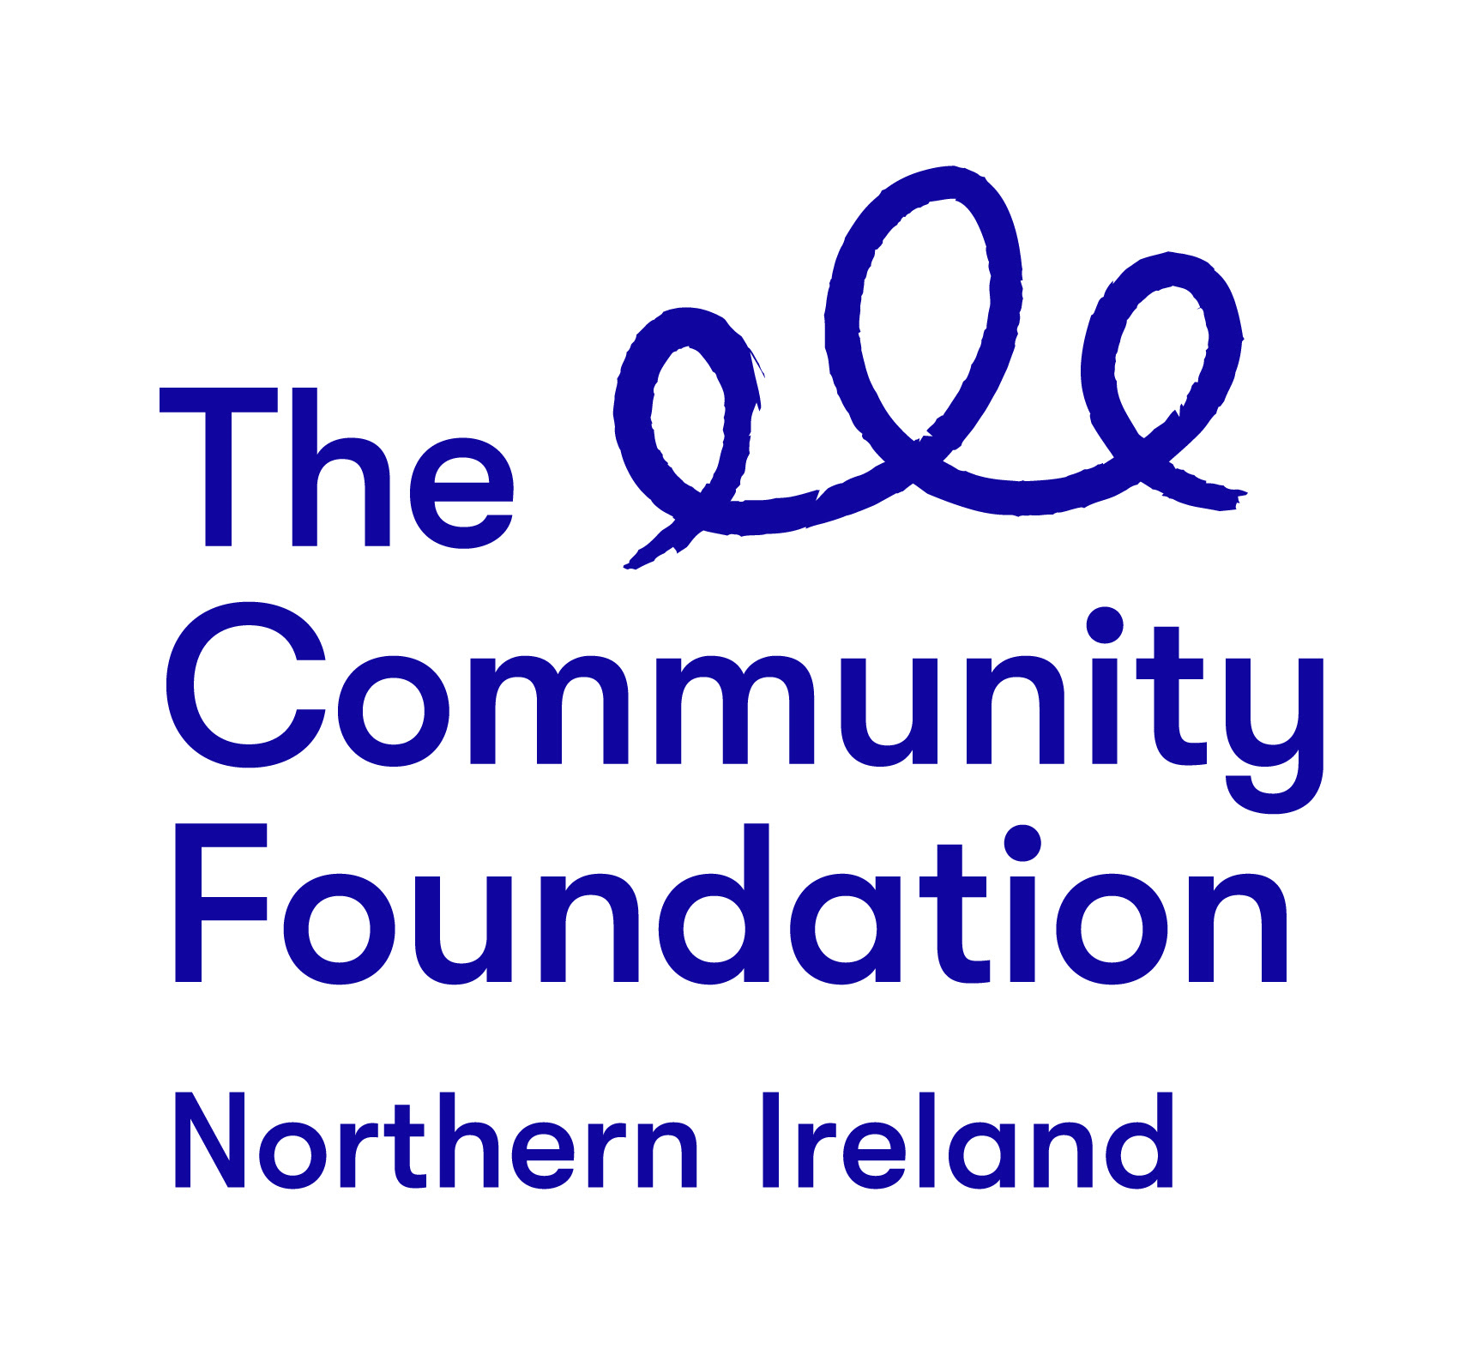

Terms of Reference

Programme Development

Safe Place To Be - LGBTQ+ and Travelling Communities

December 2019

Background to the Community Foundation for Northern Ireland

Connecting People Who Care With Causes That Matter.

For over 40 years the Community Foundation for Northern Ireland has been an independent, grant making trust, inspiring generosity and achieving impact.
We work is to make a valuable contribution to a society where everyone can prosper and live in peace. We encourage and support those who want to give and empower the local community to effect change.
The Foundation is entering an exciting new phase in our work guided by the following strategic priorities

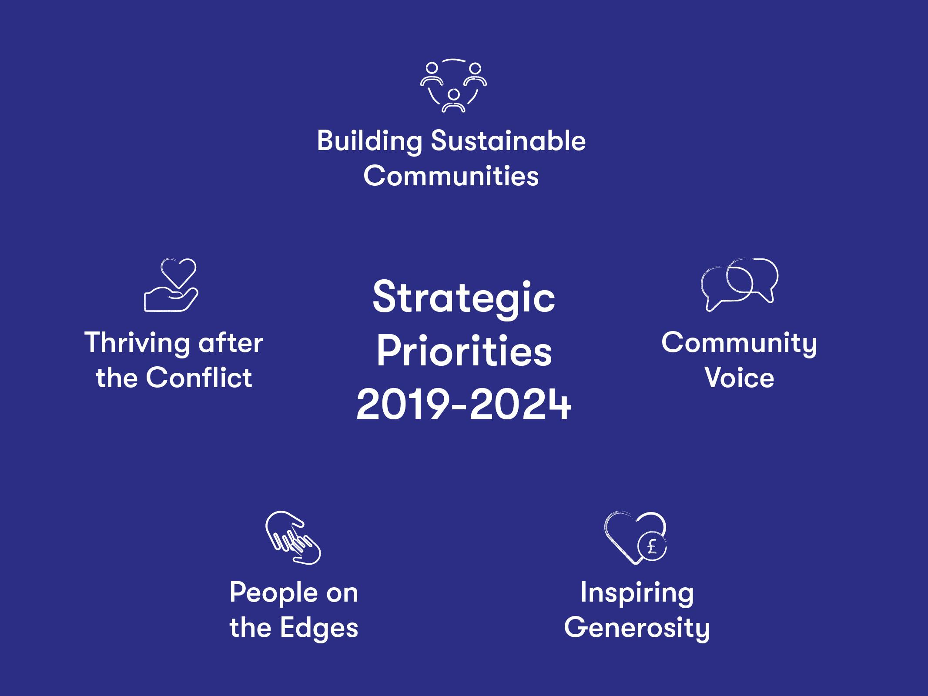

The Project - Safe Place To Be
1.0 Background:
In 2019, the Community Foundation for Northern Ireland (CFNI) was appointed by Comic Relief as its key Intermediate Funding Body for this region of the United Kingdom. Over the next two years CFNI will invest £880,000 from Comic Relief through open grant and targeted calls to community and voluntary groups across the region. This investment will make a huge contribution to Comic Reliefs four core areas of Social Change:
- Children Surviving and Thriving
- Global Health Matters
- Fighting for Gender Justice
- Safe Place To Be
1.1 Key Outcomes
Under the Safe Place to Be, Comic Relief has set out two key outcomes which any investment should work towards:
- People who have been forced from their homes to have access to the support they need to start a new life, free from conflict persecution or trafficking.

- Safe, secure and decent shelter to be better recognised worldwide and implemented as a fundamental human right

The right to safe and secure shelter is set out in the Universal Declaration of Human Rights which states that everyone is entitled to an adequate standard of living, including access to food, clothing and housing.

For people to live with dignity they need access to not only basic housing, but the ability to create a happy home in which they feel safe and secure. However, the reality is that millions of people have no access to safe shelter.

Currently over 70.8 million people have been forcibly displaced from their homes as a result of conflict or persecution (that’s one person every 2 seconds); an estimated 25.9 million of those people are refugees and over 50% of refugees are children

Trafficking and modern slavery is a hidden phenomenon, but it is estimated that 40.3million people have been trafficked

Tens of millions of children are estimated to be living on the streets worldwide4
In the UK the number of people sleeping on the streets has increased by 165% since 2010

A sixth of the world’s population (approx. 1.2 billion people) is living in slums, many with no secure tenancy or rights over the land they live on.

Source (https://www.comicrelief.com/what-we-do/safe-place-be)

1.2 Northern Ireland Perspective

From an NI perspective the Community Foundation has identified two specific areas, (see below), we want to focus on in order to develop programmes and activities that are in line with Comic Relief’s key outcomes and engage those with lived experience in these thematic areas if we are to shift the power and make a positive impact on their lives. Under each area we wish to address specific issues that arose during our research that are of particular concern. We are approaching this from an assets based perspective which pays attention to the following:
· Abundance not scarcity;
· Assets not needs;
· Inviting people into community conversations to co-create
· Develops progress that is incremental so that when change happens it has a greater chance of success;
· Is community owned and led;
· Building relationships both inside and outside the locality some of which may be before they actually need them;
· Building people’s sense of belonging through having their gifts and talents received and appreciated.

LGBTQ+ Community with special emphasis on those living in rural areas
- Increase in the number of geographically based support networks
- Localised provision for supportive social interaction

Irish Travellers
- Increase in after schools assistance and summer schemes
- Traveller Role Model Programme that is developed and supported by the Travelling community with a specific focus on young girls

2.0 The Role of the Appointed Organisation
The Community Foundation is seeking to recruit a skilled organisation who will work alongside Michael Hughes, Head of Building Sustainable Communities, to engage with relevant stakeholders, in particular those with lived experience, to better understand the needs and issues facing the LGBTQ+ Community and Irish Travellers to develop appropriate programmes to shift the change.
2.1 Required Outputs:
● Intensive engagement with those with the lived experience of the issues relevant to the LGBTQ+ and Irish Traveller community
- Identification of the issues and needs facing the LGBTQ+ and Irish Traveller communities and what steps and actions that could be taken to help overcome these issues and meet the needs.
- The above information will form the basis of a programme of work which we will then seek to support through Comic Relief. You are required to suggest what the two programmes and associated criteria could look like
- The Community Foundation also has some of its own resources - money and time - which it can apply to these issues - to convene or support work in these areas. You are also required to make suggestions for how this support could best have an impact
- How we can practically build on the issues we have identified in section 1.2 (if they are not covered above).
3.0 Delivery Timeline
Contract will commence on day of appointment (expected to be during January 2020) and will finish on Thursday 30th April 2020
Jan | Recruitment of Organisation
Jan- Feb | Engagement with LGBTQ+ and Irish Traveller Community to explore opportunities for Programme development based on lived experience.  Engagement with relevant external stakeholders who can make positive contributions to programmes
Feb - Mar | Development of draft programmes to include recommended criteria to assist with applications to the Comic Relief Programme  Presentation of draft programmes to and securing agreement from LGBTQ+ and Irish Traveller community of the appropriateness as models for enhancing sustainable quality of life changes
April | 1 year programmes finalised for both sectors with sets of application fund criteria and guidance notes to assist CFNI in soliciting applications and assessment of same

4.0 Selection Criteria
The organisation will be selected for their ability to demonstrate a high quality, flexible and rigorous approach that offers value for money to the Community Foundation. You should highlight your suitability to fulfil the brief using examples of contracts you have worked on over the last three years.
4.1 Pass or Fail Criteria
- Work undertaken in relation to carrying out community engagement, group facilitation, action plan development and report writing: Examples within the last 3 years should be drawn upon.
- The skills and experience of the people who will be used to undertake this work. Examples of their skills and experience within the last 3 years should be drawn upon.
- The mechanisms by which the organisation will ensure consistency and standards of approaches across all elements of the work required.
- Capacity to complete the work over the specified timeframe.
4.2 Weighted Scoring Areas:
Criteria | Score
Understanding of the operating context and ethos of the Community Foundation for Northern Ireland | 5%
Understanding the issues and needs facing the LGBTQ+ and Irish Traveller communities | 30%
Methodology- taking into account the issues and needs and therefore range of methodologies which will be required | 40%
Understanding of an assets based approach to community development and sustainability | 20%
Value for money | 5%

The organisation appointed will report in the first instance to the Community Foundation’s Head of Building Sustainable Communities

Making a Response
You should respond to the invitation by supplying a proposal, electronically, to mhughes@communityfoundationni.org that should inter alia include the following components:
● Your understanding of the brief;
● Your proposed approach for the delivery of the required outputs, bearing in mind the weighting criteria as detailed at 4.2
● Confirmation that you will fulfil all the tasks and deliver the outputs in the timeframe outlined
● Who will be involved in the work with their respective CVs
● A statement of experience detailing your work in this area.
● The names and addresses of two clients for whom you have completed similar assignments (detailing the nature of the work undertaken for them).
- Contract price contract for this work which must be inclusive of VAT and travel inclusive of VAT and travel is £7,500. We anticipate this equating to 25-30 days. Organisations should price accordingly to gain a competitive advantage.
It is anticipated that the appointed organisation will have access to all the necessary resources required to enable them to fulfil the assignment. However, on occasion meeting rooms and access to desk space at the Community Foundation’s offices may be available by prior arrangement.
Further Information

Contact: Michael Hughes Head of Building Sustainable Communities
Email: mhughes@communityfoundationni.org
Queries will only be accepted by email

Closing Date
The closing date for receipt of submission which should emailed to mhughes@communityfoundationni.org is 12 noon Wednesday 8th January 2020. Submissions received after the closing date will not be considered.
Note that the Community Foundation is not obliged to appoint the lowest or any tender.

