3.1 LOCATION MAP
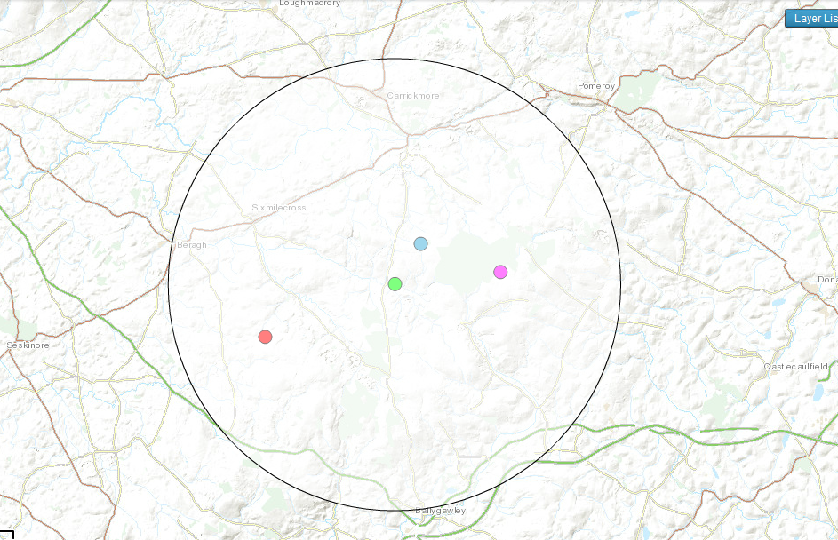
Approximate catchment of the 3 windfarms
Ballygawley
Carrickmore
Sixmilecross
Beragh
X
Gortfinbar
Eshmore
Altamuskin

Catchment area - 5 mile radius of centre point (black marker) of the 3 windfarms

