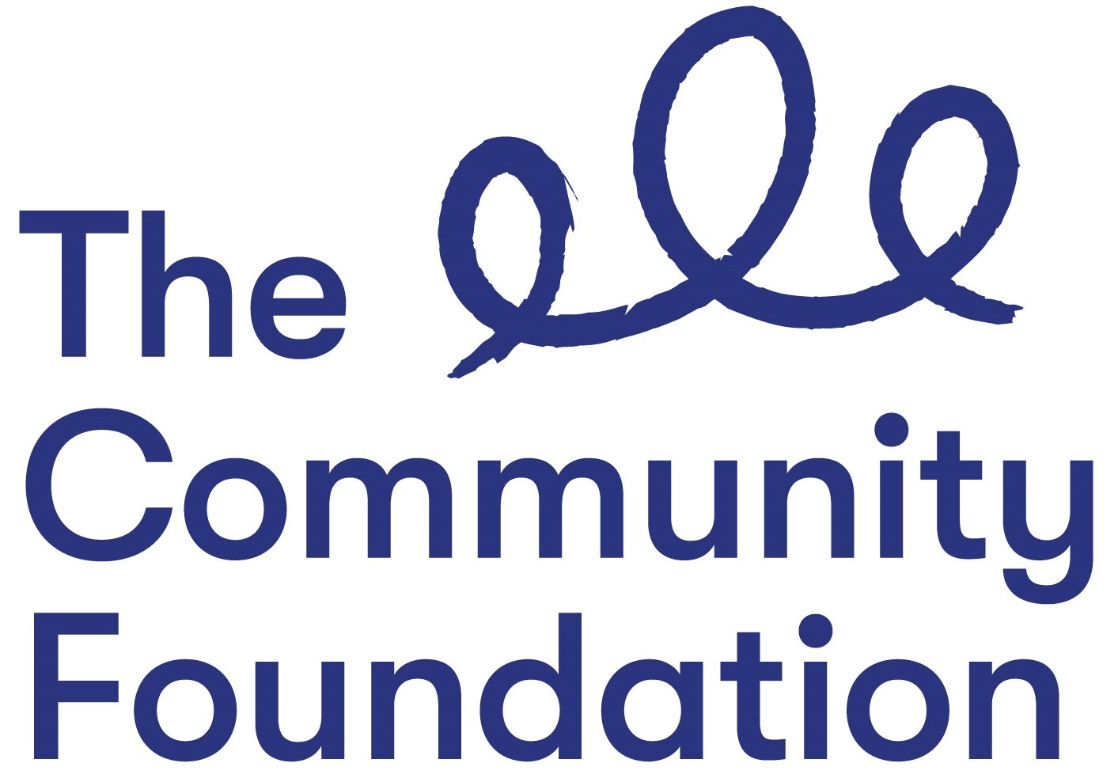
Dear Applicant

POST: Innovation & Voice Programme Officer
Full-time permanent post (35 hours per week)
24 months (fixed term), with possible extension subject to funding

Thank you for requesting an application pack for the above position. The application pack is enclosed and contains the following:
- Application Form & Fair Employment Monitoring Questionnaire
- Background Information
- Job Description and Person Specification
- Privacy Notice for Job Applicants
- Fair Employment Monitoring Form Envelope

Completing the Application Form
If you wish to be considered for this position, please complete, sign and return the application form no later than 12 noon on 22/11/2019. (An electronic form will be accepted if an electronic signature is included.)

Please do not send a C.V. as this will not be considered by the Panel. You should refer to the Person Specification when completing the form. Only those applicants who provide evidence of meeting the short-listing criteria will be invited for an interview. Please do not make general statements without providing details and examples.

Monitoring
The Community Foundation is committed to ensuring equality of opportunity in its recruitment practice. Under N.I. legislation, we are required to monitor the community background of all job applicants. A Fair Employment Monitoring Questionnaire is enclosed which you should complete and return to the Monitoring Officer with your application. This will be treated with the utmost confidentiality.

Privacy Notice
A copy of our Privacy Notice for Job Applicants is included to inform you how we will collect, process and store your personal data.

Closing Date
The closing date for receipt of completed applications is 12 noon on 22/11/2019.

Yours sincerely
Paula Gourley
Executive Officer

Enc.

