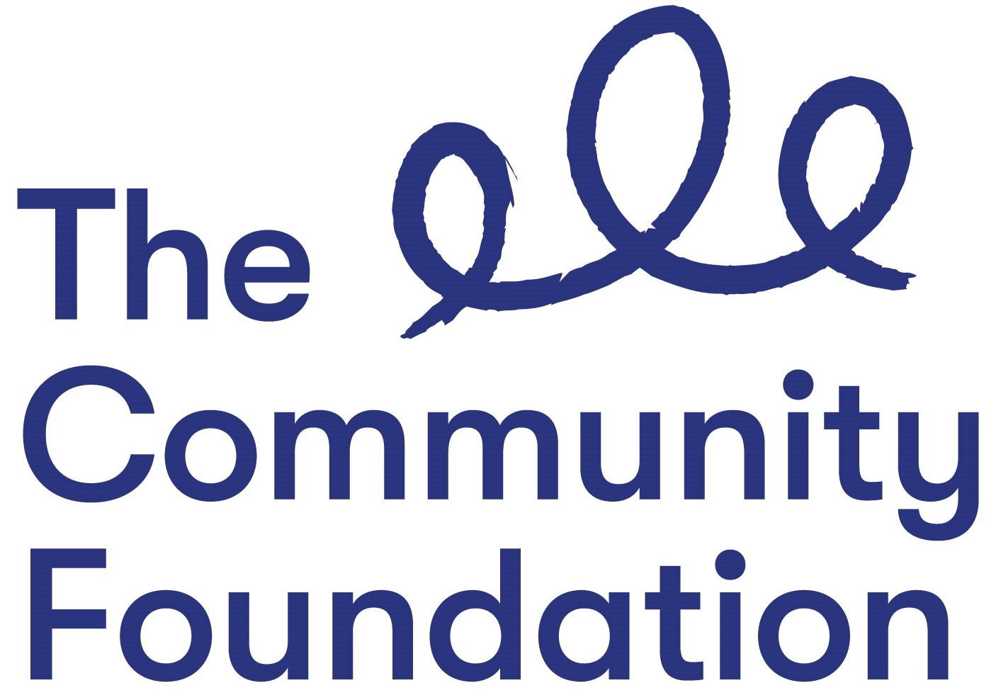

Background Information
The Community Foundation for Northern Ireland’s vision is for a peaceful, prosperous, shared and just society; and our mission is to connect people who care to causes that matter. In a society where everyone can prosper and live in peace; we encourage and support those who want to give and empower the local community to effect change.
Over the next 5 years (2019 - 2025) we will…..
- Raise £30m to support local charities and communities
- Create stronger, more sustainable community sector equipped to face today’s challenges
- Develop a more confident and vocal community sector
- Create safer, stronger, more confident individuals and communities thriving after the conflict
- Ensure there is a safer NI for those most marginalised and vulnerable
How We Work

The Community Foundation staff are a motivated, driven team. For all our roles, a high degree of self-awareness and teamwork is required.

The Community Foundation isn’t an ordinary organisation to work for and we aren’t looking for ordinary people. We expect everyone to be self-directed, motivated and take responsibility for getting their work done, pushing for the new and better things that we can do. We support and encourage people, if they don't know something, to go and find the answer themselves. We trust and expect staff to get things done without always having to ask permission
We are always challenging ourselves to do things better. We hold ourselves to the highest standards. We are always learning. We encourage staff to develop their skills, experience and qualifications to enable them to achieve their next career goal. We support staff through mentoring and coaching, training, learning opportunities and formal qualifications. We support everyone who wants to develop their leadership skills.
We look out for each other; we notice if someone is having a bad day and respond appropriately. We help each other have fun.
We look after our staff and offer an attractive salary and benefits package, including flexible working, a health cash plan, volunteering days and birthdays off, in addition to a defined contribution pension scheme with life insurance and permanent ill-health insurance.
Our Values

Generous | We encourage generosity in everything we do; we look out for each other; we deal with everyone with compassion, empathy and understanding. We are flexible in how we work with staff, donors and grantees.
Thriving | We see the potential within both our staff and the communities we work in and are committed to help both reach their full potential.
Together | We will only make the change we want to see together. We value participation, working with others and bringing people together.

