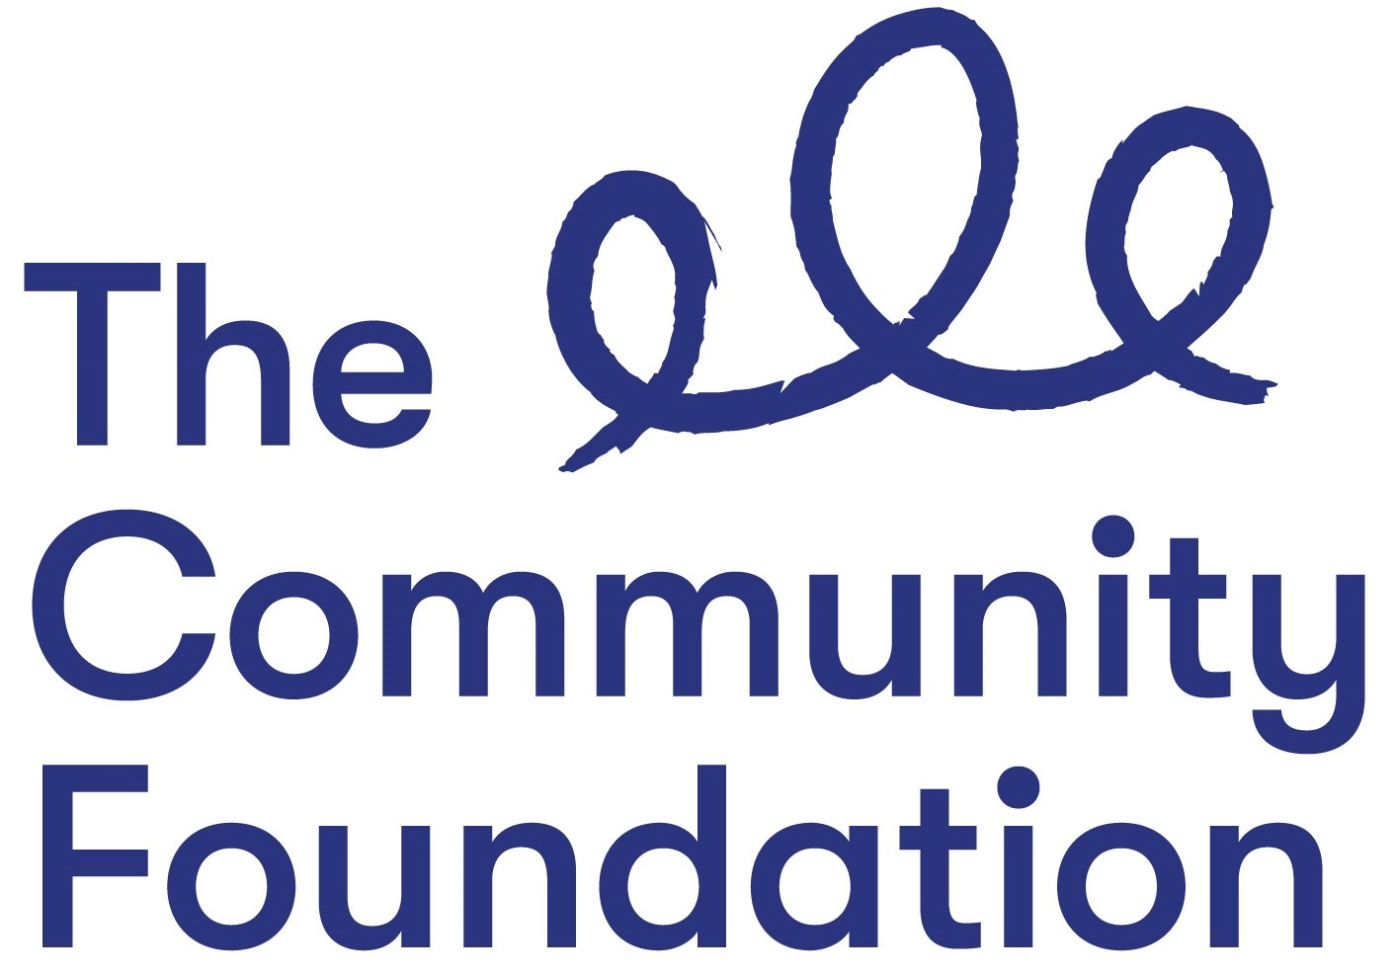

Position: Innovation & Voice Programme Officer
- NJC Points 23-25 (£26,999 - £28,785)
- starting on point 23

Closing Date: 22nd November at 12.00 noon
Ref: POIV/1119

Section 1: PERSONAL DETAILS

The Community Foundation for Northern Ireland is an Equal Opportunities Employer and welcomes applications regardless of gender, marital or family status, religious belief or political opinion, disability, race or ethnic origin, nationality, sexual orientation or age.
SURNAME: ………………………………………………………………………….

FORENAMES: ………………………………………………………………………

ADDRESS: …………………………………………………………………………..

……………………………………………………….POST CODE: ………………..

TELEPHONE NO: (Home) ……………………….

(Mobile) ……………………………..

EMAIL: ………………………………

QUALIFICATIONS:
Qualification (e.g. GCSE) | Subject | Grade Achieved | Year

FURTHER EDUCATION
Dates University/ Subjects Grade Achieved
From - To FE College etc.

MEMBERSHIP OF PROFESSIONAL ORGANISATIONS AND INSTITUTIONS
EMPLOYMENT HISTORY (please use continuation sheet if necessary)
Start with your present or most recent employment
Dates From - To  (Month & Year) | Name and Address of Employer | Position Held and Brief Description of Duties | Reason for Leaving | Salary

SECTION 2 – JOB RELATED CRITERIA

Please use this section to provide evidence of how your skills, knowledge, experience and/or qualifications meet the requirements of this post by giving examples.

NB: Only applicants who demonstrate that they meet the essential criteria will be shortlisted. Where we receive high volumes of applications, we reserve the right to shortlist those candidates who meet both the essential and desirable criteria.

ESSENTIAL CRITERIA

QUALIFICATIONS
- At least 5 GCSE’s (Grade A - C) including Maths and English;

EXPERIENCE
- At least 2 years working in a grant-making, programme delivery or programme support role within a relevant field

- At least 2 years’ experience within the past 5 years, of at least 3 of the following:

(i) Grant assessment and grant-making

(ii) Organisation and delivery of public events

(iii) Project management, including monitoring and report-writing

(iv) Writing funding applications and maintaining good donor relations

(v) Working collaboratively with external organisations, through a partnership, network or consortium

(vi) Communications work including contributing to published articles and materials

- Relevant experience and knowledge of the voluntary,community and social enterprise sector, particularly the current issues that the sector is facing.
DESIRABLE CRITERIA

- Degree in relevant discipline.

Personal Statement: Please provide a statement that illustrates how you feel you would contribute to our values of Generous, Thriving and Together.

Do you need a work permit to work in the UK?

REFERENCES:
Please provide details of 2 referees familiar with your work, one of which should be your current or most recent employer.

1. Name and Address 2. Name and Address

Telephone no: Telephone no:
Email: Email:

Can they be contacted prior to interview – Yes No

I certify that all information given is correct. I understand that any false information given may result in any job offer being withdrawn.

Signed:
Date:

APPLICATION FORMS MUST BE SIGNED AND RETURNED TO:

Paula Gourley
Community Foundation for NI
6A Albert Street
Belfast BT12 4HQ

Email: pgourley@communityfoundationni.org

CLOSING DATE: 22nd November 2019 at 12.00 noon

All applications must be completed in full, signed and returned in hard copy or by email. CVs will not be accepted or considered by the panel.
Incomplete forms or forms received after the advertised deadline will not be considered.

