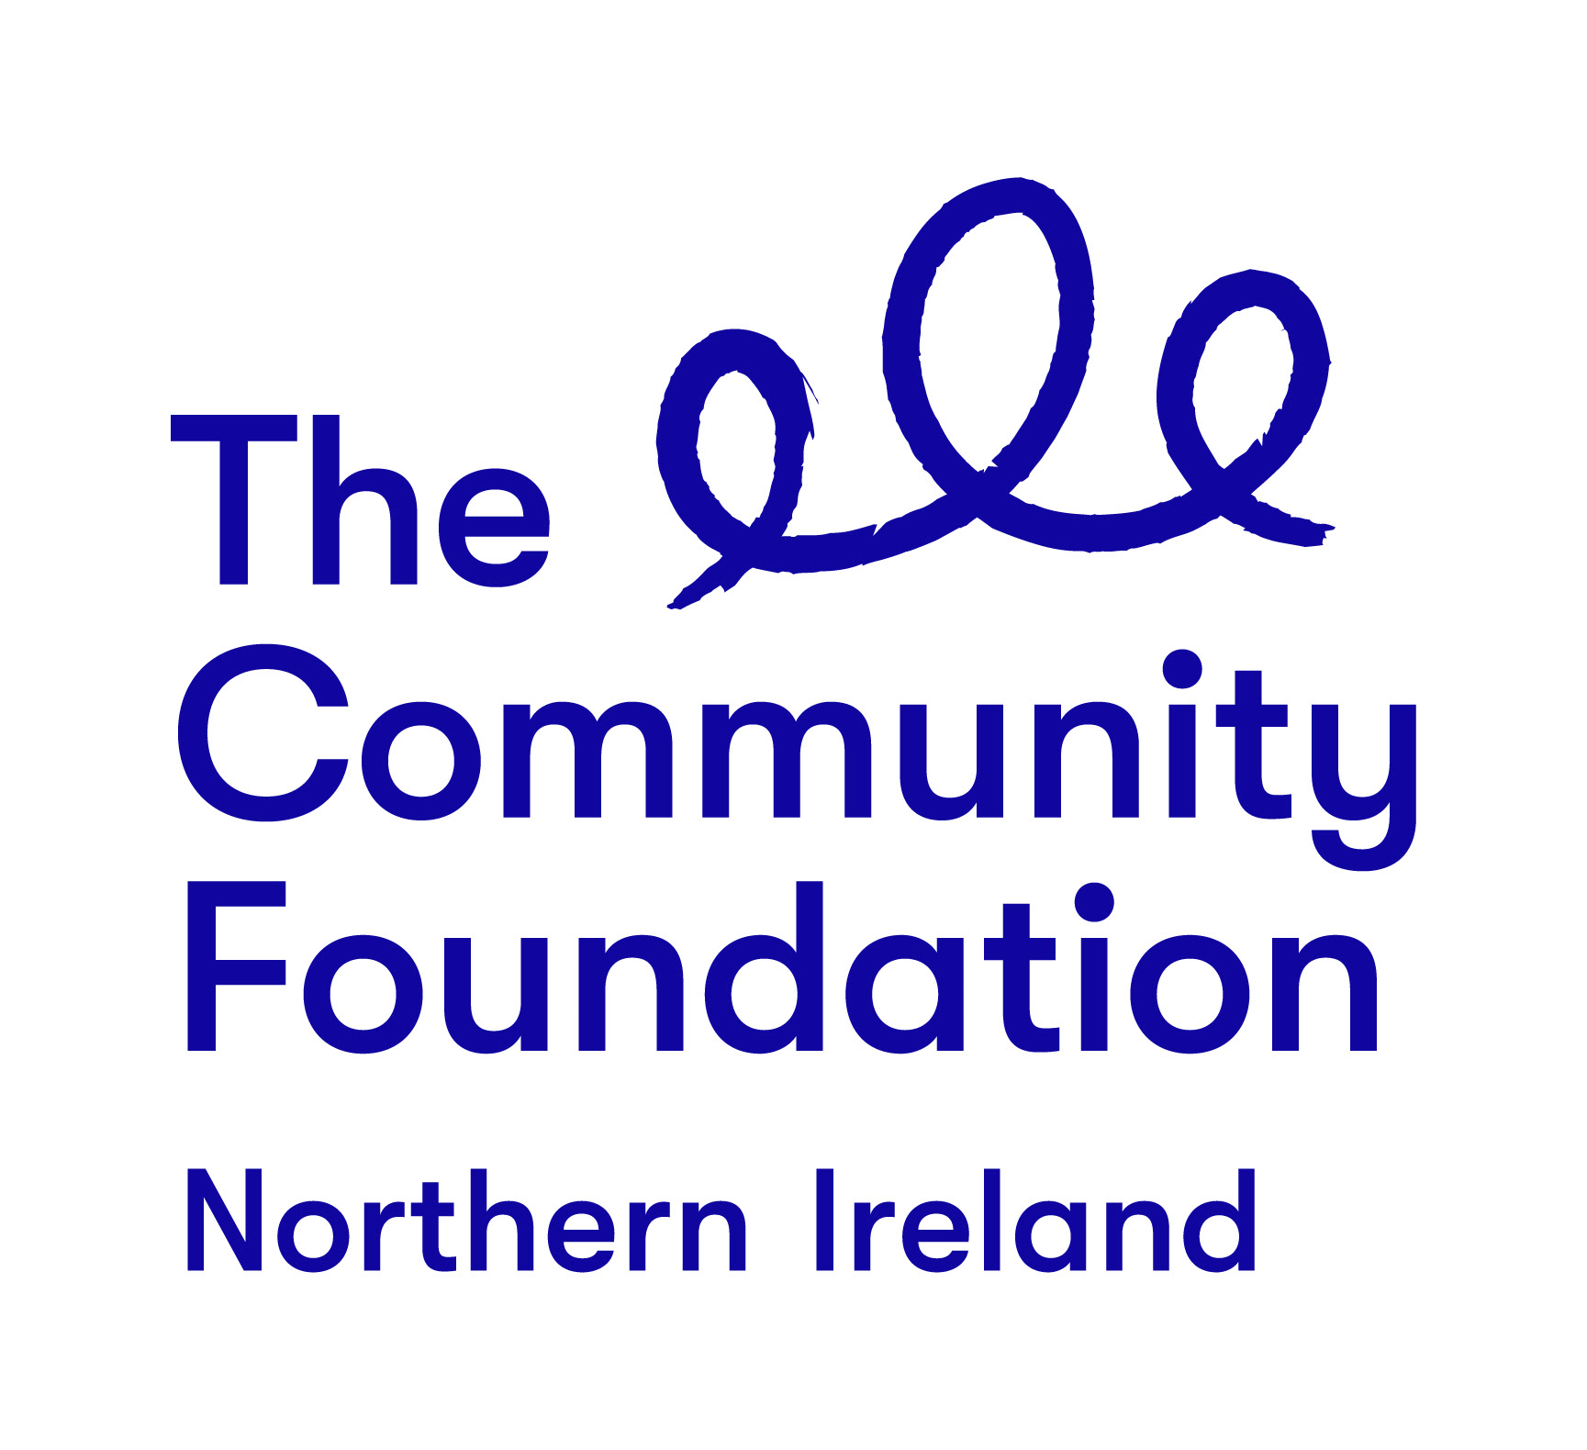

Terms of Reference

Community Facilitator

Thriving Communities - Building Sustainable Foundations

October 2019

Background to the Community Foundation for Northern Ireland

Connecting People Who Care With Causes That Matter.

For over 40 years the Community Foundation for Northern Ireland has been an independent, grant making trust, inspiring generosity and achieving impact.
We work is to make a valuable contribution to a society where everyone can prosper and live in peace. We encourage and support those who want to give and empower the local community to effect change.
The Foundation is entering an exciting new phase in our work guided by the following strategic priorities
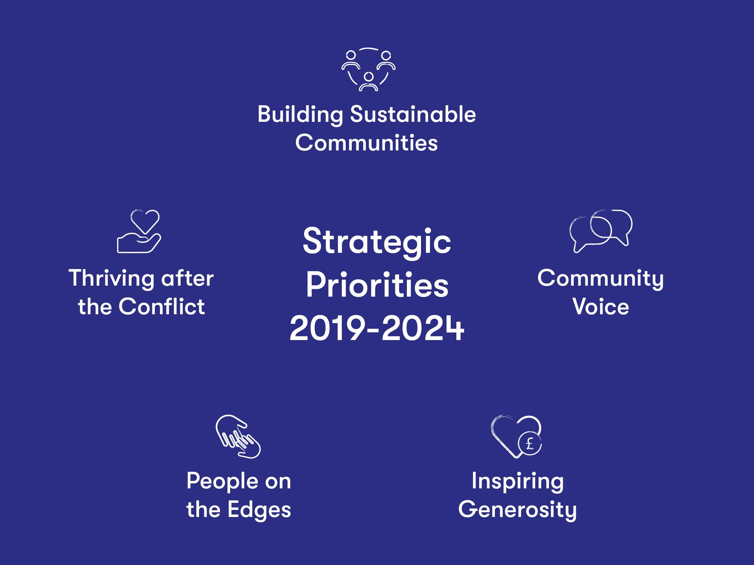
The Project - Thriving Communities – Building Sustainable Foundations
Background:
Kindly supported by the Global Fund for Community Foundations via their Fostering Community Leadership Initiative the drive for the project is to develop a Community Endowment Programme that will:
(i) Help local people to envisage a future that they will co-create and be integral to - a vision for a better area to live in and thrive in.
(ii) A future that will be sustainable and a community that will be resilient, with leadership that is transparent, encouraging and open.
(iii) Which will be focused on an assets based model that pays attention to
· Abundance not scarcity;
· Assets not needs;
· Inviting people into community conversations to co-create
· Develops progress that is incremental so that when change happens it has a greater chance of success;
· Is community owned and led;
· Building relationships both inside and outside the locality some of which may be before they actually need them;
· Building people’s sense of belonging through having their gifts and talents received and appreciated.
(iv) Act as a catalyst for and will have at its heart innovative grassroots philanthropy that builds leadership and resilience, engages residents to take charge, inspires change and stimulates the local economy.

Project Road Map
The various building blocks of the project are:
- Community Need -
Work involved in this phase would include initial project scoping, discussions with potential participants and final agreement on the groups/communities to go forward to the next phase. At this stage it would be important that groups fully understand what they would be signing up to and give formal agreement as to their participation and support.

- Community Funding - this block is the beginning of the journey towards local grassroots philanthropy exploring and tapping into the wealth within the area to support the project going forward.

  - Work involved in this phase would not just be about the normal/usual fundraising activities but a more in-depth local programme which engages the community in a movement to release financial and human capital. As a new concept within communities there should be an acknowledgement that this could be a medium to long term process

- Community Cornerstone - through a supported grassroots philanthropy process the area that has been developed secures its own resources that enhances its sustainability. However this does not end the process as through these localised initiatives the community seeks to support the building of new community leaders who are inspired to look at additional development initiatives within the community, including connecting to people in positions of power to ‘get things done’, and how such initiatives can also be supported through grassroots philanthropy.

  - Within this phase there is an expectation that a more expansive, area-based, costed, community development plan will be developed that identifies projects, activities and initiatives that will inspire change, create new opportunities and enhance community cohesion and connectivity.

- Community Sustainability - this in many ways is the exciting part of the programme which sees the local community, through its own grassroots philanthropy, have its own fund to support local projects in ways that support empowerment, growing new leaders within the community, local decision making, local accountability and collective success. Having such a localised fund will enable communities to really create a vision for their area and build a bolder, brighter and more sustainable future.

  - Work within this phase will see CFNI support the group leadership and their respective communities to build their own localised community fund and decision making processes. This will be challenging given that it will rely on the initial and continual generosity of people and businesses with a connection to the area and the acceptance that this generosity would be pooled for the benefit of local projects and people which may not have been a focus in the past for such giving.

The project will have as its foundation an inclusive process that embraces every gift from the community whether this represents capital of a financial or human nature. The programme will be a pilot to initiate a network of such communities each with its own locally managed fund that then supports these members to help their community grow and be sustainable.
This will not happen without the buy-in from the local communities and many different groups and individuals. It is envisaged that initial conversations will take place with organisations and individuals and subsequent convened mass meetings where citizens get the opportunity to work together, some for the first time, across religious and class boundaries - a process where everyone's voice will carry equal weight.
This is a very different way to approach to local community philanthropy, as it shifts thinking and practice from grants, to tapping into, and using the wealth of the community, in a sustainable way. The project builds on contacts made with and initial support from the Nebraska Community Foundation which supports communities to:
· Unleash abundant local assets
· Inspire Charitable Giving
· Connect Ambitious People
· Build Stronger Communities

The Role of the Appointed Organisation
Important to this work is an initial scoping phase that explores with a number of communities the value that they would place on such a wider programme and the development of a full programme that seeks to take interested and committed communities through the various phases as outlined above.
The Community Foundation is therefore seeking to recruit a skilled organisation who will work alongside Michael Hughes, Head of Building Sustainable Communities, to engage with local community organisations and other stakeholders in a process which scopes out interest, power dynamics and what needs to change in terms of practice, thinking and learning.
Linking closely with the Nebraska Community Foundation and the Global Fund for Community Foundations the appointed organisation will explore how these models could be transferred to a Northern Ireland context and from this learning develop a 2 year pilot programme.
Required Outputs:
● Initial community scoping identifying circa 10 communities where project is outlines and interest/commitment is assessed
● 5 communities selected to go forward to intensive planning stage
● 2 day intensive facilitation with selected groups on a collective basis
● CFNI 2 year Pilot Programme developed
● 5 Local Philanthropy Action Plans developed and launched
● Project Evaluation report for submission to CFNI Trustees and Global Fund. Given CFNI’s commitment to addressing Climate Change the evaluation report will only be required in an electronic version

Delivery Timeline
Contract will commence on day of appointment which is expected to be during November 2019 and will finish on Tuesday 31st March 2020
Oct-Nov | Recruitment of Organisation
Nov-Dec | Series of visits to identified groups (circa 10) to outline project and scope their reaction / interest to identify 5 groups/communities interested and committed to the vision of this programme
Dec - Feb | Intensive facilitation with 5 groups (minimum 2 representatives per group) to further develop understanding of community leadership, sustainability and resilience, what a pilot project could look like, how would it work in practice and the drafting of the pilot project
Feb-Mar | 2 year pilot project developed  - Report finalised for Global Fund outlining participants’ understanding of community leadership - both the theory and their own practical experience, the role of leadership in developing sustainable and resilient communities and their willingness to develop leadership within their own communities

Selection Criteria
The organisation will be selected for their ability to demonstrate a high quality, flexible and rigorous approach that offers value for money to the Community Foundation. You should highlight your suitability to fulfil the brief using examples of contracts you have worked on over the last three years.
Pass or Fail Criteria
- Work undertaken in relation to carrying out community engagement, group facilitation, action plan development and report writing: Examples within the last 3 years should be drawn upon.
- The skills and experience of the people who will be used to undertake this work. Examples of their skills and experience within the last 3 years should be drawn upon.
- The mechanisms by which the organisation will ensure consistency and standards of approaches across all elements of the work required.
- Capacity to complete the work over the specified timeframe.
Weighted Scoring Areas:
Criteria | Score
Understanding of the operating context and ethos of the Community Foundation for Northern Ireland | 10%
Methodology | 50%
Understanding of an assets based approach to community development and sustainability | 30%
Value for money | 10%

The organisation appointed will report in the first instance to the Community Foundation’s Head of Building Sustainable Communities
Making a Response
You should respond to the invitation by supplying a maximum 4 page proposal, via one electronic copy, sent to mhughes@communityfoundationni.org that should inter alia include the following components:
● Your understanding of the brief;
● Your proposed approach for the delivery of the required outputs
● Confirmation that you will fulfil all the tasks and deliver the outputs in the timeframe outlined
● Who will be involved in the work with their respective CVs
● A statement of experience detailing your work in this area.
● The names and addresses of two clients for whom you have completed similar assignments (detailing the nature of the work undertaken for them).
The maximum price contract for this work inclusive of VAT and travel is £7,000 and organisations should price accordingly to gain a competitive advantage.
It is anticipated that the appointed organisation will have access to all the necessary resources required to enable them to fulfil the assignment. However, on occasion meeting rooms and access to desk space at the Community Foundation’s offices may be available by prior arrangement.
Further Information

Contact: Michael Hughes Head of Building Sustainable Communities
Email: mhughes@communityfoundationni.org

Queries will only be accepted by email
Closing Date
The closing date for receipt of submission which should emailed to mhughes@communityfoundationni.org is 12 noon Friday 1st November 2019. Submissions received after the closing date will not be considered.
Note that the Community Foundation is not obliged to appoint the lowest or any tender.

